UNITED STATES
SECURITIES AND EXCHANGE COMMISSION
Washington, D.C. 20549
_____________________________________________________________
FORM 10-Q
(Mark One)
☒ |  |  | QUARTERLY REPORT PURSUANT TO SECTION 13 OR 15(d) OF THE SECURITIES EXCHANGE ACT OF 1934
For the quarterly period ended September 30, 2025
or
o |  |  | TRANSITION REPORT PURSUANT TO SECTION 13 OR 15(d) OF THE SECURITIES EXCHANGE ACT OF 1934
For the transition period from ________ to _________
Commission File Number: 001-39486
QUANTUM-SI INCORPORATED
(Exact name of registrant as specified in its charter)
_____________________________________________________________
Delaware |  |  |  |  |  | 85-1388175
(State or other jurisdiction of incorporation or organization) |  |  |  |  |  | (I.R.S. Employer Identification No.)
29 Business Park Drive
Branford, Connecticut |  |  |  |  |  | 06405
(Address of principal executive offices) |  |  |  |  |  | (Zip Code)
(866) 688-7374
(Registrant’s telephone number, including area code)
Not applicable
(Former name, former address and former fiscal year, if changed since last report)
Securities registered pursuant to Section 12(b) of the Act:
Title of each class |  |  |  |  |  | Trading  Symbol(s) |  |  |  |  |  | Name of each exchange on which registered
Class A common stock, $0.0001 per share |  |  |  |  |  | QSI |  |  |  |  |  | The Nasdaq Stock Market LLC
Redeemable warrants, each whole warrant exercisable for one share of Class A common stock, each at an exercise price of $11.50 per share |  |  |  |  |  | QSIAW |  |  |  |  |  | The Nasdaq Stock Market LLC
Indicate by check mark whether the registrant (1) has filed all reports required to be filed by Section 13 or 15(d) of the Securities Exchange Act of 1934 during the preceding 12 months (or for such shorter period that the registrant was required to file such reports), and (2) has been subject to such filing requirements for the past 90 days. Yes ☒ No o
Indicate by check mark whether the registrant has submitted electronically every Interactive Data File required to be submitted pursuant to Rule 405 of Regulation S-T (§232.405 of this chapter) during the preceding 12 months (or for such shorter period that the registrant was required to submit such files). Yes ☒ No o
Indicate by check mark whether the registrant is a large accelerated filer, an accelerated filer, a non-accelerated filer, a smaller reporting company, or an emerging growth company. See the definitions of “large accelerated filer,” “accelerated filer,” “smaller reporting company,” and “emerging growth company” in Rule 12b-2 of the Exchange Act.
Large accelerated filer |  |  | o |  |  |  |  |  | Accelerated filer |  |  | o
Non-accelerated filer |  |  | ☒ |  |  |  |  |  | Smaller reporting company |  |  | ☒
 |  |  |  |  |  |  |  |  | Emerging growth company |  |  | o
If an emerging growth company, indicate by check mark if the registrant has elected not to use the extended transition period for complying with any new or revised financial accounting standards provided pursuant to Section 13(a) of the Exchange Act. o
Indicate by check mark whether the registrant is a shell company (as defined in Rule 12b-2 of the Exchange Act). Yes ☐ No ☒
As of October 31, 2025, the registrant had 195,552,165 shares of Class A common stock outstanding and 19,937,500 shares of Class B common stock outstanding.

QUANTUM-SI INCORPORATED
TABLE OF CONTENTS

 |  |  |  |  |  | Page
 |  |  | Cautionary Note Regarding Forward-Looking Statements |  |  | 3
Part I. |  |  | Financial Information |  |  | 5
Item 1. |  |  | Financial Statements |  |  | 5
 |  |  | Condensed Consolidated Balance Sheets as of September 30, 2025, and December 31, 2024 (unaudited) |  |  | 5
 |  |  | Condensed Consolidated Statements of Operations and Comprehensive Loss for the three and nine months ended September 30, 2025 and 2024 (unaudited) |  |  | 6
 |  |  | Condensed Consolidated Statements of Changes in Stockholders’ Equity for the three and nine months ended September 30, 2025 and 2024 (unaudited) |  |  | 7
 |  |  | Condensed Consolidated Statements of Cash Flows for the nine months ended September 30, 2025 and 2024 (unaudited) |  |  | 8
 |  |  | Notes to Condensed Consolidated Financial Statements (unaudited) |  |  | 9
Item 2. |  |  | Management’s Discussion and Analysis of Financial Condition and Results of Operations |  |  | 27
Item 3. |  |  | Quantitative and Qualitative Disclosures About Market Risk |  |  | 36
Item 4. |  |  | Controls and Procedures |  |  | 37
Part II. |  |  | Other Information |  |  | 38
Item 1. |  |  | Legal Proceedings |  |  | 38
Item 1A. |  |  | Risk Factors |  |  | 38
Item 2. |  |  | Unregistered Sales of Equity Securities and Use of Proceeds |  |  | 38
Item 3. |  |  | Defaults Upon Senior Securities |  |  | 38
Item 4. |  |  | Mine Safety Disclosures |  |  | 38
Item 5. |  |  | Other Information |  |  | 39
Item 6. |  |  | Exhibits |  |  | 39
Signatures |  |  |  |  |  | 40
In this Quarterly Report on Form 10-Q, the terms “we”, “us”, “our”, the “Company” or “Quantum-Si” mean Quantum-Si Incorporated and our subsidiaries. Quantum-Si Incorporated was incorporated in Delaware on June 10, 2020.

2
Table of Contents
CAUTIONARY NOTE REGARDING FORWARD-LOOKING STATEMENTS
This Quarterly Report on Form 10-Q includes forward-looking statements within the meaning of Section 27A of the Securities Act of 1933, as amended (the “Securities Act”), and Section 21E of the Securities Exchange Act of 1934, as amended (the “Exchange Act”) and subject to the safe harbor created by the Private Securities Litigation Reform Act of 1995, that relate to future events, our future operations or financial performance, or our plans, strategies and prospects. These statements are based on the beliefs and assumptions of our management team. Although we believe that our plans, intentions and expectations reflected in or suggested by these forward-looking statements are reasonable, we cannot assure you that we will achieve or realize these plans, intentions or expectations. Forward-looking statements are inherently subject to risks, uncertainties and assumptions. Generally, statements that are not historical facts, including statements concerning possible or assumed future actions, business strategies, events or performance, are forward-looking statements. The actual results may differ from its expectations, estimates, and projections and, consequently, you should not rely on these forward-looking statements as predictions of future events. Words such as “expect,” “estimate,” “project,” “budget,” “forecast,” “anticipate,” “intend,” “plan,” “may,” “will,” “could,” “should,” “believes,” “predicts,” “potential,” “continue,” and similar expressions (or the negative versions of such words or expressions) are intended to identify such forward-looking statements. These forward-looking statements include, without limitation, our expectations with respect to future performance and development and commercialization of products and services. The forward-looking statements are based on projections prepared by, and are the responsibility of, management and involve significant risks and uncertainties that could cause the actual results to differ materially from those discussed in the forward-looking statements. Most of these factors are outside our control and are difficult to predict. Forward-looking statements contained in this Quarterly Report on Form 10-Q include, but are not limited to, statements about:
•the impact of international conflicts, pandemics or epidemics on our business;
•the impact of general conditions in the global economy and in the global financial markets, including changes in inflation, interest rates, tariffs, retaliatory trade policies including limitations of shipments of products, and overall economic conditions and uncertainties;
•maintaining the listing of our Class A common stock on The Nasdaq Stock Market LLC;
•changes in applicable laws or regulations;
•our ability to raise financing in the future;
•the success, cost and timing of our product development and commercialization activities;
•the commercialization and adoption of our existing products, including our Platinum® line of instruments and our consumable kits, and the success of any product we may offer in the future;
•our ability to obtain and maintain regulatory approval for our products, and any related restrictions and limitations of any approved product;
•our ability to identify, in-license or acquire additional technology;
•our ability to maintain our existing lease, license, manufacture and supply agreements;
•our ability to compete with other companies currently marketing or engaged in the development or commercialization of products and services that serve customers engaged in proteomic analysis, many of which have greater financial and marketing resources than us;
•the size and growth potential of the markets for our products and services, and our ability to serve those markets once commercialized, either alone or in partnership with others;
•our estimates regarding future expenses, future revenue, capital requirements and needs for additional financing; and
•our financial performance.
These forward-looking statements are based on information available as of the date of this report and current expectations, forecasts and assumptions, and involve a number of judgments, risks and uncertainties. Important factors could cause actual results, performance or achievements to differ materially from those indicated or implied by forward-looking statements such as those described in Part I, Item 1A, “Risk Factors” of our Annual Report on Form 10-K for the fiscal year ended December 31, 2024, this Quarterly Report on Form 10-Q and in other filings that we make with the Securities and Exchange Commission. The risks described under the heading “Risk Factors” are not exhaustive. New risk factors emerge from time to time, and it is not possible to predict all such risk factors, nor can we assess the impact of all such risk factors on our business or the extent to which any factor or combination of factors may cause actual results to differ materially from those contained in any forward-looking statements. Forward-looking statements are not guarantees of performance. You should not put undue reliance on these statements, which speak only as of the date hereof. All forward-looking statements attributable to us or persons acting on our behalf are expressly qualified in their entirety by the
3
Table of Contents
foregoing cautionary statements. We undertake no obligation to update or revise publicly any forward-looking statements, whether as a result of new information, future events or otherwise, except as required by law.

4
Table of Contents
PART I – FINANCIAL INFORMATION

Item 1. Financial Statements

QUANTUM-SI INCORPORATED
CONDENSED CONSOLIDATED BALANCE SHEETS
(in thousands, except share and par value amounts)
(unaudited)
 |  |  | September 30,  2025 |  |  |  |  |  | December 31,  2024
Assets
Current assets:
Cash and cash equivalents |  |  | $ | 30,910 |  |  |  |  | $ | 49,241
Marketable securities, current |  |  | 194,934 |  |  |  |  |  | 160,362
Accounts receivable, net of allowance of $140 and $124, respectively |  |  | 755 |  |  |  |  |  | 1,333
Legal settlement insurance receivable |  |  | 4,638 |  |  |  |  |  | —
Inventory |  |  | 3,513 |  |  |  |  |  | 4,067
Prepaid expenses and other current assets |  |  | 3,240 |  |  |  |  |  | 3,006
Total current assets |  |  | 237,990 |  |  |  |  |  | 218,009
Marketable securities, non-current |  |  | 4,691 |  |  |  |  |  | —
Property and equipment, net |  |  | 13,374 |  |  |  |  |  | 15,993
Operating lease right-of-use assets |  |  | 3,839 |  |  |  |  |  | 13,061
Other assets |  |  | 233 |  |  |  |  |  | 808
Total assets |  |  | $ | 260,127 |  |  |  |  | $ | 247,871
Liabilities and stockholders’ equity
Current liabilities:
Accounts payable |  |  | $ | 1,346 |  |  |  |  | $ | 1,931
Accrued payroll and payroll-related costs |  |  | 4,776 |  |  |  |  |  | 5,331
Accrued contracted services |  |  | 3,027 |  |  |  |  |  | 2,379
Accrued legal settlement liability |  |  | 8,000 |  |  |  |  |  | —
Accrued expenses and other current liabilities |  |  | 2,096 |  |  |  |  |  | 4,848
Warrant liabilities, current |  |  | 1,073 |  |  |  |  |  | —
Current portion of operating lease liabilities |  |  | 1,829 |  |  |  |  |  | 3,698
Total current liabilities |  |  | 22,147 |  |  |  |  |  | 18,187
Warrant liabilities, non-current |  |  | — |  |  |  |  |  | 4,995
Operating lease liabilities |  |  | 2,781 |  |  |  |  |  | 9,250
Other long-term liabilities |  |  | 40 |  |  |  |  |  | 19
Total liabilities |  |  | 24,968 |  |  |  |  |  | 32,451
Commitments and contingencies (Note 17)
Stockholders’ equity:
Class A Common stock, $0.0001 par value; 600,000,000 shares authorized as of September 30, 2025 and December 31, 2024; 195,520,747 and 146,953,271 shares issued and outstanding as of September 30, 2025 and December 31, 2024, respectively |  |  | 20 |  |  |  |  |  | 16
Class B Common stock, $0.0001 par value; 27,000,000 shares authorized as of September 30, 2025 and December 31, 2024; 19,937,500 shares issued and outstanding as of September 30, 2025 and December 31, 2024 |  |  | 2 |  |  |  |  |  | 2
Additional paid-in capital |  |  | 915,452 |  |  |  |  |  | 811,998
Accumulated other comprehensive income |  |  | 54 |  |  |  |  |  | 45
Accumulated deficit |  |  | (680,369) |  |  |  |  |  | (596,641)
Total stockholders’ equity |  |  | 235,159 |  |  |  |  |  | 215,420
Total liabilities and stockholders’ equity |  |  | $ | 260,127 |  |  |  |  | $ | 247,871
The accompanying notes are an integral part of these Condensed Consolidated Financial Statements.

5
Table of Contents
QUANTUM-SI INCORPORATED
CONDENSED CONSOLIDATED STATEMENTS OF OPERATIONS AND COMPREHENSIVE LOSS
(in thousands, except per share amounts)
(unaudited)
 |  |  | Three months ended September 30, |  |  |  |  |  |  |  |  |  |  |  | Nine months ended September 30,
 |  |  | 2025 |  |  |  |  |  | 2024 |  |  |  |  |  | 2025 |  |  |  |  |  | 2024
Revenue
Product |  |  | $ | 505 |  |  |  |  | $ | 764 |  |  |  |  | $ | 1,871 |  |  |  |  | $ | 1,776
Service |  |  | 47 |  |  |  |  |  | 23 |  |  |  |  |  | 114 |  |  |  |  |  | 90
Total revenue |  |  | 552 |  |  |  |  |  | 787 |  |  |  |  |  | 1,985 |  |  |  |  |  | 1,866
Cost of revenue
Product |  |  | 353 |  |  |  |  |  | 416 |  |  |  |  |  | 920 |  |  |  |  |  | 835
Service |  |  | 5 |  |  |  |  |  | 4 |  |  |  |  |  | 34 |  |  |  |  |  | 41
Total cost of revenue |  |  | 358 |  |  |  |  |  | 420 |  |  |  |  |  | 954 |  |  |  |  |  | 876
Gross profit |  |  | 194 |  |  |  |  |  | 367 |  |  |  |  |  | 1,031 |  |  |  |  |  | 990
Operating expenses:
Research and development |  |  | 13,883 |  |  |  |  |  | 16,171 |  |  |  |  |  | 42,813 |  |  |  |  |  | 42,653
Selling, general and administrative |  |  | 10,707 |  |  |  |  |  | 12,284 |  |  |  |  |  | 34,484 |  |  |  |  |  | 36,236
Lease termination expense, net |  |  | 13,577 |  |  |  |  |  | — |  |  |  |  |  | 13,577 |  |  |  |  |  | —
Legal settlement expense, net of insurance proceeds |  |  | 1,800 |  |  |  |  |  | — |  |  |  |  |  | 5,162 |  |  |  |  |  | —
Total operating expenses |  |  | 39,967 |  |  |  |  |  | 28,455 |  |  |  |  |  | 96,036 |  |  |  |  |  | 78,889
Loss from operations |  |  | (39,773) |  |  |  |  |  | (28,088) |  |  |  |  |  | (95,005) |  |  |  |  |  | (77,899)
Dividend and interest income |  |  | 2,580 |  |  |  |  |  | 2,688 |  |  |  |  |  | 7,439 |  |  |  |  |  | 9,149
Change in fair value of warrant liabilities |  |  | 1,516 |  |  |  |  |  | 121 |  |  |  |  |  | 3,923 |  |  |  |  |  | 917
Other (expense) income, net |  |  | (7) |  |  |  |  |  | 9 |  |  |  |  |  | (35) |  |  |  |  |  | (10)
Loss before provision for income taxes |  |  | (35,684) |  |  |  |  |  | (25,270) |  |  |  |  |  | (83,678) |  |  |  |  |  | (67,843)
Provision for income taxes |  |  | (19) |  |  |  |  |  | (43) |  |  |  |  |  | (50) |  |  |  |  |  | (43)
Net loss |  |  | $ | (35,703) |  |  |  |  | $ | (25,313) |  |  |  |  | $ | (83,728) |  |  |  |  | $ | (67,886)
Net loss per common share attributable to common stockholders, basic and diluted |  |  | $ | (0.17) |  |  |  |  | $ | (0.18) |  |  |  |  | $ | (0.44) |  |  |  |  | $ | (0.48)
Weighted-average shares used to compute net loss per share attributable to common stockholders, basic and diluted |  |  | 209,041 |  |  |  |  |  | 142,399 |  |  |  |  |  | 191,754 |  |  |  |  |  | 142,039
Other comprehensive income (loss)
Net unrealized gain (loss) on marketable securities, net of tax |  |  | $ | 102 |  |  |  |  | $ | 163 |  |  |  |  | $ | (5) |  |  |  |  | $ | 163
Foreign currency translation adjustment |  |  | (8) |  |  |  |  |  | (3) |  |  |  |  |  | 14 |  |  |  |  |  | (10)
Total other comprehensive income, net of tax |  |  | 94 |  |  |  |  |  | 160 |  |  |  |  |  | 9 |  |  |  |  |  | 153
Comprehensive loss |  |  | $ | (35,609) |  |  |  |  | $ | (25,153) |  |  |  |  | $ | (83,719) |  |  |  |  | $ | (67,733)

The accompanying notes are an integral part of these Condensed Consolidated Financial Statements.

6
Table of Contents
QUANTUM-SI INCORPORATED
CONDENSED CONSOLIDATED STATEMENTS OF CHANGES IN STOCKHOLDERS’ EQUITY
(in thousands, except share amounts)
(unaudited)
 |  |  | Class A  common stock |  |  |  |  |  |  |  |  |  |  |  | Class B  common stock |  |  |  |  |  |  |  |  |  |  |  | Additional  paid-in  capital |  |  |  |  |  | Accumulated other comprehensive gain (loss) |  |  |  |  |  | Accumulated  deficit |  |  |  |  |  | Total  stockholders’  equity
 |  |  | Shares |  |  |  |  |  | Amount |  |  |  |  |  | Shares |  |  |  |  |  | Amount
Balance - December 31, 2024 |  |  | 146,953,271 |  |  |  |  |  | $ | 16 |  |  |  |  | 19,937,500 |  |  |  |  |  | $ | 2 |  |  |  |  | $ | 811,998 |  |  |  |  | $ | 45 |  |  |  |  | $ | (596,641) |  |  |  |  | $ | 215,420
Common stock issued upon exercise of stock options |  |  | 623,834 |  |  |  |  |  | — |  |  |  |  |  | — |  |  |  |  |  | — |  |  |  |  |  | 1,600 |  |  |  |  |  | — |  |  |  |  |  | — |  |  |  |  |  | 1,600
Common stock issued upon vesting of restricted stock units |  |  | 358,511 |  |  |  |  |  | — |  |  |  |  |  | — |  |  |  |  |  | — |  |  |  |  |  | — |  |  |  |  |  | — |  |  |  |  |  | — |  |  |  |  |  | —
Common stock issued from direct equity offering, net of fees and issuance costs |  |  | 15,625,000 |  |  |  |  |  | — |  |  |  |  |  | — |  |  |  |  |  | — |  |  |  |  |  | 46,774 |  |  |  |  |  | — |  |  |  |  |  | — |  |  |  |  |  | 46,774
Stock-based compensation |  |  | — |  |  |  |  |  | — |  |  |  |  |  | — |  |  |  |  |  | — |  |  |  |  |  | 2,362 |  |  |  |  |  | — |  |  |  |  |  | — |  |  |  |  |  | 2,362
Net unrealized loss on marketable securities, net of tax |  |  | — |  |  |  |  |  | — |  |  |  |  |  | — |  |  |  |  |  | — |  |  |  |  |  | — |  |  |  |  |  | (53) |  |  |  |  |  | — |  |  |  |  |  | (53)
Foreign currency translation |  |  | — |  |  |  |  |  | — |  |  |  |  |  | — |  |  |  |  |  | — |  |  |  |  |  | — |  |  |  |  |  | 6 |  |  |  |  |  | — |  |  |  |  |  | 6
Net loss |  |  | — |  |  |  |  |  | — |  |  |  |  |  | — |  |  |  |  |  | — |  |  |  |  |  | — |  |  |  |  |  | — |  |  |  |  |  | (19,189) |  |  |  |  |  | (19,189)
Balance - March 31, 2025 |  |  | 163,560,616 |  |  |  |  |  | $ | 16 |  |  |  |  | 19,937,500 |  |  |  |  |  | $ | 2 |  |  |  |  | $ | 862,734 |  |  |  |  | $ | (2) |  |  |  |  | $ | (615,830) |  |  |  |  | $ | 246,920
Common stock issued upon exercise of stock options |  |  | 24,583 |  |  |  |  |  | — |  |  |  |  |  | — |  |  |  |  |  | — |  |  |  |  |  | 41 |  |  |  |  |  | — |  |  |  |  |  | — |  |  |  |  |  | 41
Common stock issued upon vesting of restricted stock units |  |  | 772,335 |  |  |  |  |  | — |  |  |  |  |  | — |  |  |  |  |  | — |  |  |  |  |  | — |  |  |  |  |  | — |  |  |  |  |  | — |  |  |  |  |  | —
Stock-based compensation |  |  | — |  |  |  |  |  | — |  |  |  |  |  | — |  |  |  |  |  | — |  |  |  |  |  | 2,896 |  |  |  |  |  | — |  |  |  |  |  | — |  |  |  |  |  | 2,896
Net unrealized loss on marketable securities, net of tax |  |  | — |  |  |  |  |  | — |  |  |  |  |  | — |  |  |  |  |  | — |  |  |  |  |  | — |  |  |  |  |  | (54) |  |  |  |  |  | — |  |  |  |  |  | (54)
Foreign currency translation |  |  | — |  |  |  |  |  | — |  |  |  |  |  | — |  |  |  |  |  | — |  |  |  |  |  | — |  |  |  |  |  | 16 |  |  |  |  |  | — |  |  |  |  |  | 16
Net loss |  |  | — |  |  |  |  |  | — |  |  |  |  |  | — |  |  |  |  |  | — |  |  |  |  |  | — |  |  |  |  |  | — |  |  |  |  |  | (28,836) |  |  |  |  |  | (28,836)
Balance - June 30, 2025 |  |  | 164,357,534 |  |  |  |  |  | $ | 16 |  |  |  |  | 19,937,500 |  |  |  |  |  | $ | 2 |  |  |  |  | $ | 865,671 |  |  |  |  | $ | (40) |  |  |  |  | $ | (644,666) |  |  |  |  | $ | 220,983
Common stock issued upon exercise of stock options |  |  | 143,393 |  |  |  |  |  | — |  |  |  |  |  | — |  |  |  |  |  | — |  |  |  |  |  | 221 |  |  |  |  |  | — |  |  |  |  |  | — |  |  |  |  |  | 221
Common stock issued upon vesting of restricted stock units |  |  | 1,079,701 |  |  |  |  |  | 1 |  |  |  |  |  | — |  |  |  |  |  | — |  |  |  |  |  | — |  |  |  |  |  | — |  |  |  |  |  | — |  |  |  |  |  | 1
Common stock issued from direct equity offering and upon exercise of pre-funded warrants, net of fees and issuance costs |  |  | 29,940,119 |  |  |  |  |  | 3 |  |  |  |  |  | — |  |  |  |  |  | — |  |  |  |  |  | 46,733 |  |  |  |  |  | — |  |  |  |  |  | — |  |  |  |  |  | 46,736
Stock-based compensation |  |  | — |  |  |  |  |  | — |  |  |  |  |  | — |  |  |  |  |  | — |  |  |  |  |  | 2,827 |  |  |  |  |  | — |  |  |  |  |  | — |  |  |  |  |  | 2,827
Net unrealized gain on marketable securities, net of tax |  |  | — |  |  |  |  |  | — |  |  |  |  |  | — |  |  |  |  |  | — |  |  |  |  |  | — |  |  |  |  |  | 102 |  |  |  |  |  | — |  |  |  |  |  | 102
Foreign currency translation |  |  | — |  |  |  |  |  | — |  |  |  |  |  | — |  |  |  |  |  | — |  |  |  |  |  | — |  |  |  |  |  | (8) |  |  |  |  |  | — |  |  |  |  |  | (8)
Net loss |  |  | — |  |  |  |  |  | — |  |  |  |  |  | — |  |  |  |  |  | — |  |  |  |  |  | — |  |  |  |  |  | — |  |  |  |  |  | (35,703) |  |  |  |  |  | (35,703)
Balance - September 30, 2025 |  |  | 195,520,747 |  |  |  |  |  | $ | 20 |  |  |  |  | 19,937,500 |  |  |  |  |  | $ | 2 |  |  |  |  | $ | 915,452 |  |  |  |  | $ | 54 |  |  |  |  | $ | (680,369) |  |  |  |  | $ | 235,159
 |  |  | Class A  common stock |  |  |  |  |  |  |  |  |  |  |  | Class B  common stock |  |  |  |  |  |  |  |  |  |  |  | Additional  paid-in  capital |  |  |  |  |  | Accumulated other comprehensive (loss) gain |  |  |  |  |  | Accumulated  deficit |  |  |  |  |  | Total stockholders’  equity
 |  |  | Shares |  |  |  |  |  | Amount |  |  |  |  |  | Shares |  |  |  |  |  | Amount
Balance - December 31, 2023 |  |  | 121,832,417 |  |  |  |  |  | $ | 12 |  |  |  |  | 19,937,500 |  |  |  |  |  | $ | 2 |  |  |  |  | $ | 767,239 |  |  |  |  | $ | — |  |  |  |  | $ | (495,634) |  |  |  |  | $ | 271,619
Common stock issued upon vesting of restricted stock units |  |  | 46,572 |  |  |  |  |  | — |  |  |  |  |  | — |  |  |  |  |  | — |  |  |  |  |  | — |  |  |  |  |  | — |  |  |  |  |  | — |  |  |  |  |  | —
Stock-based compensation |  |  | — |  |  |  |  |  | — |  |  |  |  |  | — |  |  |  |  |  | — |  |  |  |  |  | 1,645 |  |  |  |  |  | — |  |  |  |  |  | — |  |  |  |  |  | 1,645
Net unrealized loss on marketable securities, net of tax |  |  | — |  |  |  |  |  | — |  |  |  |  |  | — |  |  |  |  |  | — |  |  |  |  |  | — |  |  |  |  |  | (28) |  |  |  |  |  | — |  |  |  |  |  | (28)
Refund of issuance costs |  |  | — |  |  |  |  |  | — |  |  |  |  |  | — |  |  |  |  |  | — |  |  |  |  |  | 14 |  |  |  |  |  | — |  |  |  |  |  | — |  |  |  |  |  | 14
Foreign currency translation |  |  | — |  |  |  |  |  | — |  |  |  |  |  | — |  |  |  |  |  | — |  |  |  |  |  | — |  |  |  |  |  | (5) |  |  |  |  |  | — |  |  |  |  |  | (5)
Net loss |  |  | — |  |  |  |  |  | — |  |  |  |  |  | — |  |  |  |  |  | — |  |  |  |  |  | — |  |  |  |  |  | — |  |  |  |  |  | (19,474) |  |  |  |  |  | (19,474)
Balance - March 31, 2024 |  |  | 121,878,989 |  |  |  |  |  | $ | 12 |  |  |  |  | 19,937,500 |  |  |  |  |  | $ | 2 |  |  |  |  | $ | 768,898 |  |  |  |  | $ | (33) |  |  |  |  | $ | (515,108) |  |  |  |  | $ | 253,771
Common stock issued upon exercise of stock options |  |  | 96,069 |  |  |  |  |  | — |  |  |  |  |  | — |  |  |  |  |  | — |  |  |  |  |  | 136 |  |  |  |  |  | — |  |  |  |  |  | — |  |  |  |  |  | 136
Common stock issued upon vesting of restricted stock units |  |  | 407,274 |  |  |  |  |  | — |  |  |  |  |  | — |  |  |  |  |  | — |  |  |  |  |  | — |  |  |  |  |  | — |  |  |  |  |  | — |  |  |  |  |  | —
Stock-based compensation |  |  | — |  |  |  |  |  | — |  |  |  |  |  | — |  |  |  |  |  | — |  |  |  |  |  | 2,426 |  |  |  |  |  | — |  |  |  |  |  | — |  |  |  |  |  | 2,426
Net unrealized gain on marketable securities, net of tax |  |  | — |  |  |  |  |  | — |  |  |  |  |  | — |  |  |  |  |  | — |  |  |  |  |  | — |  |  |  |  |  | 28 |  |  |  |  |  | — |  |  |  |  |  | 28
Foreign currency translation |  |  | — |  |  |  |  |  | — |  |  |  |  |  | — |  |  |  |  |  | — |  |  |  |  |  | — |  |  |  |  |  | (2) |  |  |  |  |  | — |  |  |  |  |  | (2)
Net loss |  |  | — |  |  |  |  |  | — |  |  |  |  |  | — |  |  |  |  |  | — |  |  |  |  |  | — |  |  |  |  |  | — |  |  |  |  |  | (23,099) |  |  |  |  |  | (23,099)
Balance - June 30, 2024 |  |  | 122,382,332 |  |  |  |  |  | $ | 12 |  |  |  |  | 19,937,500 |  |  |  |  |  | $ | 2 |  |  |  |  | $ | 771,460 |  |  |  |  | $ | (7) |  |  |  |  | $ | (538,207) |  |  |  |  | $ | 233,260
Common stock issued upon exercise of stock options |  |  | 41,470 |  |  |  |  |  | — |  |  |  |  |  | — |  |  |  |  |  | — |  |  |  |  |  | 2 |  |  |  |  |  | — |  |  |  |  |  | — |  |  |  |  |  | 2
Common stock issued upon vesting of restricted stock units |  |  | 351,550 |  |  |  |  |  | — |  |  |  |  |  | — |  |  |  |  |  | — |  |  |  |  |  | — |  |  |  |  |  | — |  |  |  |  |  | — |  |  |  |  |  | —
Stock-based compensation |  |  | — |  |  |  |  |  | — |  |  |  |  |  | — |  |  |  |  |  | — |  |  |  |  |  | 2,411 |  |  |  |  |  | — |  |  |  |  |  | — |  |  |  |  |  | 2,411
Net unrealized gain on marketable securities, net of tax |  |  | — |  |  |  |  |  | — |  |  |  |  |  | — |  |  |  |  |  | — |  |  |  |  |  | — |  |  |  |  |  | 163 |  |  |  |  |  | — |  |  |  |  |  | 163
Foreign currency translation |  |  | — |  |  |  |  |  | — |  |  |  |  |  | — |  |  |  |  |  | — |  |  |  |  |  | — |  |  |  |  |  | (3) |  |  |  |  |  | — |  |  |  |  |  | (3)
Net loss |  |  | — |  |  |  |  |  | — |  |  |  |  |  | — |  |  |  |  |  | — |  |  |  |  |  | — |  |  |  |  |  | — |  |  |  |  |  | (25,313) |  |  |  |  |  | (25,313)
Balance - September 30, 2024 |  |  | 122,775,352 |  |  |  |  |  | $ | 12 |  |  |  |  | 19,937,500 |  |  |  |  |  | $ | 2 |  |  |  |  | $ | 773,873 |  |  |  |  | $ | 153 |  |  |  |  | $ | (563,520) |  |  |  |  | $ | 210,520

The accompanying notes are an integral part of these Condensed Consolidated Financial Statements.

7
Table of Contents
QUANTUM-SI INCORPORATED
CONDENSED CONSOLIDATED STATEMENTS OF CASH FLOWS
(in thousands)
(unaudited)
 |  |  | Nine months ended September 30,
 |  |  | 2025 |  |  |  |  |  | 2024
Cash flows from operating activities:
Net loss |  |  | $ | (83,728) |  |  |  |  | $ | (67,886)
Adjustments to reconcile net loss to net cash used in operating activities:
Depreciation and amortization |  |  | 3,281 |  |  |  |  |  | 3,606
Non-cash lease expense |  |  | 1,934 |  |  |  |  |  | 1,808
Loss on lease termination |  |  | 2,260 |  |  |  |  |  | —
Write-off of construction in process due to lease termination |  |  | 1,162 |  |  |  |  |  | —
Accretion on marketable securities |  |  | (6,458) |  |  |  |  |  | (6,517)
Loss on disposal of fixed assets |  |  | 31 |  |  |  |  |  | —
Write-down of inventory |  |  | 1,757 |  |  |  |  |  | 2,391
Change in fair value of warrant liabilities |  |  | (3,923) |  |  |  |  |  | (917)
Stock-based compensation |  |  | 8,085 |  |  |  |  |  | 6,482
Other |  |  | — |  |  |  |  |  | 23
Changes in operating assets and liabilities:
Accounts receivable, net |  |  | 578 |  |  |  |  |  | (654)
Legal settlement insurance receivable |  |  | (4,638) |  |  |  |  |  | —
Inventory |  |  | (989) |  |  |  |  |  | (1,625)
Prepaid expenses and other current assets |  |  | (247) |  |  |  |  |  | (545)
Other assets |  |  | 2 |  |  |  |  |  | —
Accounts payable |  |  | (483) |  |  |  |  |  | 89
Accrued expenses and other current liabilities |  |  | (2,283) |  |  |  |  |  | 1,343
Accrued legal settlement liability |  |  | 8,000 |  |  |  |  |  | —
Operating lease liabilities |  |  | (2,737) |  |  |  |  |  | (2,525)
Other long-term liabilities |  |  | 26 |  |  |  |  |  | 13
Net cash used in operating activities |  |  | (78,370) |  |  |  |  |  | (64,914)
Cash flows from investing activities:
Purchases of property and equipment |  |  | (2,534) |  |  |  |  |  | (3,148)
Internally developed software - capitalized costs |  |  | — |  |  |  |  |  | (59)
Purchases of marketable securities |  |  | (295,210) |  |  |  |  |  | (262,043)
Sales and maturities of marketable securities |  |  | 262,400 |  |  |  |  |  | 238,500
Net cash used in investing activities |  |  | (35,344) |  |  |  |  |  | (26,750)
Cash flows from financing activities:
Proceeds from exercise of stock options |  |  | 1,862 |  |  |  |  |  | 138
Proceeds from issuance of common stock from direct equity offerings and pre-funded warrants, net of fees and issuance costs |  |  | 93,507 |  |  |  |  |  | —
Deferred offering costs |  |  | — |  |  |  |  |  | (70)
Refund of issuance costs |  |  | — |  |  |  |  |  | 14
Net cash provided by financing activities |  |  | 95,369 |  |  |  |  |  | 82
Effect of exchange rate changes on cash and cash equivalents |  |  | 14 |  |  |  |  |  | (10)
Net decrease in cash and cash equivalents |  |  | (18,331) |  |  |  |  |  | (91,592)
Cash and cash equivalents at beginning of period |  |  | 49,241 |  |  |  |  |  | 133,860
Cash and cash equivalents at end of period |  |  | $ | 30,910 |  |  |  |  | $ | 42,268
Supplemental disclosure of non-cash investing and financing activities
Property and equipment purchased but not paid |  |  | $ | 75 |  |  |  |  | $ | 497
Deferred offering costs payable |  |  | $ | — |  |  |  |  | $ | 75
The accompanying notes are an integral part of these Condensed Consolidated Financial Statements.

8
Table of Contents
QUANTUM-SI INCORPORATED
NOTES TO CONDENSED CONSOLIDATED FINANCIAL STATEMENTS
(Unaudited)

Note 1. Description of Business and Basis of Presentation
Background
Quantum-Si Incorporated (including its subsidiaries, the “Company” or “Quantum-Si”) was incorporated in Delaware on June 10, 2020 as HighCape Capital Acquisition Corp. (“HighCape”). The Company’s legal name became Quantum-Si Incorporated following a business combination on June 10, 2021 between the Company and Q-SI Operations Inc. (formerly Quantum-Si Incorporated) (the “Business Combination”), which was founded in 2013.
Quantum-Si is a life sciences company focused on proteomics research, with the mission of transforming single-molecule analysis and democratizing its use by providing researchers and clinicians access to the proteome, the set of proteins expressed within a cell. The Company has developed a proprietary universal single-molecule detection platform that it is applying to proteomics to enable Next-Gen Protein SequencingTM (“NGPS”), to sequence proteins in a massively parallel fashion (rather than sequentially, one at a time), which can also be used for the study of nucleic acids. The Company believes that the ability to sequence proteins in a massively parallel fashion and offer a fast analysis time provides NGPS with the potential to unlock significant biological information through improved resolution and unbiased access to the proteome at a speed and scale that is not available today. Traditionally, proteomic workflows to sequence proteins required days or weeks to complete. The Company’s platform includes its Platinum line of NGPS instruments, Platinum Analysis Software, and consumable kits for use with its Platinum line of instruments.
Liquidity and Capital Resources
The Company has historically financed its operations primarily with proceeds from the issuance of equity to private investors, as well as with the proceeds received from the closing of the Business Combination. The Company has incurred significant losses and negative cash flows from operations in all periods since inception and had an accumulated deficit of $680.4 million as of September 30, 2025. The Company has incurred significant operating losses, including net losses of $83.7 million and $67.9 million for the nine months ended September 30, 2025 and 2024, respectively. As of September 30, 2025, the Company had cash, cash equivalents and investments in marketable securities, current and non-current, of $230.5 million. Management believes that the Company’s cash, cash equivalents and marketable securities, together with revenue from the sales of its products and services, will be sufficient to fund its planned operations for at least the next twelve months from the date of the issuance of the accompanying unaudited Condensed Consolidated Financial Statements.
Until such time as the Company can generate significant revenue from product sales, if ever, it expects to finance its operations through private and public equity offerings, debt financings, and/or potential future collaboration, license and development agreements. However, there can be no assurance that the Company will be able to complete any such transactions on acceptable terms or otherwise, and the Company may be unable to obtain sufficient additional capital when needed. The inability to raise capital as and when needed would have a negative impact on the Company’s financial condition and its ability to pursue its business strategy. The Company will need to generate significant revenue to achieve profitability and it may never do so.
Global Developments
Although the U.S. Federal Reserve lowered interest rates slightly in 2024 and in September 2025, it is not known whether additional action will be taken to lower interest rates and if this decrease, and any other decreases, will have an impact on inflation. While these rate fluctuations have not had a significant adverse impact on the Company to date, the impact of such rate fluctuations on the overall financial markets and the economy may adversely impact the Company in the future. In addition, the global economy has experienced and is continuing to experience high levels of inflation and global supply chain disruptions. The Company continues to monitor these supply chain, inflation and interest rate factors, as well as the uncertainty resulting from the overall economic environment.
To date, the Company has not been materially affected by enacted tariffs either by the U.S. government or foreign retaliatory tariffs; however, the Company’s finished goods and/or their components could become materially affected by
9
Table of Contents
changing tariffs in the future. If increased tariffs are imposed on the Company’s finished goods and/or components, they may impact the business, financial condition, results of operations and cash flows.
Although the Company has not been significantly impacted by geopolitical conflicts throughout the world, the Company has experienced certain constraints in product and material availability and increasing costs required to obtain certain materials and supplies as a result of these conflicts on the global economy. To date, the business has not been materially impacted by these conflicts, however, as the conflicts continue or worsen, they may impact the business, financial condition, results of operations and cash flows.
Basis of Presentation and Principles of Consolidation
The accompanying unaudited Condensed Consolidated Financial Statements include the accounts of the Company and have been prepared in accordance with accounting principles generally accepted in the United States of America (“U.S. GAAP”) and pursuant to the accounting disclosure rules and regulations of the Securities and Exchange Commission (the “SEC”). All intercompany transactions are eliminated.
These unaudited Condensed Consolidated Financial Statements should be read in conjunction with the audited Consolidated Financial Statements and the notes thereto included in the Company’s Annual Report on Form 10-K for the year ended December 31, 2024. The Condensed Consolidated Balance Sheet as of December 31, 2024 included herein was derived from the audited Consolidated Financial Statements as of that date, but does not include all disclosures, including certain notes required by U.S. GAAP, on an annual reporting basis.
In the opinion of management, the accompanying unaudited Condensed Consolidated Financial Statements reflect all normal recurring adjustments necessary to fairly state the financial position, results of operations, and cash flows for the interim periods. The results for the three and nine months ended September 30, 2025 are not necessarily indicative of the results to be expected for any subsequent quarter, the year ending December 31, 2025, or any other period.
There have been no material changes to the Company’s significant accounting policies as described in the Company’s Annual Report on Form 10-K for the year ended December 31, 2024.
Reclassifications
Certain prior year amounts have been reclassified for consistency with the current year’s presentation.

Note 2. Summary of Significant Accounting Policies
For the Company’s Significant Accounting Policies, please refer to its Annual Report on Form 10-K for the fiscal year ended December 31, 2024. Any reference in these notes to applicable guidance is meant to refer to the authoritative U.S. GAAP as found in the Accounting Standards Codification and Accounting Standards Update (“ASU”) of the Financial Accounting Standards Board (“FASB”).
Use of Estimates
The preparation of the unaudited Condensed Consolidated Financial Statements in conformity with U.S. GAAP requires the Company to make estimates and assumptions about future events that may affect the amounts recorded in its unaudited Condensed Consolidated Financial Statements and accompanying notes. Future events and their effects cannot be determined with certainty. On an ongoing basis, management evaluates these estimates and assumptions. Significant estimates and assumptions include:
•inventory valuation;
•assumptions used for leases;
•valuation of warrant liabilities;
•valuation allowances with respect to deferred tax assets;
•assumptions associated with revenue recognition; and
•assumptions underlying the fair value used in the calculation of stock-based compensation.
10
Table of Contents
The Company bases these estimates on historical and anticipated results and trends and on various other assumptions the Company believes are reasonable under the circumstances, including assumptions as to future events. Changes in estimates are recorded in the period in which they become known. Actual results could differ from those estimates, and any such differences may be material to the unaudited Condensed Consolidated Financial Statements.
Recently Issued Accounting Pronouncements
In July 2025, the FASB issued ASU 2025-05, Financial Instruments - Credit Losses (Topic 326): Measurement of Credit Losses for Accounts Receivable and Contract Assets. This standard provides entities with a practical expedient when calculating current expected credit loss by assuming that the current conditions as of the balance sheet date will not change for the remaining life of the asset. The ASU is effective for fiscal years beginning after December 15, 2025 and interim periods within those annual periods, with early adoption permitted. The ASU is to be applied on a prospective basis. The Company is currently evaluating the impact ASU 2025-05 may have on its Consolidated Financial Statements and disclosures.
In November 2024, the FASB issued ASU No. 2024-03, Disaggregation of Income Statement Expenses (“DISE”), which requires additional disclosure of the nature of expenses included in the income statement. The ASU requires disclosures about specific types of expenses included in the expense captions presented on the face of the income statement as well as disclosures about selling expenses. The amendments in this update are effective for annual reporting periods beginning after December 15, 2026 and interim reporting periods beginning after December 15, 2027, with early adoption permitted. The ASU is required to be applied prospectively with the option for retrospective application. The Company is currently evaluating the impact ASU 2024-03 may have on its Consolidated Financial Statements and disclosures.
In March 2024, the FASB issued ASU No. 2024-02, Codification Improvements - Amendments to Remove References to the Concepts Statements, which contains amendments to the Codification that remove references to various Concepts Statements. The amendments in ASU 2024-02 are not intended to result in significant accounting changes for most entities. The Company adopted ASU 2024-02 effective January 1, 2025. The adoption of ASU 2024-02 did not have a material impact to the Consolidated Financial Statements and disclosures.
In December 2023, the FASB issued ASU No. 2023-09, Income Taxes (Topic 740): Improvements to Income Tax Disclosures, which expands income tax disclosure requirements to include additional information related to the rate reconciliation of effective tax rates to statutory rates, as well as additional disaggregation of taxes paid in both U.S. and foreign jurisdictions. The amendments in ASU 2023-09 also remove disclosures related to certain unrecognized tax benefits and deferred taxes. The amendments are effective for fiscal years beginning after December 31, 2024, with early adoption permitted. The new standard is expected to apply prospectively, but retrospective application is permitted. The Company will adopt the new standard for the year ended December 31, 2025 and is currently evaluating the impact ASU 2023-09 may have on its Consolidated Financial Statements and disclosures.

Note 3. Investments in Marketable Securities
As of September 30, 2025 and December 31, 2024, the Company’s investments in marketable securities were determined to be available-for-sale securities.
Dividend and interest income from marketable securities related to the Company’s available-for-sale securities for the three and nine months ended September 30, 2025 were as follows (in thousands):
 |  |  | Three months ended September 30, |  |  |  |  |  |  |  |  |  |  |  | Nine months ended September 30,
 |  |  | 2025 |  |  |  |  |  | 2024 |  |  |  |  |  | 2025 |  |  |  |  |  | 2024
Dividend income from marketable securities |  |  | $ | 166 |  |  |  |  | $ | 233 |  |  |  |  | $ | 542 |  |  |  |  | $ | 1,576
Interest income from marketable securities |  |  | $ | 2,414 |  |  |  |  | $ | 2,455 |  |  |  |  | $ | 6,897 |  |  |  |  | $ | 7,573
The following is a summary of the Company’s available-for-sale securities recorded within Marketable securities, current and non-current, on the Condensed Consolidated Balance Sheets as of September 30, 2025 and December 31, 2024 (in thousands):
11
Table of Contents
 |  |  | September 30, 2025
 |  |  | Amortized  Costs |  |  |  |  |  |  |  | Gross  Unrealized Net Gains/(Losses) |  |  |  |  |  | Fair  Value
Financial Assets
Short-term marketable securities:
U.S. Treasury securities |  |  | $ | 63,200 |  |  |  |  |  |  | $ | 48 |  |  |  |  | $ | 63,248
Commercial paper |  |  | 131,659 |  |  |  |  |  |  |  | 27 |  |  |  |  |  | 131,686
Total short-term marketable securities |  |  | 194,859 |  |  |  |  |  |  |  | 75 |  |  |  |  |  | 194,934
Long-term marketable securities:
U.S. government agency bonds |  |  | 4,700 |  |  |  |  |  |  |  | (9) |  |  |  |  |  | 4,691
Total marketable securities |  |  | $ | 199,559 |  |  |  |  |  |  | $ | 66 |  |  |  |  | $ | 199,625
 |  |  | December 31, 2024
 |  |  | Amortized  Costs |  |  |  |  |  |  |  | Gross  Unrealized Net Gains |  |  |  |  |  | Fair  Value
Financial Assets
Short-term marketable securities:
U.S. Treasury securities |  |  | $ | 108,047 |  |  |  |  |  |  | $ | 63 |  |  |  |  | $ | 108,110
Commercial paper |  |  | 52,243 |  |  |  |  |  |  |  | 9 |  |  |  |  |  | 52,252
Total |  |  | $ | 160,290 |  |  |  |  |  |  | $ | 72 |  |  |  |  | $ | 160,362
The fair values of the Company’s available-for-sale securities included within Marketable securities, current and non-current on the Condensed Consolidated Balance Sheets as of September 30, 2025 and December 31, 2024, by remaining contractual maturity, are as follows (in thousands):
 |  |  | September 30, 2025
 |  |  | One Year  or Less |  |  |  |  |  | Over  One Year  Through  Five Years |  |  |  |  |  |  |  | Total
Financial Assets
Short-term marketable securities:
U.S. Treasury securities |  |  | $ | 63,248 |  |  |  |  | $ | — |  |  |  |  |  |  | $ | 63,248
Commercial paper |  |  | 131,686 |  |  |  |  |  | — |  |  |  |  |  |  |  | 131,686
Total short-term marketable securities |  |  | 194,934 |  |  |  |  |  | — |  |  |  |  |  |  |  | 194,934
Long-term marketable securities:
U.S. government agency bonds |  |  | — |  |  |  |  |  | 4,691 |  |  |  |  |  |  |  | 4,691
Total marketable securities |  |  | $ | 194,934 |  |  |  |  | $ | 4,691 |  |  |  |  |  |  | $ | 199,625
12
Table of Contents
 |  |  | December 31, 2024
 |  |  | One Year  or Less |  |  |  |  |  |  |  |  |  | Total
Financial Assets
Short-term marketable securities:
U.S. Treasury securities |  |  | $ | 108,110 |  |  |  |  |  |  |  |  | $ | 108,110
Commercial paper |  |  | 52,252 |  |  |  |  |  |  |  |  |  | 52,252
Total |  |  | $ | 160,362 |  |  |  |  |  |  |  |  | $ | 160,362

Note 4. Fair Value of Financial Instruments
Fair value estimates of financial instruments are made at a specific point in time, based on relevant information about financial markets and specific financial instruments. As these estimates are subjective in nature, involving uncertainties and matters of significant judgment, they cannot be determined with precision. Changes in assumptions can significantly affect estimated fair value.
The Company measures fair value as the price that would be received to sell an asset or paid to transfer a liability (an exit price) in an orderly transaction between market participants at the reporting date. The Company utilizes a three-tier hierarchy, which prioritizes the inputs used in the valuation methodologies in measuring fair value:
•Level 1: Valuations based on quoted prices in active markets for identical assets or liabilities that an entity has the ability to access.
•Level 2: Valuations based on quoted prices for similar assets or liabilities, quoted prices for identical assets or liabilities in markets that are not active, or other inputs that are observable or can be corroborated by observable data for substantially the full term of the assets or liabilities.
•Level 3: Valuations based on inputs that are supported by little or no market activity and that are significant to the fair value of the assets or liabilities.
The carrying value of cash and cash equivalents, accounts payable and accrued expenses and other current liabilities approximates their fair values due to the short-term or on demand nature of these instruments. As of September 30, 2025 and December 31, 2024, the Company’s investment portfolio included available-for-sale securities which were comprised of money market funds, U.S. Treasury bills, U.S. government agency bonds and/or commercial paper. The Company has U.S. Treasury bills, U.S. government agency bonds, and commercial papers that are classified as Level 2 due to the fair value for these instruments being determined by utilizing observable inputs in similar assets or identical assets in non-active markets.
Warrants are recorded as Warrant liabilities, current, and Warrant liabilities, non-current, on the Condensed Consolidated Balance Sheets as of September 30, 2025 and December 31, 2024, respectively. The warrant liabilities are measured at fair value at inception and on a recurring basis, with changes in fair value presented as Change in fair value of warrant liabilities in the Condensed Consolidated Statements of Operations and Comprehensive Loss.
The Public Warrants and Private Warrants were carried at fair value as of September 30, 2025 and December 31, 2024. The Public Warrants were valued using Level 1 inputs as they are traded in an active market. The Private Warrants were valued using a binomial lattice model. The primary unobservable input utilized in determining the fair value of the Private Warrants was the expected volatility of the Company’s Class A common stock. The expected volatility was based on consideration of the implied volatility from the Company’s own Public Warrant pricing and on the historical volatility observed at guideline public companies. As of September 30, 2025, the significant assumptions used in preparing the binomial lattice model for valuing the Private Warrants liability include (i) volatility of 203.4%, (ii) risk-free interest rate of 3.7%, (iii) strike price of $11.50, (iv) fair value of Class A common stock of $1.41, and (v) expected life of 0.7 years. As of December 31, 2024, the significant assumptions used in preparing the binomial lattice model for valuing the Private Warrants liability include (i) volatility of 194.3%, (ii) risk-free interest rate of 4.2%, (iii) strike price of $11.50, (iv) fair value of Class A common stock of $2.70, and (v) expected life of 1.4 years.
13
Table of Contents
There were no exercises or redemptions of the Public Warrants or Private Warrants during the three and nine months ended September 30, 2025 and 2024.
The following tables summarize the Company’s financial assets and liabilities on the Condensed Consolidated Balance Sheets as of September 30, 2025 and December 31, 2024, that are measured at fair value on a recurring basis, by level, within the fair value hierarchy (in thousands):
 |  |  |  |  |  | September 30, 2025
 |  |  |  |  |  | Level 1 |  |  |  |  |  | Level 2 |  |  |  |  |  | Level 3 |  |  |  |  |  | Total
Assets:
Cash equivalents:
Money market funds |  |  |  |  |  | $ | 19,058 |  |  |  |  | $ | — |  |  |  |  | $ | — |  |  |  |  | $ | 19,058
Commercial paper |  |  |  |  |  | 9,957 |  |  |  |  |  | — |  |  |  |  |  | — |  |  |  |  |  | 9,957
Marketable securities:
U.S. Treasury securities |  |  |  |  |  | — |  |  |  |  |  | 63,248 |  |  |  |  |  | — |  |  |  |  |  | 63,248
U.S. government agency bonds |  |  |  |  |  | — |  |  |  |  |  | 4,691 |  |  |  |  |  | — |  |  |  |  |  | 4,691
Commercial paper |  |  |  |  |  | — |  |  |  |  |  | 131,686 |  |  |  |  |  | — |  |  |  |  |  | 131,686
Total assets at fair value on a recurring basis |  |  |  |  |  | $ | 29,015 |  |  |  |  | $ | 199,625 |  |  |  |  | $ | — |  |  |  |  | $ | 228,640
Liabilities:
Public Warrants |  |  |  |  |  | $ | 1,035 |  |  |  |  | $ | — |  |  |  |  | $ | — |  |  |  |  | $ | 1,035
Private Warrants |  |  |  |  |  | — |  |  |  |  |  | — |  |  |  |  |  | 38 |  |  |  |  |  | 38
Total liabilities at fair value on a recurring basis |  |  |  |  |  | $ | 1,035 |  |  |  |  | $ | — |  |  |  |  | $ | 38 |  |  |  |  | $ | 1,073
 |  |  |  |  |  | December 31, 2024
 |  |  |  |  |  | Level 1 |  |  |  |  |  | Level 2 |  |  |  |  |  | Level 3 |  |  |  |  |  | Total
Assets:
Cash equivalents:
Money market funds |  |  |  |  |  | $ | 20,340 |  |  |  |  | $ | — |  |  |  |  | $ | — |  |  |  |  | $ | 20,340
U.S. Treasury securities |  |  |  |  |  | 16,919 |  |  |  |  |  | — |  |  |  |  |  | — |  |  |  |  |  | 16,919
Marketable securities:
U.S. Treasury securities |  |  |  |  |  | — |  |  |  |  |  | 108,110 |  |  |  |  |  | — |  |  |  |  |  | 108,110
Commercial paper |  |  |  |  |  | — |  |  |  |  |  | 52,252 |  |  |  |  |  | — |  |  |  |  |  | 52,252
Total assets at fair value on a recurring basis |  |  |  |  |  | $ | 37,259 |  |  |  |  | $ | 160,362 |  |  |  |  | $ | — |  |  |  |  | $ | 197,621
Liabilities:
Public Warrants |  |  |  |  |  | $ | 4,792 |  |  |  |  | $ | — |  |  |  |  | $ | — |  |  |  |  | $ | 4,792
Private Warrants |  |  |  |  |  | — |  |  |  |  |  | — |  |  |  |  |  | 203 |  |  |  |  |  | 203
Total liabilities at fair value on a recurring basis |  |  |  |  |  | $ | 4,792 |  |  |  |  | $ | — |  |  |  |  | $ | 203 |  |  |  |  | $ | 4,995

Note 5. Inventory
Inventory consists of the following as of September 30, 2025 and December 31, 2024 (in thousands):
14
Table of Contents
 |  |  | September 30,  2025 |  |  |  |  |  | December 31,  2024
Raw materials |  |  | $ | 680 |  |  |  |  | $ | 1,290
Work in progress |  |  | 1,620 |  |  |  |  |  | 2,212
Finished goods |  |  | 1,213 |  |  |  |  |  | 565
Total inventory |  |  | $ | 3,513 |  |  |  |  | $ | 4,067
Charges recorded for inventory write-downs included in Research and development expenses in the Condensed Consolidated Statements of Operations and Comprehensive Loss were $0.4 million and $0.8 million for the three months ended September 30, 2025 and 2024, respectively, and $1.2 million and $2.4 million for the nine months ended September 30, 2025 and 2024, respectively.
Charges recorded for inventory write-downs included in Cost of revenue in the Condensed Consolidated Statements of Operations and Comprehensive Loss were $0.3 million and $0.1 million for the three months ended September 30, 2025 and 2024, respectively, and $0.6 million and $0.1 million for the nine months ended September 30, 2025 and 2024, respectively.

Note 6. Property and Equipment, Net
Property and equipment, net, consists of the following as of September 30, 2025 and December 31, 2024 (in thousands):
 |  |  | September 30,  2025 |  |  |  |  |  | December 31,  2024
Laboratory and production equipment |  |  | $ | 14,490 |  |  |  |  | $ | 13,412
Computer equipment |  |  | 1,693 |  |  |  |  |  | 1,724
Purchased software |  |  | 57 |  |  |  |  |  | 57
Furniture and fixtures |  |  | 318 |  |  |  |  |  | 321
Leasehold improvements |  |  | 11,790 |  |  |  |  |  | 7,226
Construction in process |  |  | 428 |  |  |  |  |  | 4,960
Subtotal |  |  | 28,776 |  |  |  |  |  | 27,700
Less: Accumulated depreciation and amortization |  |  | (15,402) |  |  |  |  |  | (11,707)
Property and equipment, net |  |  | $ | 13,374 |  |  |  |  | $ | 15,993
Depreciation and amortization expense is included within Cost of revenue, Research and development and Selling, general and administrative expenses in the Condensed Consolidated Statements of Operations and Comprehensive Loss. Depreciation and amortization expense was $1.2 million for both the three months ended September 30, 2025 and 2024 and $3.3 million and $3.6 million for the nine months ended September 30, 2025 and 2024, respectively. No impairments were recorded for both the three and nine months ended September 30, 2025 or 2024.
As of December 31, 2024, the Company incurred and recognized leasehold improvements of approximately $1.2 million related to tenant improvement construction costs which were not placed in service and were included in construction in process within Property and equipment, net, on the Condensed Consolidated Balance Sheets. During the quarter ended September 30, 2025, as part of a Settlement and Mutual Release Agreement (the “Mutual Release Agreement”), the Company wrote off these construction costs, resulting in a $1.2 million loss which is included in Lease termination expense, net, in the Condensed Consolidated Statements of Operations and Comprehensive Loss. For further details regarding this lease termination, please refer to Note 17. Commitments and Contingencies.

Note 7. Leases
Lease-related costs for the three and nine months ended September 30, 2025 and 2024 are as follows (in thousands):
15
Table of Contents
 |  |  | Three months ended September 30, |  |  |  |  |  |  |  |  |  |  |  | Nine months ended September 30,
 |  |  | 2025 |  |  |  |  |  | 2024 |  |  |  |  |  | 2025 |  |  |  |  |  | 2024
Operating lease cost |  |  | $ | 854 |  |  |  |  | $ | 865 |  |  |  |  | $ | 2,582 |  |  |  |  | $ | 2,593
Variable lease cost |  |  | 538 |  |  |  |  |  | 497 |  |  |  |  |  | 1,361 |  |  |  |  |  | 1,325
Total lease cost |  |  | $ | 1,392 |  |  |  |  | $ | 1,362 |  |  |  |  | $ | 3,943 |  |  |  |  | $ | 3,918
Future minimum lease payments under non-cancellable leases as of September 30, 2025 are as follows (dollars in thousands):
 |  |  | Remaining Lease Payments
Remainder of 2025 |  |  | $ | 525
2026 |  |  | 2,090
2027 |  |  | 1,991
2028 |  |  | 354
2029 |  |  | 120
Total remaining undiscounted lease payments |  |  | $ | 5,080
Less: Imputed interest |  |  | (470)
Total lease liabilities |  |  | 4,610
Less: current portion |  |  | (1,829)
Long-term operating lease liabilities |  |  | $ | 2,781
Weighted-average remaining lease term (in years) |  |  | 2.5
Weighted-average discount rate |  |  | 8.0 |  | %
The following table provides certain cash flow and supplemental cash flow information related to the Company’s lease liabilities for the nine months ended September 30, 2025 and 2024 (in thousands):
 |  |  | Nine months ended September 30,
 |  |  | 2025 |  |  |  |  |  | 2024
Operating cash paid to settle operating lease liabilities |  |  | $ | 3,384 |  |  |  |  | $ | 3,310
Right-of-use assets obtained in exchange for lease liabilities(1) |  |  | $ | — |  |  |  |  | $ | 1,047
Derecognition of right-of-use asset and lease liability due to operating lease termination |  |  | $ | 1,687 |  |  |  |  | $ | —
(1) The nine months ended September 30, 2024 includes an increase in right-of-use assets due to the change in estimated timing of receipt of reimbursements for tenant improvements related to the New Haven, Connecticut lease.
During the quarter ended September 30, 2025, the Company entered into the Mutual Release Agreement to terminate the lease of 67,000 square feet of space in New Haven, Connecticut, resulting in the derecognition of the right-of-use asset in the amount of $7.3 million and related lease liability in the amount of $5.6 million which were included in Operating lease right-of-use assets and Operating lease liabilities, respectively, on the Condensed Consolidated Balance Sheets. For further details regarding this lease termination, please refer to Note 17. Commitments and Contingencies.

16
Table of Contents
Note 8. Accrued Expenses and Other Current Liabilities
As of September 30, 2025 and December 31, 2024, Accrued expenses and other current liabilities included on the Condensed Consolidated Balance Sheets consist of the following (in thousands):
 |  |  | September 30,  2025 |  |  |  |  |  | December 31,  2024
Legal fees |  |  | $ | 717 |  |  |  |  | $ | 2,166
Sales tax payable |  |  | 551 |  |  |  |  |  | 1,339
Restructuring costs |  |  | — |  |  |  |  |  | 679
Deferred revenue |  |  | 93 |  |  |  |  |  | 189
Royalties |  |  | 175 |  |  |  |  |  | 150
Other |  |  | 560 |  |  |  |  |  | 325
Total accrued expenses and other current liabilities |  |  | $ | 2,096 |  |  |  |  | $ | 4,848

Note 9. Equity Transactions
At-the-Market Equity Offering Program
The Company filed a universal shelf registration statement on Form S-3 and a subsequent amendment to the Form S-3 (the “Shelf Registration Statement”), on September 26, 2025 and October 9, 2025, respectively, covering the offering of Class A common stock, preferred stock, debt securities, warrants, rights and units.
On September 26, 2025, the Company entered into a Sales Agreement (the “Sales Agreement”) with Leerink Partners LLC (“Leerink”), pursuant to which the Company may offer and sell shares of its Class A common stock, having an aggregate offering price of up to $100.0 million, from time to time through an “at-the-market” offering program under which Leerink will act as sales agent (the “ATM Offering”). The Company has no obligation to sell any shares under the Sales Agreement and may at any time suspend solicitation and offers under the Sales Agreement. The ATM Offering is being made pursuant to the Shelf Registration Statement and a sales agreement prospectus related to the ATM Offering. During the three and nine months ended September 30, 2025, there were no shares sold under the Sales Agreement.
Registered Direct Offerings and Pre-funded Warrants
On July 3, 2025, the Company entered into a securities purchase agreement with a certain institutional investor, pursuant to which the Company agreed to issue and sell, in a registered direct offering (the “July 2025 Registered Direct Offering”), an aggregate of (i) 18,200,000 shares of the Company’s Class A common stock at a price of $1.67 per share and (ii) pre-funded warrants to purchase 11,740,119 shares of Class A common stock (the “Pre-Funded Warrants”). The Pre-Funded Warrants were exercised in full on August 1, 2025 at the exercise price of $0.0001 for one share of Class A common stock per Pre-Funded Warrant. The gross proceeds to the Company from the July 2025 Registered Direct Offering were $50.0 million. After deducting estimated placement agents’ fees and other offering expenses payable by the Company, net proceeds as of September 30, 2025 were approximately $46.7 million.
In addition, in connection with the July 2025 Registered Direct Offering, the Company provided written notice, effective as of July 3, 2025, to Canaccord Genuity LLC of its election to terminate the equity distribution agreement dated December 11, 2024 for the Company’s at-the-market offering. At the time of termination, the Company had sold 23,425,650 shares of its Class A common stock under the equity distribution agreement for aggregate gross proceeds of $36.2 million.
On January 3, 2025, the Company entered into a securities purchase agreement with certain institutional investors pursuant to which the Company agreed to issue and sell, in a registered direct offering (the “January 2025 Registered Direct Offering,” and together with the July 2025 Registered Direct Offering, the “Registered Direct Offerings”) an aggregate of 15,625,000 shares of the Company’s Class A common stock at a price of $3.20 per share. The gross proceeds to the Company from the January 2025 Registered Direct Offering were $50.0 million. After deducting estimated placement agents’ fees and other offering expenses payable by the Company, net proceeds recorded as of September 30, 2025 were approximately $46.8 million.

17
Table of Contents
In connection with the Registered Direct Offerings, the Company entered into placement agency agreements with A.G.P./Alliance Global Partners (“AGP”), pursuant to which AGP agreed to serve as the sole placement agent for the Company on a reasonable best efforts basis. In connection with the Registered Direct Offerings, the Company agreed to pay AGP an aggregate cash fee equal to 6.0% of the gross proceeds received in the respective offering. The securities in both Registered Direct Offerings were sold pursuant to the Company’s universal shelf registration statement on Form S-3, which was originally filed with the SEC on August 11, 2023, and related base prospectuses and prospectus supplements dated July 3, 2025 and January 3, 2025, respectively, thereunder.
Preferred Stock
As of September 30, 2025 and December 31, 2024, the Company had authorized 1,000,000 shares of preferred stock at $0.0001 par value per share. There were no preferred shares outstanding for both periods.
Preferred stock may be issued from time to time in one or more series. Any shares of preferred stock which may be redeemed, purchased or acquired by the Company may be reissued except as otherwise provided by law.

Note 10. Stock-based Compensation
Equity Incentive Plan
The Quantum-Si Incorporated 2021 Equity Incentive Plan (the “2021 Plan”) provides for grants of stock options, stock appreciation rights, restricted stock, restricted stock units, and other stock or cash-based awards. Directors, officers and other employees of the Company and its subsidiaries, as well as others performing consulting or advisory services for the Company, are eligible for grants under the 2021 Plan. As of September 30, 2025, there were 14,064,970 shares available for future grant under the 2021 Plan.
Inducement Equity Incentive Plan
On May 8, 2023, the Company adopted the 2023 Inducement Equity Incentive Plan (the “2023 Inducement Plan”) to reserve 3,000,000 shares of its Class A common stock to be used exclusively for grants of awards to individuals that were not previously employees or directors of the Company as a material inducement to such individuals’ entry into employment with the Company within the meaning of Rule 5635(c)(4) of the Nasdaq Listing Rules. On August 23, 2024, the Company amended the 2023 Inducement Plan to reserve an additional 3,000,000 shares of its Class A common stock under the 2023 Inducement Plan. The terms and conditions of the 2023 Inducement Plan, as amended, are substantially similar to those of the 2021 Plan. As of September 30, 2025, there were 1,332,739 shares available for future issuance under the 2023 Inducement Plan, as amended.
Stock Options
The Company granted participants an aggregate of 1,166,855 stock option awards during the nine months ended September 30, 2025 with vesting subject to the participant’s continued employment with or continued service provided to the Company through the applicable vesting dates. There were no such options granted during the three months ended September 30, 2025. During the three and nine months ended September 30, 2024, the Company granted an aggregate of 735,294 and 2,282,600 stock option awards, respectively, to participants with vesting subject to the participant’s continued employment with or continued service provided to the Company through the applicable vesting dates.
The Company recorded $1.6 million and $1.7 million for stock-based compensation related to stock options for the three months ended September 30, 2025 and 2024, respectively, and $4.8 million for stock-based compensation related to stock options for both the nine months ended September 30, 2025 and 2024.
The fair value of each stock option award granted during the nine months ended September 30, 2025 was estimated as of the grant date using a Black-Scholes model with the following assumptions:
18
Table of Contents
 |  |  |  |  |  | Nine months ended September 30, 2025
Expected term (in years) |  |  |  |  |  | 4.6 - 5.5
Risk-free interest rate |  |  |  |  |  | 4.4%
Expected volatility |  |  |  |  |  | 107.4% - 114.2%
Expected dividend yield |  |  |  |  |  | —
Weighted average grant date fair value per share |  |  |  |  |  | $1.15 - $1.88
A summary of the stock option activity for the nine months ended September 30, 2025 is presented in the table below:
 |  |  | Number of  Options |  |  |  |  |  | Weighted Average  Exercise Price  (per share) |  |  |  |  |  | Weighted Average  Remaining  Contractual Term  (in years) |  |  |  |  |  | Aggregate  Intrinsic Value  (in thousands)
Outstanding at December 31, 2024 |  |  | 20,803,142 |  |  |  |  |  | $ | 2.61 |  |  |  |  | 7.8 |  |  |  |  |  | $ | 11,507
Granted |  |  | 1,166,855 |  |  |  |  |  | 1.44
Exercised |  |  | (791,810) |  |  |  |  |  | 2.35
Forfeited |  |  | (1,138,461) |  |  |  |  |  | 4.07
Outstanding at September 30, 2025 |  |  | 20,039,726 |  |  |  |  |  | $ | 2.47 |  |  |  |  | 7.3 |  |  |  |  |  | $ | 330
Options exercisable at September 30, 2025 |  |  | 10,564,684 |  |  |  |  |  | $ | 2.89 |  |  |  |  | 6.5 |  |  |  |  |  | $ | 93
Vested and expected to vest at September 30, 2025 |  |  | 17,886,021 |  |  |  |  |  | $ | 2.53 |  |  |  |  | 7.3 |  |  |  |  |  | $ | 276
As of September 30, 2025, total unrecognized stock-based compensation related to stock options was $7.8 million, which is expected to be recognized over a remaining weighted average vesting period of 1.7 years.
Performance Stock Options
In November 2022 and May 2023, the Company granted 2,780,000 and 1,000,000 performance-based stock option awards to its Chief Executive Officer and Chief Financial Officer, respectively. The vesting of these awards are subject to continued service to the Company and certain market conditions. The market conditions require the Company’s Class A common stock to trade above specified levels for certain periods of time. The fair values of the awards were estimated at the grant date using the Monte Carlo simulation model.
On March 15, 2024, the market conditions that trigger the vesting of these performance-based stock option awards were modified. The modified market conditions require the Company’s Class A common stock to trade above specified levels for certain defined periods of time that are different from the original awards. The Company accounted for the modifications as modifications of market conditions. The total incremental stock-based compensation expense to be recognized for these awards within Selling, general and administrative operating expenses in the Condensed Consolidated Statements of Operations and Comprehensive Loss is approximately $2.4 million. Incremental stock-based compensation expense was $0.2 million and $0.6 million for the three and nine months ended September 30, 2025, respectively, and $0.2 million and $0.4 million for the three and nine months ended September 30, 2024, respectively.
Restricted Stock Units
The Company granted participants an aggregate of 254,101 and 8,435,844 restricted stock unit (“RSU”) awards during the three and nine months ended September 30, 2025, respectively, and an aggregate of 2,050,983 and 8,380,356 RSU awards during the three and nine months ended September 30, 2024, respectively, to participants with vesting subject to the participant’s continued employment with or continued service provided to the Company through the applicable vesting dates.
19
Table of Contents
The Company recorded $1.2 million and $0.7 million for stock-based compensation related to RSU awards for the three months ended September 30, 2025 and 2024, respectively, and $3.3 million and $1.7 million for stock-based compensation related to RSU awards for the nine months ended September 30, 2025 and 2024, respectively.
A summary of the RSU activity for the nine months ended September 30, 2025 is presented in the table below:
 |  |  | Number  of Shares  Underlying  RSUs |  |  |  |  |  | Weighted  Average  Grant-Date  Fair Value
Outstanding non-vested RSUs at December 31, 2024 |  |  | 7,179,009 |  |  |  |  |  | $ | 1.39
Granted |  |  | 8,435,844 |  |  |  |  |  | 1.21
Vested |  |  | (2,210,547) |  |  |  |  |  | 1.41
Forfeited |  |  | (840,860) |  |  |  |  |  | 1.30
Outstanding non-vested RSUs at September 30, 2025 |  |  | 12,563,446 |  |  |  |  |  | $ | 1.27
As of September 30, 2025, total unrecognized stock-based compensation related to restricted stock units was $15.2 million, which is expected to be recognized over the remaining weighted average vesting period of 3.1 years.
Stock-based compensation is allocated to Research and development and Selling, general and administrative operating expenses in the Condensed Consolidated Statements of Operations and Comprehensive Loss. Stock-based compensation expense for the three and nine months ended September 30, 2025 and 2024 was allocated as follows (in thousands):
 |  |  | Three months ended September 30, |  |  |  |  |  |  |  |  |  |  |  | Nine months ended September 30,
 |  |  | 2025 |  |  |  |  |  | 2024 |  |  |  |  |  | 2025 |  |  |  |  |  | 2024
Research and development |  |  | $ | 745 |  |  |  |  | $ | 754 |  |  |  |  | $ | 2,151 |  |  |  |  | $ | 2,012
Selling, general and administrative |  |  | 2,082 |  |  |  |  |  | 1,657 |  |  |  |  |  | 5,934 |  |  |  |  |  | 4,470
Total stock-based compensation |  |  | $ | 2,827 |  |  |  |  | $ | 2,411 |  |  |  |  | $ | 8,085 |  |  |  |  | $ | 6,482

Note 11. Warrant Liabilities
Public Warrants
As of September 30, 2025 and December 31, 2024, there were an aggregate of 3,833,319 outstanding Public Warrants, which entitle the holder to acquire Class A common stock. Each whole warrant entitles the registered holder to purchase one share of Class A common stock at an exercise price of $11.50 per share, subject to adjustment as discussed below, beginning on September 9, 2021. The warrants will expire on June 10, 2026 or earlier upon redemption or liquidation.
Redemptions
At any time while the warrants are exercisable, the Company may redeem not less than all of the outstanding Public Warrants:
• in whole and not in part;
•at a price of $0.01 per warrant;
•upon not less than 30 days’ prior written notice of redemption (the “30-day redemption period”) to each warrant holder; and
•if, and only if, the closing price of the Company’s Class A common stock equals or exceeds $18.00 per share (as adjusted for stock splits, stock capitalizations, reorganizations, recapitalizations and the like) for any 20 trading days within a 30-trading day period ending three business days before the Company sends the notice of redemption to the warrant holders.
20
Table of Contents
If the foregoing conditions are satisfied and the Company issues a notice of redemption of the Public Warrants at $0.01 per warrant, each holder of Public Warrants will be entitled to exercise their Public Warrants held prior to the scheduled redemption date.
If the Company calls the Public Warrants for redemption for $0.01 as described above, the Company’s Board of Directors (the “Board”) may elect to require any holder that wishes to exercise his, her or its Public Warrants to do so on a “cashless basis.” If the Board makes such election, all holders of Public Warrants would pay the exercise price by surrendering their warrants for that number of shares of Class A common stock equal to the quotient obtained by dividing (x) the product of the number of shares of Class A common stock underlying the warrants, multiplied by the excess of the “fair market value” over the exercise price of the warrants by (y) the “fair market value”. For purposes of the redemption provisions of the warrants, the “fair market value” means the average last reported sale price of the Class A common stock for the 10 trading days ending on the third trading day prior to the date on which the notice of redemption is sent to the holders of warrants.
The Public Warrants do not meet the criteria to be classified in stockholders’ equity as the exercise of the Public Warrants may be settled in cash upon the occurrence of a tender offer or exchange offer in which the maker of the tender offer or exchange offer, upon completion of the tender offer or exchange offer, beneficially owns more than 50% of the outstanding shares of the Company’s Class A common stock, even if it would not result in a change of control of the Company. This provision precludes the Public Warrants from being classified in equity and thus, they are classified as current and long-term liabilities on the Condensed Consolidated Balance Sheets as of September 30, 2025 and December 31, 2024, respectively.
Private Warrants
As of September 30, 2025 and December 31, 2024, there were 135,000 Private Warrants outstanding. The Private Warrants are identical to the Public Warrants, except that so long as they are held by HighCape Capital Acquisition LLC or any of its permitted transferees, (i) the Private Warrants and the shares of Class A common stock issuable upon the exercise of the Private Warrants were not transferable, assignable or saleable until 30 days after the completion of the Business Combination, (ii) the Private Warrants will be exercisable for cash or on a cashless basis, at the holder’s option, and (iii) the Private Warrants are not subject to the Company’s redemption option at the price of $0.01 per warrant. The Private Warrants are subject to the Company’s redemption option at the price of $0.01 per warrant, provided that the other conditions of such redemption are met, as described above. If the Private Warrants are held by a holder other than HighCape Capital Acquisition LLC or any of its permitted transferees, the Private Warrants will be redeemable by the Company in all redemption scenarios applicable to the Public Warrants and exercisable by such holders on the same basis as the Public Warrants.
The Private Warrants do not meet the criteria to be classified in stockholders’ equity as the terms of the warrants provide for potential changes to the settlement amounts depending upon the characteristics of the warrant holder, and because the holder of a warrant is not an input into the pricing of a fixed-for-fixed option on equity shares. This provision precludes the Private Warrants from being classified in equity and thus, they are classified as current and long-term liabilities on the Condensed Consolidated Balance Sheets as of September 30, 2025 and December 31, 2024, respectively.
As of September 30, 2025 and December 31, 2024, the combined fair value of warrant liabilities was $1.1 million and $5.0 million, respectively. The Company recognized gains of $1.5 million and $0.1 million for the three months ended September 30, 2025 and 2024, respectively, and gains of $3.9 million and $0.9 million for the nine months ended September 30, 2025 and 2024, respectively, as a Change in fair value of warrant liabilities in the Condensed Consolidated Statements of Operations and Comprehensive Loss. There were no exercises or redemptions of the Public Warrants or Private Warrants during the three and nine months ended September 30, 2025 or 2024.
For further details regarding the warrant liabilities, please refer to Note 4. Fair Value of Financial Instruments.

Note 12. Net Loss Per Share
The Company presents both basic earnings per share (“EPS”) and diluted EPS. Basic and diluted net loss per share was the same for each period presented as the inclusion of all common share equivalents would have been anti-dilutive.
The following table presents the calculations for the three and nine months ended September 30, 2025 and 2024 of basic and diluted net loss per share for the Company’s common stock (in thousands, except per share amounts):
21
Table of Contents
 |  |  | Three months ended September 30, |  |  |  |  |  |  |  |  |  |  |  | Nine months ended September 30,
 |  |  | 2025 |  |  |  |  |  | 2024 |  |  |  |  |  | 2025 |  |  |  |  |  | 2024
Numerator
Net loss |  |  | $ | (35,703) |  |  |  |  | $ | (25,313) |  |  |  |  | $ | (83,728) |  |  |  |  | $ | (67,886)
Numerator for basic and diluted EPS - loss attributable to common stockholders |  |  | $ | (35,703) |  |  |  |  | $ | (25,313) |  |  |  |  | $ | (83,728) |  |  |  |  | $ | (67,886)
Denominator
Common stock |  |  | 209,041 |  |  |  |  |  | 142,399 |  |  |  |  |  | 191,754 |  |  |  |  |  | 142,039
Denominator for basic and diluted EPS - weighted-average common stock |  |  | 209,041 |  |  |  |  |  | 142,399 |  |  |  |  |  | 191,754 |  |  |  |  |  | 142,039
Basic and diluted net loss per share |  |  | $ | (0.17) |  |  |  |  | $ | (0.18) |  |  |  |  | $ | (0.44) |  |  |  |  | $ | (0.48)
Net loss per share attributable to Class A and Class B common stockholders was the same on a basic and diluted basis, as the inclusion of all potential common equivalent shares outstanding would have been anti-dilutive. The following potential dilutive shares were excluded from the calculation of diluted net loss per share because their effect would be anti-dilutive for both the three and nine months ended September 30, 2025 and 2024 (in thousands):
 |  |  | Nine months ended September 30,
 |  |  | 2025 |  |  |  |  |  | 2024
Outstanding options to purchase common stock |  |  | 20,039,726 |  |  |  |  |  | 22,156,173
Outstanding restricted stock units |  |  | 12,563,446 |  |  |  |  |  | 7,449,922
Outstanding warrants |  |  | 3,968,319 |  |  |  |  |  | 3,968,319
 |  |  | 36,571,491 |  |  |  |  |  | 33,574,414

Note 13. Restructuring
The Company committed to organizational restructurings during the fourth quarter of 2024, designed to decrease its costs and create a more streamlined organization to support its business. Total restructuring charges were approximately $2.4 million as of September 30, 2025. There were no restructuring liabilities as of September 30, 2025 and $0.7 million of restructuring liabilities as of December 31, 2024. These liabilities are included in Accrued expenses and other current liabilities on the Condensed Consolidated Balance Sheets.
The Company’s restructuring costs, primarily for cash severance and other severance costs, are allocated to the following operating expense categories as follows (in thousands):
22
Table of Contents
 |  |  |  |  |  | Research and development |  |  |  |  |  | Selling, general and administrative |  |  |  |  |  | Total
Balance as of December 31, 2024 |  |  |  |  |  | $ | 513 |  |  |  |  | $ | 166 |  |  |  |  | $ | 679
Restructuring charges incurred(1) |  |  |  |  |  | 134 |  |  |  |  |  | — |  |  |  |  |  | 134
Cash payments and other adjustments(1) |  |  |  |  |  | (346) |  |  |  |  |  | (142) |  |  |  |  |  | (488)
Balance as of March 31, 2025 |  |  |  |  |  | 301 |  |  |  |  |  | 24 |  |  |  |  |  | 325
Restructuring charges incurred(1) |  |  |  |  |  | 178 |  |  |  |  |  | — |  |  |  |  |  | 178
Cash payments and other adjustments(1) |  |  |  |  |  | (190) |  |  |  |  |  | (24) |  |  |  |  |  | (214)
Balance as of June 30, 2025 |  |  |  |  |  | 289 |  |  |  |  |  | — |  |  |  |  |  | 289
Cash payments and other adjustments(1) |  |  |  |  |  | (289) |  |  |  |  |  | — |  |  |  |  |  | (289)
Balance as of September 30, 2025 |  |  |  |  |  | $ | — |  |  |  |  | $ | — |  |  |  |  | $ | —
Current liabilities |  |  |  |  |  |  |  |  |  |  |  |  |  |  |  |  |  | $ | —
Long-term liabilities |  |  |  |  |  |  |  |  |  |  |  |  |  |  |  |  |  | —
Total liabilities as of September 30, 2025 |  |  |  |  |  |  |  |  |  |  |  |  |  |  |  |  |  | $ | —
(1) Restructuring charges incurred and Cash payments and other adjustments include non-cash charges related to stock-based compensation expense and charges for cash severance and other severance costs, including health care coverage for a specified period of time after separation.
The Company’s restructuring activities were complete as of December 31, 2024 and, as of September 30, 2025, the Company does not expect to incur material additional charges associated with these activities.

Note 14. Income Taxes
Income taxes for the three and nine months ended September 30, 2025 and 2024 were recorded at the Company’s estimated annual effective income tax rate, subject to adjustments for discrete events, if they occur. The Company’s estimated annual effective tax rate for the three and nine months ended September 30, 2025 was (0.05)% and (0.06)%, respectively. The Company’s estimated annual effective tax rate for both the three and nine months ended September 30, 2024 was (0.17)% and (0.06)%, respectively. The primary reconciling items between the federal statutory rate of 21.0% and the Company’s overall effective tax rate for these periods were related the valuation allowance recorded against the full amount of the Company’s U.S. net deferred tax assets and cash taxes of its cost-plus foreign subsidiary.
A valuation allowance is required when it is more likely than not that some portion or all of the Company’s deferred tax assets will not be realized. The realization of deferred tax assets depends on the generation of sufficient future taxable income during the period in which the Company’s related temporary differences become deductible. Management believes that based on the earnings history of the Company, it is more likely than not that the benefits of these assets will not be realized, and therefore, a full valuation allowance has been recorded against the Company’s U.S. net deferred tax assets as of September 30, 2025 and December 31, 2024.
On July 4, 2025, the One Big Beautiful Bill Act (“OBBBA”) was signed into law, which enacts significant changes to U.S. tax and related laws. Some of the provisions of the new tax law affecting corporations include, but are not limited to, current deduction of domestic research expenses, increasing the limit of the deduction of interest expense deduction to thirty percent of EBITDA, and one hundred percent bonus depreciation on eligible property acquired after January 19, 2025. There were no changes to the Company’s tax expense or effective income tax rate given the Company’s valuation allowance position.

Note 15. Segment Information
Quantum-Si is a life sciences company focused on proteomics research, with the mission of transforming single-molecule analysis and democratizing its use by providing researchers and clinicians access to the proteome, the set of proteins expressed within a cell. The Company’s platform includes its Platinum NGPS instrument, Platinum Analysis Software, and consumable kits for use with its Platinum line of instruments.
23
Table of Contents
The Company’s Chief Operating Decision Maker (the “CODM”), its Chief Executive Officer, reviews financial information presented on a consolidated basis for purposes of assessing financial performance, making operating decisions and allocating resources. Accordingly, the Company has determined that it operates as a single reportable segment. The CODM utilizes the Company’s long-range plan, which includes product development roadmaps and long-range financial models, as a key input to resource allocation. The CODM makes decisions on resource allocation, assesses the performance of the business, and monitors budget versus actual results on a consolidated basis using loss from operations as reported in the Condensed Consolidated Statements of Operations and Comprehensive Loss. Net loss and the change in cash and cash equivalents and marketable securities are also measures that are considered in monitoring budget versus actual results.

Significant expenses within loss from operations, as well as within net loss, include research and development, and selling, general and administrative expenses, which are each separately presented on the Company’s Condensed Consolidated Statements of Operations and Comprehensive Loss. Other segment items included in net loss on the Company’s Condensed Consolidated Statements of Operations and Comprehensive Loss are lease termination expense, net, legal settlement expense, net of insurance proceeds, dividend and interest income, change in fair value of warrant liabilities, other expense or income, net, and provision for income taxes.
The Company’s revenue is derived from sales of products and services. Product revenue is primarily generated from the sales of instruments and consumables used in protein sequencing and analysis. Service revenue is primarily generated from service maintenance contracts including access to analysis software and advanced training for instrument use.
Total revenue generated from domestic and international sales for the three and nine months ended September 30, 2025 and 2024 is as follows (in thousands):
 |  |  |  |  |  | Three months ended September 30, |  |  |  |  |  |  |  |  |  |  |  | Nine months ended September 30,
 |  |  |  |  |  | 2025 |  |  |  |  |  | 2024 |  |  |  |  |  | 2025 |  |  |  |  |  | 2024
Domestic |  |  |  |  |  | $ | 211 |  |  |  |  | $ | 402 |  |  |  |  | $ | 490 |  |  |  |  | $ | 819
International |  |  |  |  |  | 341 |  |  |  |  |  | 385 |  |  |  |  |  | 1,495 |  |  |  |  |  | 1,047
Total revenue |  |  |  |  |  | $ | 552 |  |  |  |  | $ | 787 |  |  |  |  | $ | 1,985 |  |  |  |  | $ | 1,866

Note 16. Related Party Transactions
The Company was a party to the Amended and Restated Technology Services Agreement (the “ARTSA”), most recently amended on November 11, 2020, by and among 4Catalyzer Corporation (“4C”), the Company and other participant companies controlled by Dr. Jonathan Rothberg, the former Chairman of the Board and current director. The Company entered into a First Addendum to the ARTSA on February 17, 2021 pursuant to which the Company agreed to terminate its participation under the ARTSA no later than immediately prior to the effective time of the Business Combination, resulting in the termination of the Company’s participation under the ARTSA on June 10, 2021. In connection with the termination of the Company’s participation under the ARTSA, the Company terminated its existing arm’s length lease agreement with 4C and negotiated an arm’s length lease agreement. Under the ARTSA, the Company and the other participant companies had agreed to share certain non-core technologies, which means any technologies, information or equipment owned or otherwise controlled by the participant company that are not specifically related to the core business area of the participant and subject to certain restrictions on use. The ARTSA also provided for 4C to perform certain services for the Company and each other participant company such as monthly administrative, management and technical consulting services to the Company which were pre-funded approximately once per quarter.
There were no expenses paid to 4C for the three months ended September 30, 2025 and $0.1 million of expenses paid to 4C for the three months ended September 30, 2024. Expenses paid to 4C for the nine months ended September 30, 2025 and 2024 were $0.1 million and $0.2 million, respectively. These expenses included amounts for month-to-month sublease arrangements for office and laboratory spaces from 4C and certain administrative expenses and are included in Selling, general and administrative expenses in the Condensed Consolidated Statements of Operations and Comprehensive Loss. There were no such amounts due as of September 30, 2025 and such amounts due as of December 31, 2024 were immaterial.
The ARTSA also provided for the participant companies to provide other services to each other. As of September 30, 2025 and December 31, 2024 there were no amounts payable to or from the Company related to these services.
24
Table of Contents
Effective November 1, 2022, the Company entered into an Advisory Agreement with Dr. Rothberg (the “Advisory Agreement”), pursuant to which Dr. Rothberg previously served as Chairman of the Board, advises the Chief Executive Officer and the Board on strategic matters, and provides consulting, business development and similar services on matters relating to the Company’s current, future and potential scientific and strategic initiatives and such other consulting services reasonably requested from time to time. Pursuant to the Advisory Agreement, as compensation for the services provided, in March 2023, the Company granted Dr. Rothberg an option to purchase 250,000 shares of Class A common stock pursuant to the 2021 Plan. In connection with the Advisory Agreement, Dr. Rothberg’s title was changed from Executive Chairman to Chairman of the Board. Subsequently, in May 2024, with Charles Kummeth’s appointment as Chairman of the Board, Dr. Rothberg’s title was changed from Chairman of the Board to Director.

Note 17. Commitments and Contingencies
Commitments
Licenses related to certain intellectual property
The Company licenses certain intellectual property, some of which may be utilized in its current or future product offerings. To preserve the right to use such intellectual property, the Company is required to make annual minimum fixed payments totaling approximately $0.2 million as well as royalties based on net sales if the royalties exceed annual minimum fixed payments. As of both September 30, 2025 and December 31, 2024, the Company had accrued royalties of approximately $0.2 million included in Accrued expenses and other current liabilities on the Condensed Consolidated Balance Sheets.
Other commitments
The Company sponsors a 401(k) defined contribution plan covering all eligible U.S. employees (the “401(k) Plan”). Contributions to the 401(k) Plan are discretionary. The Company did not make any matching contributions to the 401(k) Plan for the three and nine months ended September 30, 2025 and 2024.
Contingencies
The Company is subject to claims in the ordinary course of business. Except as discussed below, the Company is not currently a party to any pending or threatened litigation, the outcome of which would be expected to have a material adverse effect on its financial condition, results of operations, or cash flows. The Company discloses contingent liabilities even if the liability is not probable or estimable, or both, if there is a reasonable possibility that a material loss may have been incurred.
Delaware Stockholder Litigation

On May 16, 2024, a punitive class action lawsuit was filed in the Delaware Court of Chancery, styled Farzad v. HighCape Capital, et al. (the “Delaware Stockholder Litigation”). The Delaware Stockholder Litigation asserts breach of fiduciary duty claims against the former officers and directors of HighCape, including Kevin Rakin, Matt Zuga, David Colpman, Robert Taub and Antony Loebel, HighCape Capital Acquisition LLC and HighCape Capital L.P.; aiding and abetting breach of fiduciary duty claims against Foresite Capital Management, LLC and Dr. Rothberg; and unjust enrichment claims against all defendants related to the Business Combination. The Delaware Stockholder Litigation complaint alleges that the transactions contemplated by the Business Combination were a product of an unfair process which was allegedly impacted by conflicts of interest, resulting in mispricing of the Business Combination. Quantum-Si, as part of the Business Combination, had previously agreed to indemnify certain of the defendants related to actions such as the Delaware Stockholder Litigation to the extent allowable by law.
On July 22, 2025, the parties of the Delaware Stockholder Litigation, through a mediation process, reached a preliminary settlement. As a result, as of September 30, 2025, the Company recorded a gross Accrued legal settlement liability of $8.0 million and a $4.6 million Legal settlement insurance receivable on the Condensed Consolidated Balance Sheets, and associated legal settlement fees of $3.4 million in Legal settlement, net of insurance proceeds, in the Condensed Consolidated Statements of Operations and Comprehensive Loss during the nine months ended September 30, 2025. Of the $8.0 million accrued liability, $7.6 million represents the preliminary legal settlement amount and $0.4 million is an estimate of legal and related expenses to finalize the legal settlement.
25
Table of Contents
The preliminary legal settlement is subject to execution of definitive documentation and a number of court procedural processes, including notice to and approval of the class members, and final court approval. These activities are estimated to take 3-6 months to complete. The Company deemed these remaining court procedural processes as probable of occurring.
Contract Manufacturer Matter
In April 2023, the Company informed the contract manufacturer that had manufactured the Platinum and another development product, Carbon™, that it intended to wind down the relationship and transition to a different contract manufacturer. In October 2023, the former contract manufacturer filed a complaint against the Company in the State of Texas alleging breach of contract and made claims for economic damage and attorney costs. In January 2024, the suit was withdrawn and refiled in the State of Minnesota alleging similar claims. The Company denied all liability and countersued alleging claims of negligence. In August 2025, the Company paid $1.8 million to the former contract manufacturer to settle and discharge all claims. This amount is included in Legal settlement expense, net of insurance proceeds, in the Condensed Consolidated Statements of Operations and Comprehensive Loss.
Winchester Mutual Release Agreement

In December 2021, the Company signed a 10-year lease with Winchester Office LLC (“Winchester”) as landlord (the “Lease Agreement”) for approximately 67,000 square feet of space in New Haven, Connecticut (the “Premises”). The lease commenced on January 8, 2022 with rent payments beginning on July 7, 2022 and an original lease expiration date of July 31, 2032. Under the lease, Winchester contractually agreed to reimburse the Company for up to $9.1 million in improvements to the space, to be used for such improvements as the Company deems “necessary or desirable”. On September 13, 2022, the Company filed a lawsuit against Winchester, alleging that Winchester had: (i) refused to reimburse the Company for costs related to improvements already incurred and submitted, (ii) delayed the Company’s completion of improvements, in order to avoid reimbursing the costs of those improvements, and (iii) improperly rejected the Company’s proposed improvement plans. On September 23, 2025, the Company and Winchester entered into the Mutual Release Agreement in connection with the Lease Agreement. Pursuant to the Mutual Release Agreement, the Company and Winchester agreed to terminate the Lease Agreement, effective as of September 23, 2025 (the “Early Termination Date”), subject to the terms and conditions therein. The Mutual Release Agreement provided that the Company surrender the Premises on or prior to the Early Termination Date. The Company had no further rent obligations after the Early Termination Date.
For both the three and nine months ended September 30, 2025, the Company recorded $13.6 million of total Lease termination expense, net, in the Condensed Consolidated Statements of Operations and Comprehensive Loss related to the Mutual Release Agreement. Included in this amount is (i) consideration for Winchester’s agreement to terminate the Lease Agreement as of the Early Termination Date and settle all disputes between the parties in the gross amount of $11.0 million, less the surrender of a $0.6 million security deposit and a $0.2 million credit for the monthly recurring charges incurred for September 2025, resulting in a net cash payment of $10.2 million, (ii) the write-off of tenant improvement construction costs, which were not placed in service and which were included in construction in process within Property and equipment, net, on the Condensed Consolidated Balance Sheets, resulting in a loss of $1.2 million (iii) the derecognition of $1.7 million of net operating lease right-of-use assets and related lease liabilities and (iv) the write-off related to the surrender of the $0.6 million security deposit.
Indemnification Provisions
The Company enters into agreements that contain indemnification provisions with other parties in the ordinary course of business, including business partners, investors, contractors, and the Company’s officers, directors and certain employees. The Company has agreed to indemnify and defend the indemnified party claims and related losses suffered or incurred by the indemnified party from actual or threatened third-party claims because of the Company’s activities or non-compliance with certain representations and warranties made by the Company. It is not possible to determine the maximum potential loss under these indemnification provisions due to the Company’s limited history of prior indemnification claims and the unique facts and circumstances involved in any particular case. To date, losses recorded in the Condensed Consolidated Statements of Operations and Comprehensive Loss in connection with the indemnification provisions have not been material.

26
Table of Contents
Item 2. Management’s Discussion and Analysis of Financial Condition and Results of Operations
The following discussion and analysis provides information which management believes is relevant to an assessment and understanding of our condensed consolidated results of operations and financial condition. The discussion should be read in conjunction with (i) the unaudited Condensed Consolidated Financial Statements and notes thereto contained in this Quarterly Report on Form 10-Q, (ii) the Consolidated Financial Statements and notes thereto for the year ended December 31, 2024 contained in our Annual Report on Form 10-K for the year ended December 31, 2024, filed with the Securities and Exchange Commission (the “SEC”) on March 3, 2025, and (iii) our other public reports filed with the SEC. This discussion contains forward looking statements and involves numerous risks and uncertainties, including, but not limited to, those described in the “Risk Factors” section of our Annual Report on Form 10-K for the year ended December 31, 2024, this Quarterly Report on Form 10-Q and in other filings that we make with the Securities and Exchange Commission. Actual results may differ materially from those contained in any forward-looking statements. Unless the context otherwise requires, references to “we”, “us”, “our”, the “Company” or “Quantum-Si” are intended to mean the business and operations of Quantum-Si Incorporated and its consolidated subsidiaries. The unaudited Condensed Consolidated Financial Statements for the three and nine months ended September 30, 2025 and 2024 present the financial position and results of operations of Quantum-Si Incorporated and its consolidated subsidiaries.

Overview
We are a life sciences company focused on proteomics research, with the mission of transforming single-molecule analysis and democratizing its use by providing researchers and clinicians access to the proteome, the set of proteins expressed within a cell. We have developed a proprietary universal single-molecule detection platform that we are applying to proteomics to enable Next-Gen Protein SequencingTM (“NGPS”), to sequence proteins in a massively parallel fashion (rather than sequentially, one at a time), which can also be used for the study of nucleic acids. We believe that the ability to sequence proteins in a massively parallel fashion and offer a fast analysis time provides NGPS with the potential to unlock significant biological information through improved resolution and unbiased access to the proteome at a speed and scale that is not available today. Traditionally, proteomic workflows to sequence proteins required days or weeks to complete. Our platform includes our Platinum NGPS instrument, Platinum Analysis Software, and consumable kits for use with our Platinum line of instruments. In 2021, we introduced our Platinum early access program to sites with participation from leading academic centers and key industry partners. The early access program introduced the Platinum single-molecule sequencing system to key opinion leaders across the globe for both expansion and development of applications and workflows. We began a controlled launch of the Platinum instrument and started to take orders in December 2022, and subsequently began a controlled commercial launch of Platinum in January 2023, and then moved to a full commercial launch of Platinum beginning the second quarter of 2024. In January 2025, we announced the launch of our Platinum Pro benchtop sequencer. First shipments of Platinum Pro occurred in March 2025.
Going forward, we intend to follow a systematic, phased approach to continue to successfully launch updates and enhancements to our platform which may include improvements to our hardware, software and chemistry that works together to produce the overall platform.
We believe that our platform offers a differentiated solution in a rapidly evolving proteomics tools market. Within our initial focus market of proteomics, our platform is designed to provide users a seamless opportunity to gain key insights into the immediate state of biological pathways and cell state. Our platform aims to address many of the key challenges and bottlenecks with legacy proteomic solutions, such as mass spectrometry (“MS”), which include high instrument costs both in terms of acquisition and ownership, and complexity with data analysis, which together limit broad adoption. We believe our platform, which is designed to streamline sequencing and data analysis at a lower instrument cost and with greater automation than legacy proteomic solutions, could allow our product to have wide utility across the study of the proteome. For example, our platform could be used for biomarker discovery and disease detection, pathway analysis, immune response, vaccine development, quality assurance and quality control, among other applications.

Our evolving product roadmap provides for continued updates and enhancements to our current platform including instrumentation, consumable kits and software tools. We intend to execute on this roadmap through a combination of internal development programs and external partnerships to bring to market the most comprehensive proteomics platform in our industry. For example, in November 2024 we announced our next generation platform, ProteusTM, which is estimated to launch in the second half of 2026.

Proteus aims to provide single molecule, amino acid level resolution while also providing significantly higher sequencing output per sample, increased sample throughout per run, automation of the sequencing workflow and automated data
27
Table of Contents
analysis. The Proteus platform is being developed to be a modular, scalable system that allows for expansion in the overall platform, the number of consumables that be processed concurrently and the overall output of sample data from the platform. The first generation of Proteus and associated sequencing consumables is anticipated to include motion control, liquid handling, and a new on-board single optical system with the ability to accept a new consumable chip that has approximately 80 million features. We believe this new platform will provide much deeper insights while simplifying and significantly reducing the cost of the underlying consumable.

Restructuring
In November 2024, we announced that we committed to an organizational restructuring program designed to streamline and focus our overall corporate resources, as well as align required resources to focus on future product development objectives, including our recently announced Proteus™ platform. As a result, we terminated approximately 23% of our 187 employee workforce. In connection with the restructuring, we recognized one-time cash charges related to severance and other benefits of approximately $2.3 million in the fourth quarter of 2024. We may also incur additional costs not currently contemplated due to events that may occur as a result of, or that are associated with, the restructuring. Our restructuring activities were complete as of December 31, 2024 and, as of September 30, 2025, we do not expect to incur material additional charges associated with these activities. For further information regarding our restructuring activities, please refer to Note 13. Restructuring in the notes to the unaudited Condensed Consolidated Financial Statements.
Equity Transactions
At-the-Market Equity Offering Program

On September 26, 2025, we entered into a Sales Agreement (the “Sales Agreement”) with Leerink Partners LLC (“Leerink”), pursuant to which we may offer and sell shares of our Class A common stock having an aggregate offering price of up to $100.0 million, from time to time through an “at-the-market” offering program under which Leerink will act as sales agent (the “2025 ATM Offering”). We have no obligation to sell any shares under the Sales Agreement and may at any time suspend solicitation and offers under the Sales Agreement. The 2025 ATM Offering is being made pursuant to a universal shelf registration statement on Form S-3, which we originally filed on September 26, 2025, and a sales agreement prospectus related to the 2025 ATM Offering. During the three and nine months ended September 30, 2025, there were no shares sold under the Sales Agreement.
Registered Direct Offerings and Pre-funded Warrants
On July 3, 2025, we entered into a securities purchase agreement with a certain institutional investor, pursuant to which we agreed to issue and sell, in a registered direct offering (the “July 2025 Registered Direct Offering”), an aggregate of (i) 18,200,000 shares of our Class A common stock at a price of $1.67 per share and (ii) pre-funded warrants to purchase 11,740,119 shares of Class A common stock (the “Pre-Funded Warrants”). The Pre-Funded Warrants were exercised in full on August 1, 2025 at the exercise price of $0.0001 for one share of Class A common stock per Pre-Funded Warrant. The gross proceeds from the July 2025 Registered Direct Offering were $50.0 million. After deducting estimated placement agents’ fees and other offering expenses payable by us, net proceeds as of September 30, 2025 were approximately $46.7 million.
In addition, in connection with the July 2025 Registered Direct Offering, we provided written notice, effective as of July 3, 2025, to Canaccord Genuity LLC (“Canaccord”) of our election to terminate the equity distribution agreement dated December 11, 2024 for our at-the-market offering. At the time of termination, we had sold 23,425,650 shares of our Class A common stock under the equity distribution agreement for aggregate gross proceeds of $36.2 million.
On January 3, 2025, we entered into a securities purchase agreement with certain institutional investors pursuant to which we agreed to issue and sell, in a registered direct offering (the “January 2025 Registered Direct Offering,” and together with the July 2025 Registered Direct Offering, the “Registered Direct Offerings”) an aggregate of 15,625,000 shares of our Class A common stock at a price of $3.20 per share. The gross proceeds from the January 2025 Registered Direct Offering were $50.0 million. After deducting estimated placement agents’ fees and other offering expenses payable by us, net proceeds recorded as of September 30, 2025 were approximately $46.8 million.

In connection with both Registered Direct Offerings, we entered into placement agency agreements with A.G.P./Alliance Global Partners (“AGP”), pursuant to which AGP agreed to serve as our sole placement agent on a reasonable best efforts basis. In connection with the Registered Direct Offerings, we agreed to pay AGP an aggregate cash fee equal to 6.0% of the
28
Table of Contents
gross proceeds received in the respective offering. The securities in both Registered Direct Offerings were sold pursuant to our universal shelf registration statement on Form S-3, which was originally filed with the SEC on August 11, 2023, and related base prospectuses and prospectus supplements dated July 3, 2025 and January 3, 2025, respectively, thereunder.
For further information regarding our equity transactions, please refer to the Liquidity Outlook section below.

Results of Operations for the Three and Nine Months Ended September 30, 2025 as Compared to the Three and Nine Months Ended September 30, 2024
The following table presents the Condensed Consolidated Statements of Operations and Comprehensive Loss for the three and nine months ended September 30, 2025 and 2024 (dollars in thousands):
 |  |  | Three months ended September 30, |  |  |  |  |  |  |  |  |  |  |  |  |  |  |  |  |  |  |  |  |  |  |  | Nine months ended September 30,
 |  |  | 2025 |  |  |  |  |  | 2024 |  |  |  |  |  | $ Change |  |  |  |  |  | % Change |  |  |  |  |  | 2025 |  |  |  |  |  | 2024 |  |  |  |  |  | $ Change |  |  |  |  |  | % Change
Revenue
Product |  |  | $ | 505 |  |  |  |  | $ | 764 |  |  |  |  | $ | (259) |  |  |  |  | (33.9) |  | % |  |  |  | $ | 1,871 |  |  |  |  | $ | 1,776 |  |  |  |  | $ | 95 |  |  |  |  | 5.3 |  | %
Service |  |  | 47 |  |  |  |  |  | 23 |  |  |  |  |  | 24 |  |  |  |  |  | 104.3 |  | % |  |  |  | 114 |  |  |  |  |  | 90 |  |  |  |  |  | 24 |  |  |  |  |  | 26.7 |  | %
Total revenue |  |  | 552 |  |  |  |  |  | 787 |  |  |  |  |  | (235) |  |  |  |  |  | (29.9) |  | % |  |  |  | 1,985 |  |  |  |  |  | 1,866 |  |  |  |  |  | 119 |  |  |  |  |  | 6.4 |  | %
Cost of revenue
Product |  |  | 353 |  |  |  |  |  | 416 |  |  |  |  |  | (63) |  |  |  |  |  | (15.1) |  | % |  |  |  | 920 |  |  |  |  |  | 835 |  |  |  |  |  | 85 |  |  |  |  |  | 10.2 |  | %
Service |  |  | 5 |  |  |  |  |  | 4 |  |  |  |  |  | 1 |  |  |  |  |  | 25.0 |  | % |  |  |  | 34 |  |  |  |  |  | 41 |  |  |  |  |  | (7) |  |  |  |  |  | (17.1) |  | %
Total cost of revenue |  |  | 358 |  |  |  |  |  | 420 |  |  |  |  |  | (62) |  |  |  |  |  | (14.8) |  | % |  |  |  | 954 |  |  |  |  |  | 876 |  |  |  |  |  | 78 |  |  |  |  |  | 8.9 |  | %
Gross profit |  |  | 194 |  |  |  |  |  | 367 |  |  |  |  |  | (173) |  |  |  |  |  | (47.1) |  | % |  |  |  | 1,031 |  |  |  |  |  | 990 |  |  |  |  |  | 41 |  |  |  |  |  | 4.1 |  | %
Operating expenses:
Research and development |  |  | 13,883 |  |  |  |  |  | 16,171 |  |  |  |  |  | (2,288) |  |  |  |  |  | (14.1) |  | % |  |  |  | 42,813 |  |  |  |  |  | 42,653 |  |  |  |  |  | 160 |  |  |  |  |  | 0.4 |  | %
Selling, general and administrative |  |  | 10,707 |  |  |  |  |  | 12,284 |  |  |  |  |  | (1,577) |  |  |  |  |  | (12.8) |  | % |  |  |  | 34,484 |  |  |  |  |  | 36,236 |  |  |  |  |  | (1,752) |  |  |  |  |  | (4.8) |  | %
Lease termination expense, net |  |  | 13,577 |  |  |  |  |  | — |  |  |  |  |  | 13,577 |  |  |  |  |  | nm(1) |  |  |  |  |  | 13,577 |  |  |  |  |  | — |  |  |  |  |  | 13,577 |  |  |  |  |  | nm(1)
Legal settlement expense, net of insurance proceeds |  |  | 1,800 |  |  |  |  |  | — |  |  |  |  |  | 1,800 |  |  |  |  |  | nm(1) |  |  |  |  |  | 5,162 |  |  |  |  |  | — |  |  |  |  |  | 5,162 |  |  |  |  |  | nm(1)
Total operating expenses |  |  | 39,967 |  |  |  |  |  | 28,455 |  |  |  |  |  | 11,512 |  |  |  |  |  | 40.5 |  | % |  |  |  | 96,036 |  |  |  |  |  | 78,889 |  |  |  |  |  | 17,147 |  |  |  |  |  | 21.7 |  | %
Loss from operations |  |  | (39,773) |  |  |  |  |  | (28,088) |  |  |  |  |  | (11,685) |  |  |  |  |  | 41.6 |  | % |  |  |  | (95,005) |  |  |  |  |  | (77,899) |  |  |  |  |  | (17,106) |  |  |  |  |  | 22.0 |  | %
Dividend and interest income |  |  | 2,580 |  |  |  |  |  | 2,688 |  |  |  |  |  | (108) |  |  |  |  |  | (4.0) |  | % |  |  |  | 7,439 |  |  |  |  |  | 9,149 |  |  |  |  |  | (1,710) |  |  |  |  |  | (18.7) |  | %
Change in fair value of warrant liabilities |  |  | 1,516 |  |  |  |  |  | 121 |  |  |  |  |  | 1,395 |  |  |  |  |  | 1152.9 |  | % |  |  |  | 3,923 |  |  |  |  |  | 917 |  |  |  |  |  | 3,006 |  |  |  |  |  | 327.8 |  | %
Other (expense) income, net |  |  | (7) |  |  |  |  |  | 9 |  |  |  |  |  | (16) |  |  |  |  |  | (177.8) |  | % |  |  |  | (35) |  |  |  |  |  | (10) |  |  |  |  |  | (25) |  |  |  |  |  | 250.0 |  | %
Loss before provision for income taxes |  |  | (35,684) |  |  |  |  |  | (25,270) |  |  |  |  |  | (10,414) |  |  |  |  |  | 41.2 |  | % |  |  |  | (83,678) |  |  |  |  |  | (67,843) |  |  |  |  |  | (15,835) |  |  |  |  |  | 23.3 |  | %
Provision for income taxes |  |  | (19) |  |  |  |  |  | (43) |  |  |  |  |  | 24 |  |  |  |  |  | (55.8) |  | % |  |  |  | (50) |  |  |  |  |  | (43) |  |  |  |  |  | (7) |  |  |  |  |  | 16.3 |  | %
Net loss |  |  | $ | (35,703) |  |  |  |  | $ | (25,313) |  |  |  |  | $ | (10,390) |  |  |  |  | 41.0 |  | % |  |  |  | $ | (83,728) |  |  |  |  | $ | (67,886) |  |  |  |  | $ | (15,842) |  |  |  |  | 23.3 |  | %
(1) “nm” indicates change is not meaningful.

Revenue, Cost of Revenue and Gross Profit
Revenue is derived from sales of products and services. Product revenue is generated from the following sources: (i) sales of our Platinum line of instruments, (ii) consumables kits, including library preparation kits, sequencing kit (which includes
29
Table of Contents
sequencing reagents and semiconductor chips), and other related reagent kits, and (iii) freight revenue, which is recognized upon shipment. Service revenue is generated from service maintenance contracts including Platinum Analysis Software access, and advanced training for instrument use.
Cost of revenue primarily consists of product and service costs including material costs, personnel costs and benefits, inbound and outbound freight, packaging, warranty replacement costs, royalty costs, facilities costs, depreciation and amortization expense, and inventory write-offs.
Revenue, Cost of revenue and Gross profit for the three and nine months ended September 30, 2025 and 2024 are as follows (dollars in thousands):
 |  |  | Three months ended September 30, |  |  |  |  |  |  |  |  |  |  |  |  |  |  |  |  |  |  |  |  |  |  |  | Nine months ended September 30,
 |  |  | 2025 |  |  |  |  |  | 2024 |  |  |  |  |  | $ Change |  |  |  |  |  | % Change |  |  |  |  |  | 2025 |  |  |  |  |  | 2024 |  |  |  |  |  | $ Change |  |  |  |  |  | % Change
Revenue
Product |  |  | $ | 505 |  |  |  |  | $ | 764 |  |  |  |  | $ | (259) |  |  |  |  | (33.9) |  | % |  |  |  | $ | 1,871 |  |  |  |  | $ | 1,776 |  |  |  |  | $ | 95 |  |  |  |  | 5.3 |  | %
Service |  |  | 47 |  |  |  |  |  | 23 |  |  |  |  |  | 24 |  |  |  |  |  | 104.3 |  | % |  |  |  | 114 |  |  |  |  |  | 90 |  |  |  |  |  | 24 |  |  |  |  |  | 26.7 |  | %
Total revenue |  |  | 552 |  |  |  |  |  | 787 |  |  |  |  |  | (235) |  |  |  |  |  | (29.9) |  | % |  |  |  | 1,985 |  |  |  |  |  | 1,866 |  |  |  |  |  | 119 |  |  |  |  |  | 6.4 |  | %
Cost of revenue
Product |  |  | 353 |  |  |  |  |  | 416 |  |  |  |  |  | (63) |  |  |  |  |  | (15.1) |  | % |  |  |  | 920 |  |  |  |  |  | 835 |  |  |  |  |  | 85 |  |  |  |  |  | 10.2 |  | %
Service |  |  | 5 |  |  |  |  |  | 4 |  |  |  |  |  | 1 |  |  |  |  |  | 25.0 |  | % |  |  |  | 34 |  |  |  |  |  | 41 |  |  |  |  |  | (7) |  |  |  |  |  | (17.1) |  | %
Total cost of revenue |  |  | 358 |  |  |  |  |  | 420 |  |  |  |  |  | (62) |  |  |  |  |  | (14.8) |  | % |  |  |  | 954 |  |  |  |  |  | 876 |  |  |  |  |  | 78 |  |  |  |  |  | 8.9 |  | %
Gross profit |  |  | $ | 194 |  |  |  |  | $ | 367 |  |  |  |  | $ | (173) |  |  |  |  | (47.1) |  | % |  |  |  | $ | 1,031 |  |  |  |  | $ | 990 |  |  |  |  | $ | 41 |  |  |  |  | 4.1 |  | %
Gross profit margin |  |  | 35.1 |  | % |  |  |  | 46.6 |  | % |  |  |  |  |  |  |  |  |  |  |  |  |  |  |  | 51.9 |  | % |  |  |  | 53.1 |  | %
Total revenue for the sale of our Platinum line of instruments, related reagent kits and service maintenance contracts decreased by $0.2 million, or 29.9%, and increased $0.1 million, or 6.4%, for the three and nine months ended September 30, 2025, respectively, when compared to the same periods in 2024. For the three months ended September 30, 2025, we experienced longer capital sales cycles, largely driven by low or no capital spend budgets at certain customers, primarily from actual and potential budget cuts from the National Institute of Health (“NIH”). For the nine months ended September 30, 2025, revenue was higher, primarily from the contribution of the first quarter 2025 results, which largely occurred before significant NIH funding constraints were announced, as well as general higher momentum in our commercialization efforts year over year in the first quarter.
Total cost of revenue decreased $0.1 million, or 14.8%, and increased $0.1 million, or 8.9%, for the three and nine months ended September 30, 2025, respectively, as compared to the same periods in 2024. The change in the cost of revenue is based on the relative revenue and volume decreases for the three months ended September 30, 2025 as compared to the to the same period in 2024 and increases in revenue and volume for the nine months ended September 30, 2025 as compared to the same period in 2024.
Gross profit decreased $0.2 million, or 47.1% for the three months ended September 30, 2025 and increased slightly for the nine months ended September 30, 2025 as compared to the same periods in 2024.

Gross profit margin was 35.1% and 51.9% for the three and nine months ended September 30, 2025, respectively, as compared to 46.6% and 53.1% for the same periods in 2024, respectively. This change in margin was primarily based on the mix of products sold during each period and, for the nine months ended September 30, 2025, includes approximately a 1% benefit for inventory utilized that was carried at low or no value that predates the commercial launch of our Platinum line of instruments. There was no such benefit for the three months ended September 30, 2025. The three and nine months ended September 30, 2024 include approximately a 1% and 6% benefit, respectively, for inventory utilized that was carried at low or no value that predates the commercial launch of our Platinum line of instruments. Our gross profit margin will continue to be impacted by this utilized inventory and has also been impacted and may continue to be impacted by
30
Table of Contents
inventory acquisition costs. We expect gross profit margin to be variable for the foreseeable future as we work through our continued commercialization efforts.
We began a controlled launch of the Platinum instrument and started to take orders in December 2022, and subsequently began a controlled commercial launch of Platinum in January 2023, and then moved to a full commercial launch of Platinum beginning in the second quarter of 2024. In January 2025, we announced the launch of our Platinum Pro benchtop sequencer. First shipments of Platinum Pro occurred in March 2025.

Research and Development Expenses
Research and development expenses primarily consist of personnel costs and benefits, stock-based compensation, lab supplies, consulting and professional services, fabrication services, charges related to product without an alternative future use, facilities costs, software, and other outsourced expenses. Research and development expenses are recognized as incurred. Our research and development expenses are primarily related to developing new products and services.
Research and development expenses for the three and nine months ended September 30, 2025 and 2024 are as follows (dollars in thousands):
 |  |  | Three months ended September 30, |  |  |  |  |  |  |  |  |  |  |  |  |  |  |  |  |  |  |  |  |  |  |  | Nine months ended September 30,
 |  |  | 2025 |  |  |  |  |  | 2024 |  |  |  |  |  | $ Change |  |  |  |  |  | % Change |  |  |  |  |  | 2025 |  |  |  |  |  | 2024 |  |  |  |  |  | $ Change |  |  |  |  |  | % Change
Research and development |  |  | $ | 13,883 |  |  |  |  | $ | 16,171 |  |  |  |  | $ | (2,288) |  |  |  |  | (14.1) |  | % |  |  |  | $ | 42,813 |  |  |  |  | $ | 42,653 |  |  |  |  | $ | 160 |  |  |  |  | 0.4 |  | %
Research and development expenses decreased by $2.3 million, or 14.1%, for the three months ended September 30, 2025, when compared to the same period in 2024. This decrease was primarily driven by a $1.3 million decrease in payroll and payroll-related costs resulting primarily from the reduction in headcount related to the November 2024 restructuring, a $0.9 million decrease in laboratory supplies expense, a $0.4 million decrease in professional services and consulting fees and a $0.1 million net decrease in other expenses. These decreases were partially offset by a $0.4 million increase in fabrication and outsourced services driven by efforts to support the development of our Proteus platform.
Research and development expenses increased by $0.2 million, or 0.4%, for the nine months ended September 30, 2025, when compared to the same period in 2024. This increase was primarily due to a $4.2 million increase in fabrication and outsourced services driven by efforts supporting the development of our Proteus platform partially offset by a $2.2 million decrease in payroll and payroll-related costs resulting primarily from the reduction in headcount related to the November 2024 restructuring, a $1.0 million decrease in laboratory supplies, a $0.4 million decrease in professional services and consulting fees and a $0.4 million net decrease in other expenses.

Selling, General and Administrative Expenses
Selling, general and administrative expenses primarily consist of personnel costs and benefits, stock-based compensation, patent and filing fees, consulting and professional services, legal and accounting services, facilities costs, depreciation and amortization expense, insurance and office expenses, product advertising and marketing.
Selling, general and administrative expenses for the three and nine months ended September 30, 2025 and 2024 are as follows (dollars in thousands):
 |  |  | Three months ended September 30, |  |  |  |  |  |  |  |  |  |  |  |  |  |  |  |  |  |  |  |  |  |  |  | Nine months ended September 30,
 |  |  | 2025 |  |  |  |  |  | 2024 |  |  |  |  |  | $ Change |  |  |  |  |  | % Change |  |  |  |  |  | 2025 |  |  |  |  |  | 2024 |  |  |  |  |  | $ Change |  |  |  |  |  | % Change
Selling, general and administrative |  |  | $ | 10,707 |  |  |  |  | $ | 12,284 |  |  |  |  | $ | (1,577) |  |  |  |  | (12.8) |  | % |  |  |  | $ | 34,484 |  |  |  |  | $ | 36,236 |  |  |  |  | $ | (1,752) |  |  |  |  | (4.8) |  | %
Selling, general and administrative expenses decreased $1.6 million, or 12.8%, for the three months ended September 30, 2025, when compared to the same period in 2024. This decrease was primarily due to a $0.8 million decrease in payroll and payroll-related costs, a $0.3 million decrease in tax expense, a $0.3 million decrease in legal fees, a $0.2 million decrease in insurance expense due to lower insurance premiums, a $0.1 million decrease in depreciation expense and a $0.4 million net decrease in other expenses. These decreases were partially offset by a $0.4 million increase in stock-based compensation and a $0.1 million increase in professional services and consulting fees.
31
Table of Contents
Selling, general and administrative expenses decreased $1.8 million, or 4.8%, for the nine months ended September 30, 2025, when compared to the same period in 2024. This decrease was primarily due to a $0.6 million decrease in legal fees. a $0.5 million decrease in payroll and payroll-related costs, a $0.5 million decrease in depreciation expense, a $0.4 million decrease in insurance expense due to lower premiums, a $0.4 million decrease in tax expense, a $0.2 million decrease in software expense and a $0.9 million net decrease in other expenses. These decreases were partially offset by a $1.5 million increase in stock-based compensation expense and a $0.2 million increase in professional services and consulting fees.

Lease Termination Expense, Net
For the three and nine months ended September 30, 2025 and 2024, Lease termination expense, net is as follows (dollars in thousands):
 |  |  | Three months ended September 30, |  |  |  |  |  |  |  |  |  |  |  |  |  |  |  |  |  |  |  |  |  |  |  | Nine months ended September 30,
 |  |  | 2025 |  |  |  |  |  | 2024 |  |  |  |  |  | $ Change |  |  |  |  |  | % Change |  |  |  |  |  | 2025 |  |  |  |  |  | 2024 |  |  |  |  |  | $ Change |  |  |  |  |  | % Change
Lease termination expense, net |  |  | $ | 13,577 |  |  |  |  | $ | — |  |  |  |  | $ | 13,577 |  |  |  |  | nm(1) |  |  |  |  |  | $ | 13,577 |  |  |  |  | $ | — |  |  |  |  | $ | 13,577 |  |  |  |  | nm(1)
(1) “nm” indicates change is not meaningful.
Lease termination expense, net, increased $13.6 million for both the three and nine month ended September 30, 2025, when compared to the same periods in 2024. This increase was due to a settlement agreement to terminate the New Haven, Connecticut lease. For further details regarding this settlement, please refer to Note 17. Commitments and Contingencies in the notes to the unaudited Condensed Consolidated Financial Statements.

Legal Settlement Expense, Net of Insurance Proceeds
For the three and nine months ended September 30, 2025 and 2024, Legal settlement expense, net of insurance proceeds is as follows (dollars in thousands):
 |  |  | Three months ended September 30, |  |  |  |  |  |  |  |  |  |  |  |  |  |  |  |  |  |  |  |  |  |  |  | Nine months ended September 30,
 |  |  | 2025 |  |  |  |  |  | 2024 |  |  |  |  |  | $ Change |  |  |  |  |  | % Change |  |  |  |  |  | 2025 |  |  |  |  |  | 2024 |  |  |  |  |  | $ Change |  |  |  |  |  | % Change
Legal settlement expense, net of insurance proceeds |  |  | $ | 1,800 |  |  |  |  | $ | — |  |  |  |  | $ | 1,800 |  |  |  |  | nm(1) |  |  |  |  |  | $ | 5,162 |  |  |  |  | $ | — |  |  |  |  | $ | 5,162 |  |  |  |  | nm(1)
(1) “nm” indicates change is not meaningful.
Legal settlement expense, net of insurance proceeds, increased $1.8 million and $5.2 million for the three and nine months ended September 30, 2025, as compared to the same periods in 2024. This increase was due to a $3.4 million preliminary legal settlement being reached for the Delaware Stockholder Litigation in the second quarter of 2025 and a $1.8 million settlement being paid to the prior contract manufacturer that had manufactured the Platinum and Carbon instruments in the third quarter of 2025. For further information on these settlements, please refer to Note 17. Commitments and Contingencies in the notes to the unaudited Condensed Consolidated Financial Statements.

32
Table of Contents
Dividend and Interest Income
For the three and nine months ended September 30, 2025 and 2024, dividend and interest income was derived primarily from fixed income securities and money market mutual funds.
Dividend and interest income for the three and nine months ended September 30, 2025 and 2024 is as follows (dollars in thousands):
 |  |  | Three months ended September 30, |  |  |  |  |  |  |  |  |  |  |  |  |  |  |  |  |  |  |  |  |  |  |  | Nine months ended September 30,
 |  |  | 2025 |  |  |  |  |  | 2024 |  |  |  |  |  | $ Change |  |  |  |  |  | % Change |  |  |  |  |  | 2025 |  |  |  |  |  | 2024 |  |  |  |  |  | $ Change |  |  |  |  |  | % Change
Dividend and interest income |  |  | $ | 2,580 |  |  |  |  | $ | 2,688 |  |  |  |  | $ | (108) |  |  |  |  | (4.0) |  | % |  |  |  | $ | 7,439 |  |  |  |  | $ | 9,149 |  |  |  |  | $ | (1,710) |  |  |  |  | (18.7) |  | %
Dividend and interest income decreased by $0.1 million and $1.7 million for the three and nine months ended September 30, 2025, respectively, as compared to the same respective periods in 2024. These decreases are a result of lower market interest rates on invested capital as well as relative lower invested balances in the three and nine months ended September 30, 2025.

Change in Fair Value of Warrant Liabilities
Warrant liabilities were recorded at fair value as part of the Business Combination. Change in fair value of warrant liabilities primarily consists of the change in the fair value of our Public Warrants and Private Warrants.
Change in warrant liabilities for the three and nine months ended September 30, 2025 and 2024 is as follows (dollars in thousands):
 |  |  | Three months ended September 30, |  |  |  |  |  |  |  |  |  |  |  |  |  |  |  |  |  |  |  |  |  |  |  | Nine months ended September 30,
 |  |  | 2025 |  |  |  |  |  | 2024 |  |  |  |  |  | $ Change |  |  |  |  |  | % Change |  |  |  |  |  | 2025 |  |  |  |  |  | 2024 |  |  |  |  |  | $ Change |  |  |  |  |  | % Change
Change in fair value of warrant liabilities |  |  | $ | 1,516 |  |  |  |  | $ | 121 |  |  |  |  | $ | 1,395 |  |  |  |  | 1152.9 |  | % |  |  |  | $ | 3,923 |  |  |  |  | $ | 917 |  |  |  |  | $ | 3,006 |  |  |  |  | 327.8 |  | %
For the three months ended September 30, 2025, we recognized $1.5 million of income from the decrease in the fair value of warrant liabilities as compared to $0.1 million of income from the decrease in the fair value of warrant liabilities for the same period in 2024, resulting in an increase in income of $1.4 million, or 1152.9%.
For the nine months ended September 30, 2025, we recognized $3.9 million of income from the decrease in the fair value of warrant liabilities as compared to $0.9 million of income from the decrease in the fair value of warrant liabilities for the same period in 2024, resulting in an increase in income of $3.0 million, or 327.8%.
These changes in the fair value of warrant liabilities were primarily driven by the change in the underlying trading price of our Class A common stock during the periods reported.

Other (Expense) Income, Net
Other (expense) income, net, typically consists of currency revaluations and income from credit card cash rewards programs. Other (expense) income, net, for the three and nine months ended September 30, 2025 and 2024 is as follows (dollars in thousands):
 |  |  | Three months ended September 30, |  |  |  |  |  |  |  |  |  |  |  |  |  |  |  |  |  |  |  |  |  |  |  | Nine months ended September 30,
 |  |  | 2025 |  |  |  |  |  | 2024 |  |  |  |  |  | $ Change |  |  |  |  |  | % Change |  |  |  |  |  | 2025 |  |  |  |  |  | 2024 |  |  |  |  |  | $ Change |  |  |  |  |  | % Change
Other (expense) income, net |  |  | $ | (7) |  |  |  |  | $ | 9 |  |  |  |  | $ | (16) |  |  |  |  | (177.8) |  | % |  |  |  | $ | (35) |  |  |  |  | $ | (10) |  |  |  |  | $ | (25) |  |  |  |  | 250.0 |  | %
Other (expense) income, net, increased for both the three and nine months ended September 30, 2025 as compared to the same periods in 2024.

Liquidity and Capital Resources
33
Table of Contents
The following table presents a summary of our consolidated cash flows for operating, investing, and financing activities for the nine months ended September 30, 2025 and 2024 (in thousands):
 |  |  | Nine months ended September 30,
 |  |  | 2025 |  |  |  |  |  | 2024
Net cash used in operating activities |  |  | $ | (78,370) |  |  |  |  | $ | (64,914)
Net cash used in investing activities |  |  | (35,344) |  |  |  |  |  | (26,750)
Net cash provided by financing activities |  |  | 95,369 |  |  |  |  |  | 82
Effect of exchange rate changes on cash and cash equivalents |  |  | 14 |  |  |  |  |  | (10)
Net decrease in cash and cash equivalents |  |  | $ | (18,331) |  |  |  |  | $ | (91,592)
Net cash used in operating activities
For the nine months ended September 30, 2025, net cash used in operating activities of $78.4 million was primarily due to a net loss of $83.7 million resulting from continued spend on research and development and commercialization efforts, accretion on marketable securities of $6.5 million, a change in fair value of warrant liabilities of $3.9 million which was primarily driven by the change in the underlying trading price of our Class A common stock, and net changes in operating assets and liabilities of $2.8 million partially offset by stock-based compensation of $8.1 million, depreciation and amortization of $3.3 million, a loss on lease termination of $2.3 million and related $1.2 million write-off of construction in process for the New Haven, Connecticut lease, non-cash lease expense of $1.9 million and write-downs of inventory of $1.8 million.
The net cash used in operating activities of $64.9 million for the nine months ended September 30, 2024 was primarily due to a net loss of $67.9 million resulting from continued spend on research and development and commercialization efforts, accretion on marketable securities of $6.5 million and changes in operating assets and liabilities of $3.9 million, partially offset by stock-based compensation of $6.5 million, depreciation and amortization of $3.6 million, write-downs of inventory of $2.4 million and a change in fair value of warrant liabilities of $0.9 million which was primarily driven by the change in the underlying trading price of our Class A common stock.
Net cash used in investing activities
For the nine months ended September 30, 2025, net cash used in investing activities was $35.3 million compared to net cash used in investing activities of $26.8 million for the same period in 2024. This increase in cash used was primarily due to a $33.2 million increase in cash used to purchase marketable securities that was partially offset by a $23.9 million increase in cash provided by the sales and maturities of marketable securities and a $0.6 million decrease in purchases of property and equipment.
Net cash provided by financing activities
For the nine months ended September 30, 2025, net cash provided by financing activities was $95.4 million compared to $0.1 million for the same period in 2024. This increase in cash provided was primarily due to $93.5 million of net proceeds from the issuance of common stock from net direct equity and pre-funded warrant offerings that occurred in January and July of 2025 and a $1.7 million increase in proceeds from the exercise of stock options. Further information regarding the direct equity and pre-funded warrant offerings can be found below under the header Liquidity Outlook.

Liquidity Outlook
Since our inception, we have funded our operations primarily with proceeds from the issuance of equity to private investors, as well as with the proceeds received from the closing of the Business Combination. Additionally, we began to generate revenue during 2023 from commercial sales of our Platinum instrument. Our primary uses of liquidity have been operating expenses, capital expenditures and our acquisition of certain assets. Cash flows from operations have been historically negative as we continue to invest in the development of our technology in NGPS. Going forward, we anticipate debt or equity offerings will be the primary source of funds to support our operating needs and capital expenditures until we reach scale of our commercial operations. We expect to incur negative operating cash flows on an annual basis for the foreseeable future until such time that we can scale our revenue growth.
34
Table of Contents
We expect that our existing cash and cash equivalents and investments in marketable securities, together with revenue from the sale of our products and services, will be sufficient to meet our liquidity, capital expenditure, and anticipated working capital requirements and fund our operations for at least the next 12 months. We expect to use our cash and cash equivalents and investments in marketable securities and funds from revenue generated to invest in our continued commercialization efforts, to further invest in research and development, for other operating expenses, business acquisitions and for working capital and general corporate purposes.
As of September 30, 2025, we had cash and cash equivalents and investments in marketable securities, current and non-current of $230.5 million. Our future capital requirements may vary from those currently planned and will depend on various factors including the pace and success of product commercialization.
Our ongoing commercialization of our Platinum line of instruments as well as our continuing research and development efforts to enhance our instruments may require an accelerated amount of spending to enhance the sales and marketing teams, continue to drive development, and build inventory. Other factors that could accelerate cash needs include: (i) delays in achieving scientific and technical milestones, (ii) unforeseen capital expenditures and fabrication costs related to manufacturing for commercialization, (iii) changes we may make in our business or commercialization strategy, (iv) costs of running a public company, (v) other items affecting our forecasted level of expenditures and use of cash resources, including potential acquisitions, and (vi) increased product and service costs.
On August 11, 2023, we filed a universal shelf registration statement on Form S-3 (the “2023 Shelf Registration Statement”) covering the offering of Class A common stock, preferred stock, debt securities, warrants, rights and units. After the closing of the July 2025 Registered Direct Offering, the remaining capacity of the 2023 Shelf Registration Statement was approximately $13.8 million. We filed a universal shelf registration statement on Form S-3 and a subsequent amendment to the Form S-3 (the “2025 Shelf Registration Statement”), on September 26, 2025 and October 9, 2025, respectively, covering the offering of Class A common stock, preferred stock, debt securities, warrants, rights and units.
On December 11, 2024, we entered into an Equity Distribution Agreement (the “Canaccord Sales Agreement”) with Canaccord to sell shares of our Class A common stock having an aggregate offering price of up to $75.0 million, from time to time through an “at-the-market” offering program under which Canaccord acted as sales agent (the “2024 ATM Offering”). We had no obligation to sell any shares under the Canaccord Sales Agreement and could at any time suspend solicitation and offers under the Canaccord Sales Agreement. The 2024 ATM Offering was made pursuant to the 2023 Shelf Registration Statement and a prospectus supplement related to the 2024 ATM Offering dated December 11, 2024. During the year ended December 31, 2024, we sold and issued 23,425,650 shares of our Class A common stock under the 2024 ATM Offering, resulting in gross proceeds of $36.2 million. Net proceeds were $34.8 million after commissions and issuance costs of $1.4 million. We sold no shares of our Class A common stock under the 2024 ATM Offering during the three and nine months ended September 30, 2025. In connection with the July 2025 Registered Direct Offering, we provided written notice, effective as of July 3, 2025, to Canaccord of our election to terminate the Canaccord Sales Agreement for our at-the-market offering. At the time of termination, we had sold 23,425,650 shares of our Class A common stock under the Canaccord Sales Agreement for aggregate gross proceeds of $36.2 million.
On January 3, 2025, we entered into a securities purchase agreement with certain institutional investors in connection with the January 2025 Registered Direct Offering. The gross proceeds from the January 2025 Registered Direct Offering were $50.0 million. After deducting estimated placement agents’ fees and other offering expenses payable by us, net proceeds recorded as of September 30, 2025 were approximately $46.8 million.
On July 3, 2025, we entered into a securities purchase agreement with a certain institutional investor in connection with the July 2025 Registered Direct Offering. The Pre-Funded Warrants were exercised in full on August 1, 2025 at the exercise price of $0.0001 for one share of Class A common stock per Pre-Funded Warrant. The gross proceeds from the July 2025 Registered Direct Offering were $50.0 million. After deducting estimated placement agents’ fees and other offering expenses payable by us, net proceeds as of September 30, 2025 were approximately $46.7 million.
On September 26, 2025, we entered into the Leerink Sales Agreement. We have no obligation to sell any shares under the Leerink Sales Agreement and may at any time suspend solicitation and offers under the Leerink Sales Agreement. The 2025 ATM Offering is being made pursuant to the 2025 Shelf Registration Statement and a prospectus supplement related to the 2025 ATM Offering. During the three and nine months ended September 30, 2025, there were no shares sold under the Leerink Sales Agreement. Shares offered and sold in the 2025 ATM Offering ,if any, will be sold pursuant to the 2025 Shelf Registration Statement.
35
Table of Contents
In the future, we may be unable to obtain any required additional financing on terms favorable to us, if at all. If adequate funds are not available to us on acceptable terms or otherwise, we may be unable to successfully develop or enhance products and services, respond to competitive pressure or take advantage of acquisition opportunities, any of which could have a material adverse effect on our business, financial condition, operating results and cash flows.

Contractual Obligations
We lease certain facilities and equipment under non-cancellable lease agreements that expire at various dates through 2029. As of September 30, 2025, future lease payments were approximately $5.1 million.
Licenses related to certain intellectual property
We license certain intellectual property, some of which may be utilized in our current or future product offerings. To preserve the right to use such intellectual property, we are required to make annual minimum fixed payments totaling approximately $0.2 million as well as royalties based on net sales if the royalties exceed annual minimum fixed payments.

Critical Accounting Policies and Significant Judgments and Estimates
Our management’s discussion and analysis of our financial condition and results of operations is based on our unaudited Condensed Consolidated Financial Statements, which have been prepared in accordance with U.S. GAAP. The preparation of these unaudited Condensed Consolidated Financial Statements requires us to make estimates and assumptions that affect the reported amounts of assets and liabilities and the disclosure of contingent assets and liabilities at the date of the unaudited Condensed Consolidated Financial Statements, as well as expenses incurred during the reporting periods. Our estimates are based on historical experience and various other factors we believe to be reasonable under the circumstances, the results of which form the basis for making judgments about items not readily apparent from other sources. Actual results may differ from these estimates under different assumptions or conditions. Please refer to our critical accounting policies as disclosed in our Annual Report on Form 10-K for the year ended December 31, 2024 and Note 2. Summary of Significant Accounting Policies in the accompanying notes to the unaudited Condensed Consolidated Financial Statements for a complete description of our significant accounting policies.

Recently Issued Accounting Pronouncements
Please refer to Note 2. Summary of Significant Accounting Policies in the accompanying notes to the unaudited Condensed Consolidated Financial Statements included elsewhere in this Quarterly Report on Form 10-Q for a description of recently issued accounting pronouncements that may potentially impact our financial position and results of operations.

Item 3. Quantitative and Qualitative Disclosures About Market Risk
Inflation risk
We believe inflation can and has had an impact on the underlying cost of our supplies and manufacturing components related to our business. To the extent our costs are impacted by general inflationary pressures, we may not be able to fully offset such higher costs through price increases or manufacturing efficiencies. Our inability or failure to do so could harm our business, financial condition, results of operations or cash flows.
Interest rate risk
As of September 30, 2025, our marketable securities are comprised primarily of investments in money market funds backed by U.S. government issued securities, U.S. Treasury bills, U.S. government agency bonds and high-quality corporate commercial paper. The primary objective of our investments is the preservation of capital to fulfill liquidity needs. We do not enter into investments for trading or speculative purposes. Based on the short-term nature of the majority of our holdings, future interest rate changes are not expected to have a material impact on our marketable securities.
Foreign Currency Risk
Presently, we operate our business primarily within the United States, with limited sales outside the United States. To date, we have executed the majority of our transactions in U.S. dollars. In the future, we anticipate expanding into Europe and other locations outside the United States. This expansion may include transacting business in currencies other than the U.S.
36
Table of Contents
Dollar. Despite this, we anticipate conducting limited activity outside the U.S. Dollar in the near term, and therefore foreign currency translation risk is not expected to have a material impact on our unaudited Condensed Consolidated Financial Statements. However, the growth of our operations, scope of transactions outside the United States, and the use of currencies other than the U.S. Dollar may grow in the future, at which point it is possible foreign currency translation will have a material effect on our operations. To date, we have not entered into any hedging arrangements with respect to foreign currency risk. As our international operations grow, we will continue to reassess our approach to managing our risk relating to fluctuations in currency rates.

Item 4.
Controls and Procedures
Evaluation of Disclosure Controls and Procedures
Under the supervision and with the participation of our management, including our principal executive officer and principal financial officer, we conducted an evaluation of the effectiveness of the design and operation of our disclosure controls and procedures, as defined in Rules 13a-15(e) and 15d-15(e) under the Exchange Act.
Disclosure controls and procedures are controls and other procedures that are designed to ensure that information required to be disclosed in our reports filed or submitted under the Exchange Act is recorded, processed, summarized and reported, within the time periods specified in the SEC’s rules and forms. Disclosure controls and procedures include controls and procedures designed to ensure that information required to be disclosed in our reports filed under the Exchange Act is accumulated and communicated to management, including our Chief Executive Officer and Chief Financial Officer, to allow timely decisions regarding required disclosure. Based on the evaluation of our disclosure controls and procedures, our Chief Executive Officer and Chief Financial Officer concluded that our disclosure controls and procedures were effective as of September 30, 2025.
Changes in Internal Control over Financial Reporting
There were no changes in our internal control over financial reporting during the quarter ended September 30, 2025 that have materially affected, or are reasonably likely to materially affect, our internal control over financial reporting.

37
Table of Contents
PART II - OTHER INFORMATION

ITEM 1. LEGAL PROCEEDINGS.
From time to time, the Company is engaged in legal proceedings in the ordinary course of business. For further information on the Company’s legal proceedings, please refer to Note 17. Commitments and Contingencies in the notes to the unaudited Condensed Consolidated Financial Statements.

ITEM 1A. RISK FACTORS.
Our business, results of operations, financial condition and cash flows are subject to various risks and uncertainties including the risk factors described under the caption “Risk Factors” in our Annual Report on Form 10-K for the year ended December 31, 2024, as filed with the SEC on March 3, 2025 and the risk factor described below:

Our use of artificial intelligence and machine learning is subject to evolving laws and regulations and risks associated with unauthorized use, and may not result in the competitive advantages desired, all of which could expose us to competitive risk and legal liability.

We use artificial intelligence, machine learning and automated decision-making technologies (“AI”) to assist in the performance, efficiency, and speed of various functions at the Company, including, but not limited to, general and administrative activities and research and development.

The regulatory framework for AI is rapidly evolving as many federal, state and foreign government bodies and agencies have introduced or are currently considering additional laws and regulations for areas including but not limited to consumer protection and transparency, bias and discrimination, intellectual property, employment and use in regulated healthcare devices. Additionally, existing laws and regulations may be interpreted in ways that would affect the operation of AI at the Company. As a result, implementation standards and enforcement practices are likely to remain uncertain for the foreseeable future, and we cannot yet determine the impact future laws, regulations, standards, or market perception of their requirements may have on our business and may not always be able to anticipate how to respond to these laws or regulations. Further, the unauthorized use of AI tools can result in the exposure of sensitive data, including our intellectual property or trade secrets or the personal information of our employees, customers, or other business partners to unauthorized persons or to the public.

There can be no assurance that we will realize the desired or anticipated benefits from AI, or any at all. Our use of AI could result in additional compliance costs, regulatory investigations and actions, and lawsuits; and If as a result, we are unable to use AI, it could make our business less efficient, result in competitive disadvantages, and our business, financial condition, results of operations and cash flows could be adversely affected.

ITEM 2. UNREGISTERED SALES OF EQUITY SECURITIES AND USE OF PROCEEDS.
Unregistered Sales of Equity Securities and Use of Proceeds
Not applicable.
Issuer Purchases of Equity Securities
Not applicable.

ITEM 3. DEFAULTS UPON SENIOR SECURITIES.
Not applicable.

ITEM 4. MINE SAFETY DISCLOSURES.
Not applicable.

38
Table of Contents
ITEM 5. OTHER INFORMATION.
Rule 10b5-1 Trading Arrangements
Effective September 9, 2025, in connection with estate planning, Dr. Rothberg, who is a member of the Board, acting on his own behalf and on behalf of entities owned by trusts created for the benefit of his children, entered into a 10b5-1 sales plan (the “Sales Plan”) intended to satisfy the affirmative defense of Rule 10b5-1(c) under the Exchange Act. The Sales Plan provides for the sale of up to 8,973,841 shares of the Company’s Class A common stock beginning on January 14, 2026 and shall terminate upon the earliest of (i) January 14, 2027, (ii) the sale of 8,973,841 shares of the Company’s Class A common stock, or (iii) the occurrence of any of the other terminating events set forth in the Sales Plan.
Other than as disclosed above, during the quarter ended September 30, 2025, no other officers or directors, as defined in Rule 16a-1(f), adopted, modified or terminated a “Rule 10b5-1 trading arrangement” or a “non-Rule 10b5-1 trading arrangement,” as defined in Item 408 of Regulation S-K.
Departure of Certain Officers
On November 3, 2025, Quantum-Si Incorporated (the “Company”) entered into a separation agreement (the “Separation Agreement”) with Todd Bennett, the Company’s Chief Commercial Officer. Pursuant to the Separation Agreement, Mr. Bennett’s employment with the Company will terminate as of November 7, 2025 (the “Separation Date”). Pursuant to the terms of the Quantum-Si Incorporated Executive Severance Plan, the Separation Agreement provides, among other things, that (i) the Company will make a one-time lump sum separation payment to Mr. Bennett in an amount equal to $318,750; and (ii) if Mr. Bennett enrolls in COBRA coverage, the Company will pay the employer portion of Mr. Bennett’s COBRA health insurance for the lesser of the period ending August 31, 2026 or the month in which Mr. Bennett becomes eligible to participate in a subsequent employer’s COBRA benefits. All unvested options and restricted stock units will be forfeited as of the Separation Date. The Separation Agreement also includes a release and waiver by Mr. Bennett and other customary provisions.
The foregoing description of the Separation Agreement is not complete and is qualified in its entirety by reference to the full text of the Separation Agreement, a copy of which is filed as Exhibit 10.5 to this quarterly report on Form 10-Q.

ITEM 6. EXHIBITS.
The following exhibits are filed as part of, or incorporated by reference into, this Quarterly Report on Form 10-Q.
Exhibit  Number |  |  |  |  |  | Exhibit Description |  |  |  |  |  | Filed Herewith |  |  |  |  |  | Incorporated by  Reference Herein  from  Form or Schedule |  |  |  |  |  | Filing Date
3.1 |  |  |  |  |  | Second Amended and Restated Certificate of Incorporation of Quantum-Si Incorporated, as amended. |  |  |  |  |  |  |  |  |  |  |  | Form 10-Q  (Exhibit 3.1) |  |  |  |  |  | 8/7/2024
3.2 |  |  |  |  |  | Amended and Restated Bylaws of Quantum-Si Incorporated. |  |  |  |  |  |  |  |  |  |  |  | Form 10-K  (Exhibit 3.2) |  |  |  |  |  | 3/1/2022
4.1 |  |  |  |  |  | Form of Pre-funded Warrant. |  |  |  |  |  |  |  |  |  |  |  | Form 8-K  (Exhibit 4.1) |  |  |  |  |  | 7/7/2025
10.1# |  |  |  |  |  | Mutual Release Agreement, dated September 23, 2025, by and between Quantum-Si Incorporated and Winchester Office, LLC. |  |  |  |  |  |  |  |  |  |  |  | Form 8-K  (Exhibit 10.1) |  |  |  |  |  | 9/26/2025
10.2 |  |  |  |  |  | Sales Agreement, dated as of September 26, 2025, by and between Quantum-Si Incorporated and Leerink Partners LLC. |  |  |  |  |  |  |  |  |  |  |  | Form S-3  (Exhibit 1.2) |  |  |  |  |  | 9/26/2025
10.3 |  |  |  |  |  | Form of Securities Purchase Agreement, by and among Quantum-Si Incorporated and the Purchaser. |  |  |  |  |  |  |  |  |  |  |  | Form 8-K  (Exhibit 10.1) |  |  |  |  |  | 7/7/2025
10.4 |  |  |  |  |  | Form of Placement Agency Agreement between the Company and the Placement Agent. |  |  |  |  |  |  |  |  |  |  |  | Form 8-K  (Exhibit 10.2) |  |  |  |  |  | 7/7/2025
10.5+ |  |  |  |  |  | Separation Agreement, dated as of November 3, 2025 by and between Quantum-Si Incorporated and Mr. Todd Bennett. |  |  |  |  |  | X
31.1 |  |  |  |  |  | Certification of the Principal Executive Officer pursuant to Section 302 of the Sarbanes-Oxley Act of 2002 |  |  |  |  |  | X
31.2 |  |  |  |  |  | Certification of the Principal Financial Officer pursuant to Section 302 of the Sarbanes-Oxley Act of 2002 |  |  |  |  |  | X
32.1* |  |  |  |  |  | Certification of the Principal Executive Officer pursuant to Section 906 of the Sarbanes-Oxley Act of 2002 |  |  |  |  |  | X
32.2* |  |  |  |  |  | Certification of the Principal Financial Officer pursuant to Section 906 of the Sarbanes-Oxley Act of 2002 |  |  |  |  |  | X
101.INS |  |  |  |  |  | Inline XBRL Instance Document (the instance document does not appear in the Interactive Data File because its XBRL tags are embedded within the Inline XBRL document) |  |  |  |  |  | X
101.SCH |  |  |  |  |  | Inline XBRL Taxonomy Extension Schema Document |  |  |  |  |  | X
104 |  |  |  |  |  | Cover Page Interactive Data File (embedded within the Inline XBRL document) |  |  |  |  |  | X

# Portions of this exhibit have been omitted pursuant to Item 601(b)(10) of Regulation S-K because they are both (i) not material and (ii) contain the type of information that the Company customarily and actually treats as private or confidential.
+Management contract or compensatory plan or arrangement.

*The certifications attached as Exhibit 32.1 and 32.2 that accompany this Quarterly Report on Form 10-Q are not deemed filed with the Securities and Exchange Commission and are not to be incorporated by reference into any filing of Quantum-Si Incorporated under the Securities Act of 1933, as amended, or the Securities Exchange Act of 1934, as amended (whether made before or after the date of such Form 10-Q), irrespective of any general incorporation language contained in such filing.

39
Table of Contents
SIGNATURES
Pursuant to the requirements of the Securities Exchange Act of 1934, the registrant has duly caused this report to be signed on its behalf by the undersigned thereunto duly authorized.
 |  |  | QUANTUM-SI INCORPORATED
Date: November 5, 2025 |  |  | By: |  |  | /s/ Jeffrey Hawkins
 |  |  |  |  |  | Jeffrey Hawkins
 |  |  |  |  |  | President and Chief Executive Officer
Date: November 5, 2025 |  |  | By: |  |  | /s/ Jeffry Keyes
 |  |  |  |  |  | Jeffry Keyes
 |  |  |  |  |  | Chief Financial Officer and Treasurer
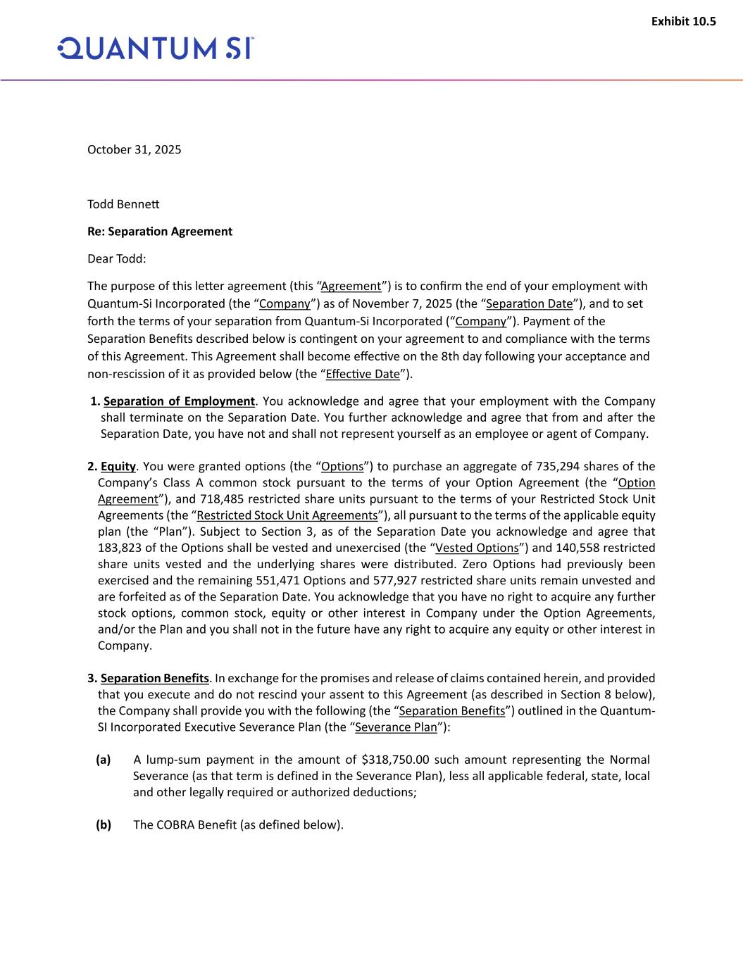
40
Exhibit 10.5 October 31, 2025 Todd Bennett Re: Separation Agreement Dear Todd: The purpose of this letter agreement (this “Agreement”) is to confirm the end of your employment with Quantum-Si Incorporated (the “Company”) as of November 7, 2025 (the “Separation Date”), and to set forth the terms of your separation from Quantum-Si Incorporated (“Company”). Payment of the Separation Benefits described below is contingent on your agreement to and compliance with the terms of this Agreement. This Agreement shall become effective on the 8th day following your acceptance and non-rescission of it as provided below (the “Effective Date”). 1. Separation of Employment. You acknowledge and agree that your employment with the Company shall terminate on the Separation Date. You further acknowledge and agree that from and after the Separation Date, you have not and shall not represent yourself as an employee or agent of Company. 2. Equity. You were granted options (the “Options”) to purchase an aggregate of 735,294 shares of the Company’s Class A common stock pursuant to the terms of your Option Agreement (the “Option Agreement”), and 718,485 restricted share units pursuant to the terms of your Restricted Stock Unit Agreements (the “Restricted Stock Unit Agreements”), all pursuant to the terms of the applicable equity plan (the “Plan”). Subject to Section 3, as of the Separation Date you acknowledge and agree that 183,823 of the Options shall be vested and unexercised (the “Vested Options”) and 140,558 restricted share units vested and the underlying shares were distributed. Zero Options had previously been exercised and the remaining 551,471 Options and 577,927 restricted share units remain unvested and are forfeited as of the Separation Date. You acknowledge that you have no right to acquire any further stock options, common stock, equity or other interest in Company under the Option Agreements, and/or the Plan and you shall not in the future have any right to acquire any equity or other interest in Company. 3. Separation Benefits. In exchange for the promises and release of claims contained herein, and provided that you execute and do not rescind your assent to this Agreement (as described in Section 8 below), the Company shall provide you with the following (the “Separation Benefits”) outlined in the Quantum- SI Incorporated Executive Severance Plan (the “Severance Plan”): (a) A lump-sum payment in the amount of $318,750.00 such amount representing the Normal Severance (as that term is defined in the Severance Plan), less all applicable federal, state, local and other legally required or authorized deductions; (b) The COBRA Benefit (as defined below).

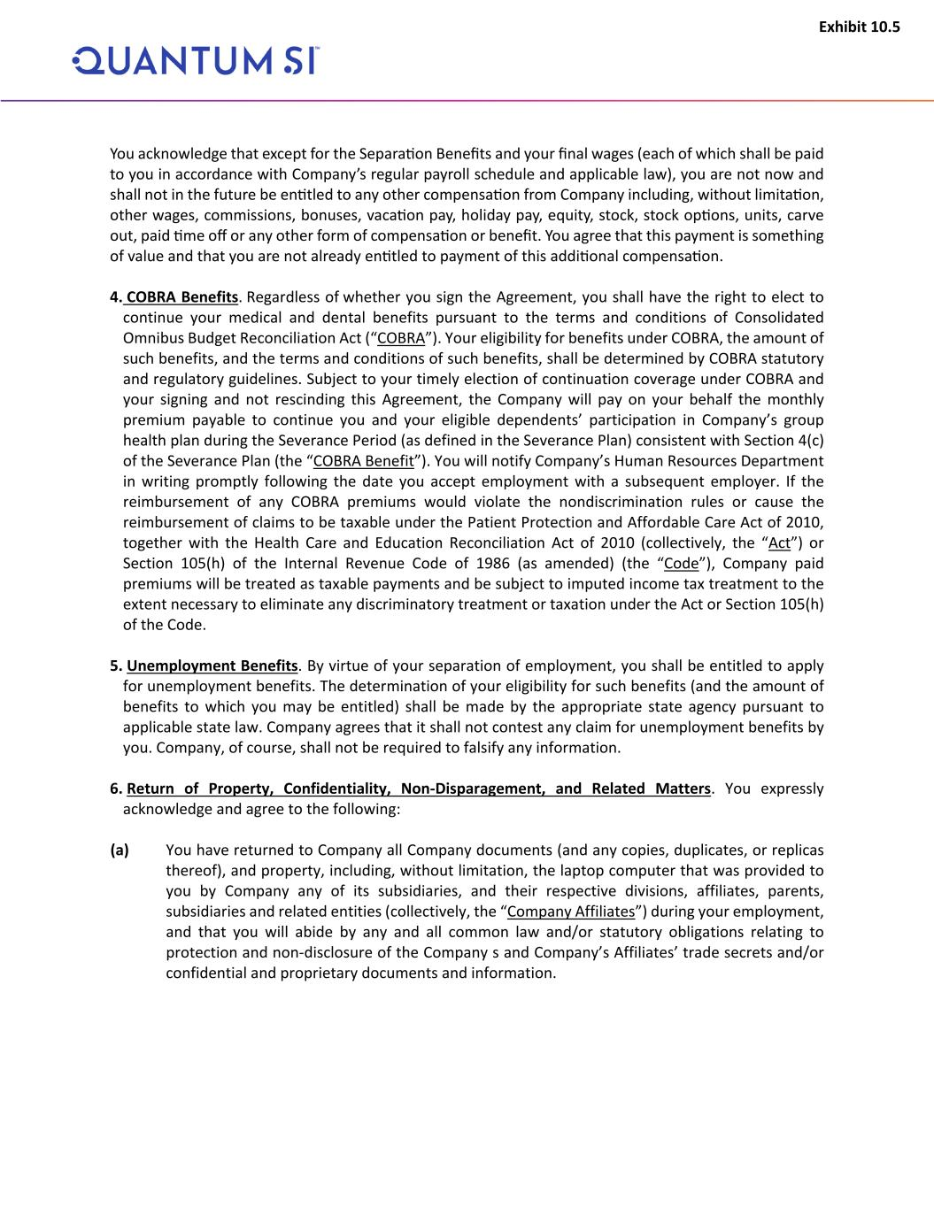
Exhibit 10.5 You acknowledge that except for the Separation Benefits and your final wages (each of which shall be paid to you in accordance with Company’s regular payroll schedule and applicable law), you are not now and shall not in the future be entitled to any other compensation from Company including, without limitation, other wages, commissions, bonuses, vacation pay, holiday pay, equity, stock, stock options, units, carve out, paid time off or any other form of compensation or benefit. You agree that this payment is something of value and that you are not already entitled to payment of this additional compensation. 4. COBRA Benefits. Regardless of whether you sign the Agreement, you shall have the right to elect to continue your medical and dental benefits pursuant to the terms and conditions of Consolidated Omnibus Budget Reconciliation Act (“COBRA”). Your eligibility for benefits under COBRA, the amount of such benefits, and the terms and conditions of such benefits, shall be determined by COBRA statutory and regulatory guidelines. Subject to your timely election of continuation coverage under COBRA and your signing and not rescinding this Agreement, the Company will pay on your behalf the monthly premium payable to continue you and your eligible dependents’ participation in Company’s group health plan during the Severance Period (as defined in the Severance Plan) consistent with Section 4(c) of the Severance Plan (the “COBRA Benefit”). You will notify Company’s Human Resources Department in writing promptly following the date you accept employment with a subsequent employer. If the reimbursement of any COBRA premiums would violate the nondiscrimination rules or cause the reimbursement of claims to be taxable under the Patient Protection and Affordable Care Act of 2010, together with the Health Care and Education Reconciliation Act of 2010 (collectively, the “Act”) or Section 105(h) of the Internal Revenue Code of 1986 (as amended) (the “Code”), Company paid premiums will be treated as taxable payments and be subject to imputed income tax treatment to the extent necessary to eliminate any discriminatory treatment or taxation under the Act or Section 105(h) of the Code. 5. Unemployment Benefits. By virtue of your separation of employment, you shall be entitled to apply for unemployment benefits. The determination of your eligibility for such benefits (and the amount of benefits to which you may be entitled) shall be made by the appropriate state agency pursuant to applicable state law. Company agrees that it shall not contest any claim for unemployment benefits by you. Company, of course, shall not be required to falsify any information. 6. Return of Property, Confidentiality, Non-Disparagement, and Related Matters. You expressly acknowledge and agree to the following: (a) You have returned to Company all Company documents (and any copies, duplicates, or replicas thereof), and property, including, without limitation, the laptop computer that was provided to you by Company any of its subsidiaries, and their respective divisions, affiliates, parents, subsidiaries and related entities (collectively, the “Company Affiliates”) during your employment, and that you will abide by any and all common law and/or statutory obligations relating to protection and non-disclosure of the Company s and Company’s Affiliates’ trade secrets and/or confidential and proprietary documents and information.

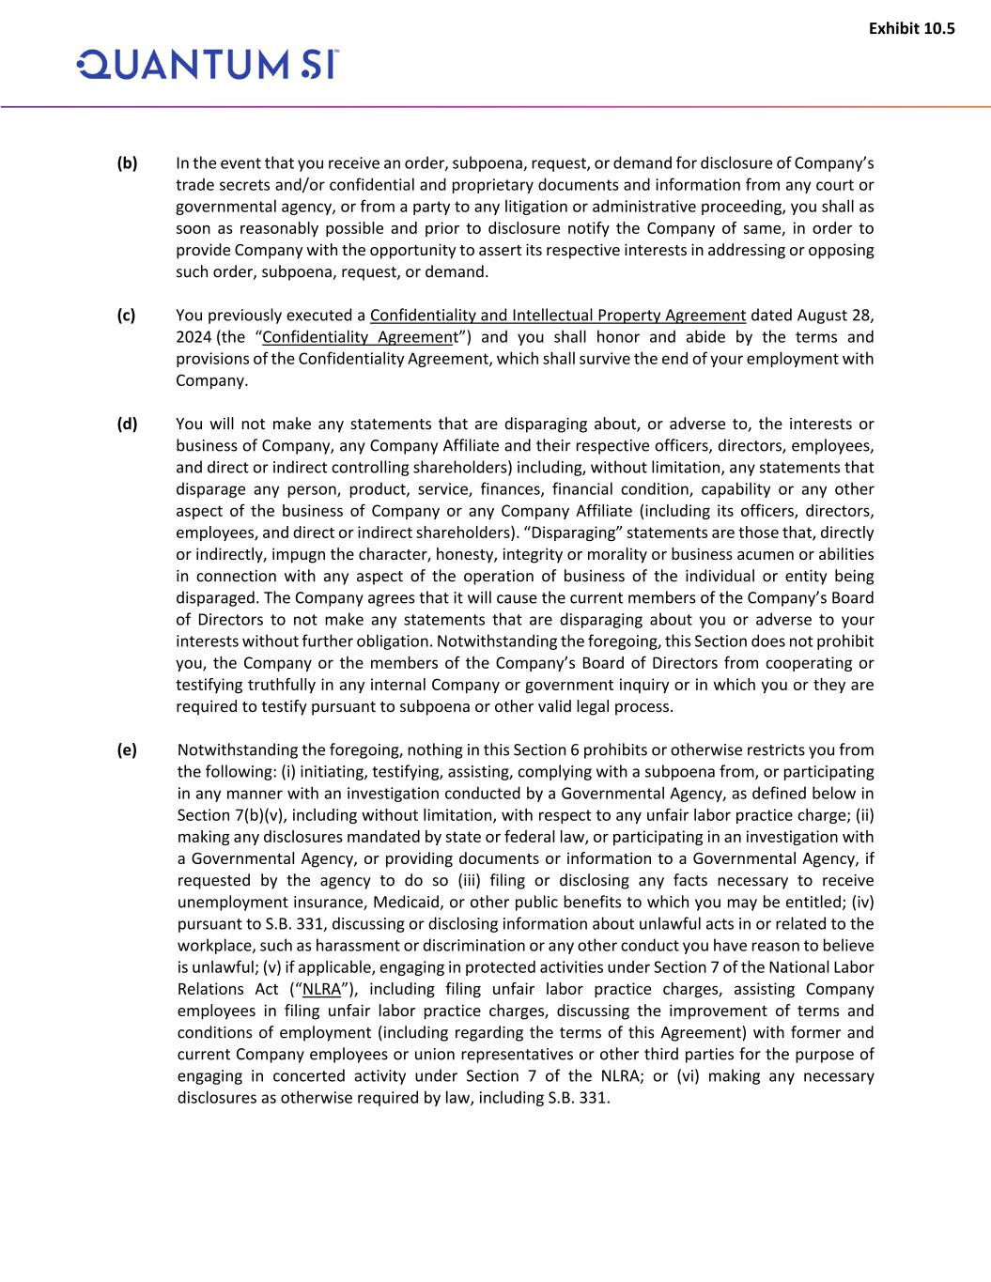
Exhibit 10.5 (b) In the event that you receive an order, subpoena, request, or demand for disclosure of Company’s trade secrets and/or confidential and proprietary documents and information from any court or governmental agency, or from a party to any litigation or administrative proceeding, you shall as soon as reasonably possible and prior to disclosure notify the Company of same, in order to provide Company with the opportunity to assert its respective interests in addressing or opposing such order, subpoena, request, or demand. (c) You previously executed a Confidentiality and Intellectual Property Agreement dated August 28, 2024 (the “Confidentiality Agreement”) and you shall honor and abide by the terms and provisions of the Confidentiality Agreement, which shall survive the end of your employment with Company. (d) You will not make any statements that are disparaging about, or adverse to, the interests or business of Company, any Company Affiliate and their respective officers, directors, employees, and direct or indirect controlling shareholders) including, without limitation, any statements that disparage any person, product, service, finances, financial condition, capability or any other aspect of the business of Company or any Company Affiliate (including its officers, directors, employees, and direct or indirect shareholders). “Disparaging” statements are those that, directly or indirectly, impugn the character, honesty, integrity or morality or business acumen or abilities in connection with any aspect of the operation of business of the individual or entity being disparaged. The Company agrees that it will cause the current members of the Company’s Board of Directors to not make any statements that are disparaging about you or adverse to your interests without further obligation. Notwithstanding the foregoing, this Section does not prohibit you, the Company or the members of the Company’s Board of Directors from cooperating or testifying truthfully in any internal Company or government inquiry or in which you or they are required to testify pursuant to subpoena or other valid legal process. (e) Notwithstanding the foregoing, nothing in this Section 6 prohibits or otherwise restricts you from the following: (i) initiating, testifying, assisting, complying with a subpoena from, or participating in any manner with an investigation conducted by a Governmental Agency, as defined below in Section 7(b)(v), including without limitation, with respect to any unfair labor practice charge; (ii) making any disclosures mandated by state or federal law, or participating in an investigation with a Governmental Agency, or providing documents or information to a Governmental Agency, if requested by the agency to do so (iii) filing or disclosing any facts necessary to receive unemployment insurance, Medicaid, or other public benefits to which you may be entitled; (iv) pursuant to S.B. 331, discussing or disclosing information about unlawful acts in or related to the workplace, such as harassment or discrimination or any other conduct you have reason to believe is unlawful; (v) if applicable, engaging in protected activities under Section 7 of the National Labor Relations Act (“NLRA”), including filing unfair labor practice charges, assisting Company employees in filing unfair labor practice charges, discussing the improvement of terms and conditions of employment (including regarding the terms of this Agreement) with former and current Company employees or union representatives or other third parties for the purpose of engaging in concerted activity under Section 7 of the NLRA; or (vi) making any necessary disclosures as otherwise required by law, including S.B. 331.

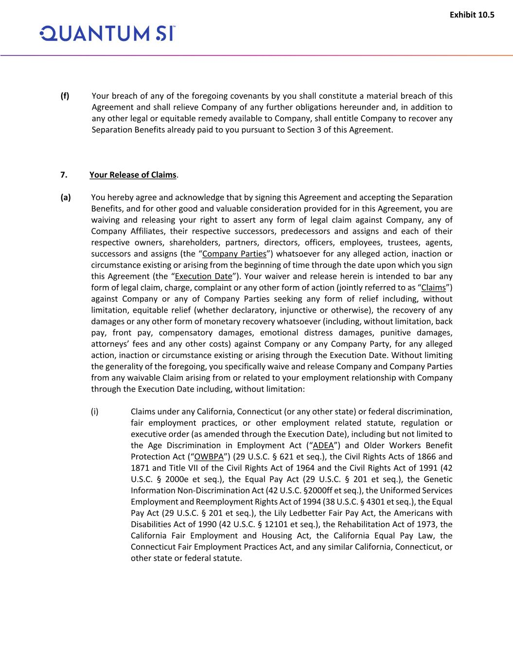
Exhibit 10.5 (f) Your breach of any of the foregoing covenants by you shall constitute a material breach of this Agreement and shall relieve Company of any further obligations hereunder and, in addition to any other legal or equitable remedy available to Company, shall entitle Company to recover any Separation Benefits already paid to you pursuant to Section 3 of this Agreement. 7. Your Release of Claims. (a) You hereby agree and acknowledge that by signing this Agreement and accepting the Separation Benefits, and for other good and valuable consideration provided for in this Agreement, you are waiving and releasing your right to assert any form of legal claim against Company, any of Company Affiliates, their respective successors, predecessors and assigns and each of their respective owners, shareholders, partners, directors, officers, employees, trustees, agents, successors and assigns (the “Company Parties”) whatsoever for any alleged action, inaction or circumstance existing or arising from the beginning of time through the date upon which you sign this Agreement (the “Execution Date”). Your waiver and release herein is intended to bar any form of legal claim, charge, complaint or any other form of action (jointly referred to as “Claims”) against Company or any of Company Parties seeking any form of relief including, without limitation, equitable relief (whether declaratory, injunctive or otherwise), the recovery of any damages or any other form of monetary recovery whatsoever (including, without limitation, back pay, front pay, compensatory damages, emotional distress damages, punitive damages, attorneys’ fees and any other costs) against Company or any Company Party, for any alleged action, inaction or circumstance existing or arising through the Execution Date. Without limiting the generality of the foregoing, you specifically waive and release Company and Company Parties from any waivable Claim arising from or related to your employment relationship with Company through the Execution Date including, without limitation: (i) Claims under any California, Connecticut (or any other state) or federal discrimination, fair employment practices, or other employment related statute, regulation or executive order (as amended through the Execution Date), including but not limited to the Age Discrimination in Employment Act (“ADEA”) and Older Workers Benefit Protection Act (“OWBPA”) (29 U.S.C. § 621 et seq.), the Civil Rights Acts of 1866 and 1871 and Title VII of the Civil Rights Act of 1964 and the Civil Rights Act of 1991 (42 U.S.C. § 2000e et seq.), the Equal Pay Act (29 U.S.C. § 201 et seq.), the Genetic Information Non-Discrimination Act (42 U.S.C. §2000ff et seq.), the Uniformed Services Employment and Reemployment Rights Act of 1994 (38 U.S.C. § 4301 et seq.), the Equal Pay Act (29 U.S.C. § 201 et seq.), the Lily Ledbetter Fair Pay Act, the Americans with Disabilities Act of 1990 (42 U.S.C. § 12101 et seq.), the Rehabilitation Act of 1973, the California Fair Employment and Housing Act, the California Equal Pay Law, the Connecticut Fair Employment Practices Act, and any similar California, Connecticut, or other state or federal statute.

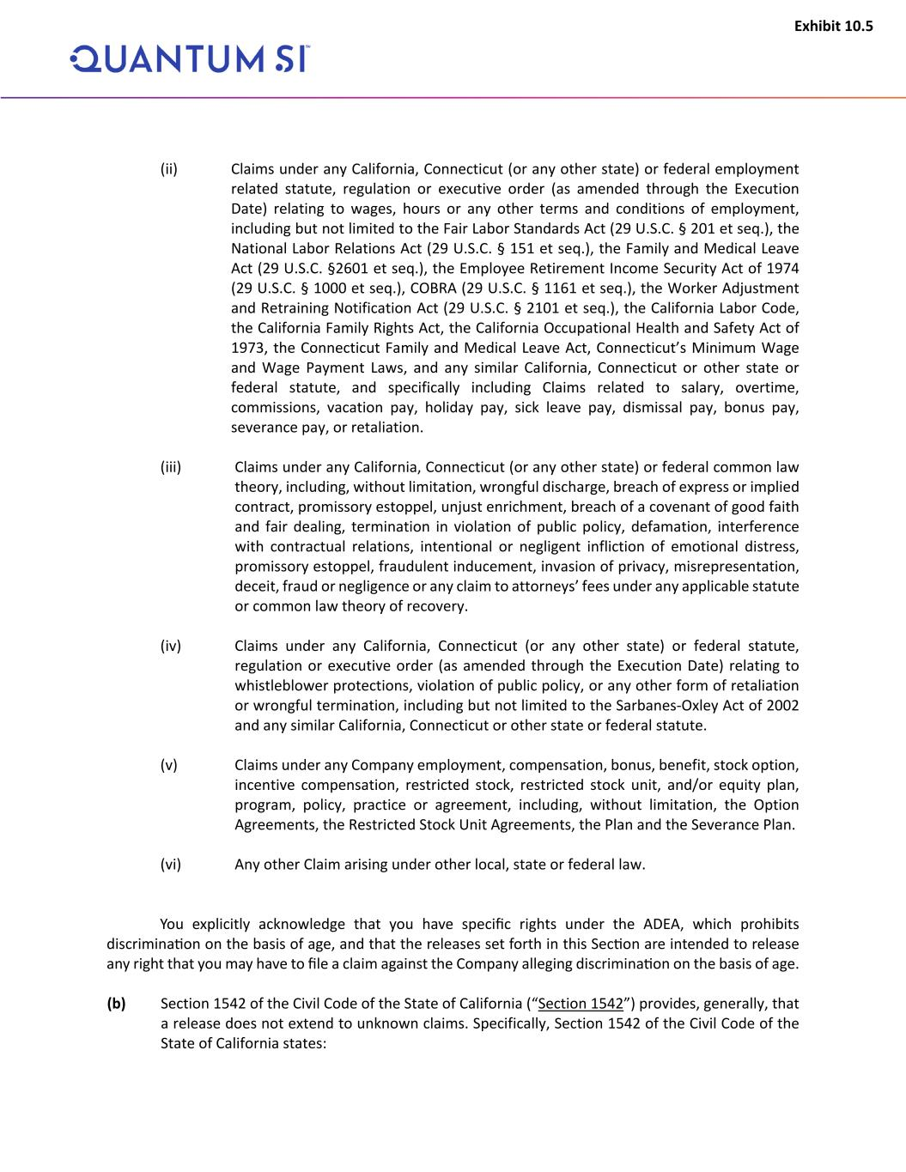
Exhibit 10.5 (ii) Claims under any California, Connecticut (or any other state) or federal employment related statute, regulation or executive order (as amended through the Execution Date) relating to wages, hours or any other terms and conditions of employment, including but not limited to the Fair Labor Standards Act (29 U.S.C. § 201 et seq.), the National Labor Relations Act (29 U.S.C. § 151 et seq.), the Family and Medical Leave Act (29 U.S.C. §2601 et seq.), the Employee Retirement Income Security Act of 1974 (29 U.S.C. § 1000 et seq.), COBRA (29 U.S.C. § 1161 et seq.), the Worker Adjustment and Retraining Notification Act (29 U.S.C. § 2101 et seq.), the California Labor Code, the California Family Rights Act, the California Occupational Health and Safety Act of 1973, the Connecticut Family and Medical Leave Act, Connecticut’s Minimum Wage and Wage Payment Laws, and any similar California, Connecticut or other state or federal statute, and specifically including Claims related to salary, overtime, commissions, vacation pay, holiday pay, sick leave pay, dismissal pay, bonus pay, severance pay, or retaliation. (iii) Claims under any California, Connecticut (or any other state) or federal common law theory, including, without limitation, wrongful discharge, breach of express or implied contract, promissory estoppel, unjust enrichment, breach of a covenant of good faith and fair dealing, termination in violation of public policy, defamation, interference with contractual relations, intentional or negligent infliction of emotional distress, promissory estoppel, fraudulent inducement, invasion of privacy, misrepresentation, deceit, fraud or negligence or any claim to attorneys’ fees under any applicable statute or common law theory of recovery. (iv) Claims under any California, Connecticut (or any other state) or federal statute, regulation or executive order (as amended through the Execution Date) relating to whistleblower protections, violation of public policy, or any other form of retaliation or wrongful termination, including but not limited to the Sarbanes-Oxley Act of 2002 and any similar California, Connecticut or other state or federal statute. (v) Claims under any Company employment, compensation, bonus, benefit, stock option, incentive compensation, restricted stock, restricted stock unit, and/or equity plan, program, policy, practice or agreement, including, without limitation, the Option Agreements, the Restricted Stock Unit Agreements, the Plan and the Severance Plan. (vi) Any other Claim arising under other local, state or federal law. You explicitly acknowledge that you have specific rights under the ADEA, which prohibits discrimination on the basis of age, and that the releases set forth in this Section are intended to release any right that you may have to file a claim against the Company alleging discrimination on the basis of age. (b) Section 1542 of the Civil Code of the State of California (“Section 1542”) provides, generally, that a release does not extend to unknown claims. Specifically, Section 1542 of the Civil Code of the State of California states:

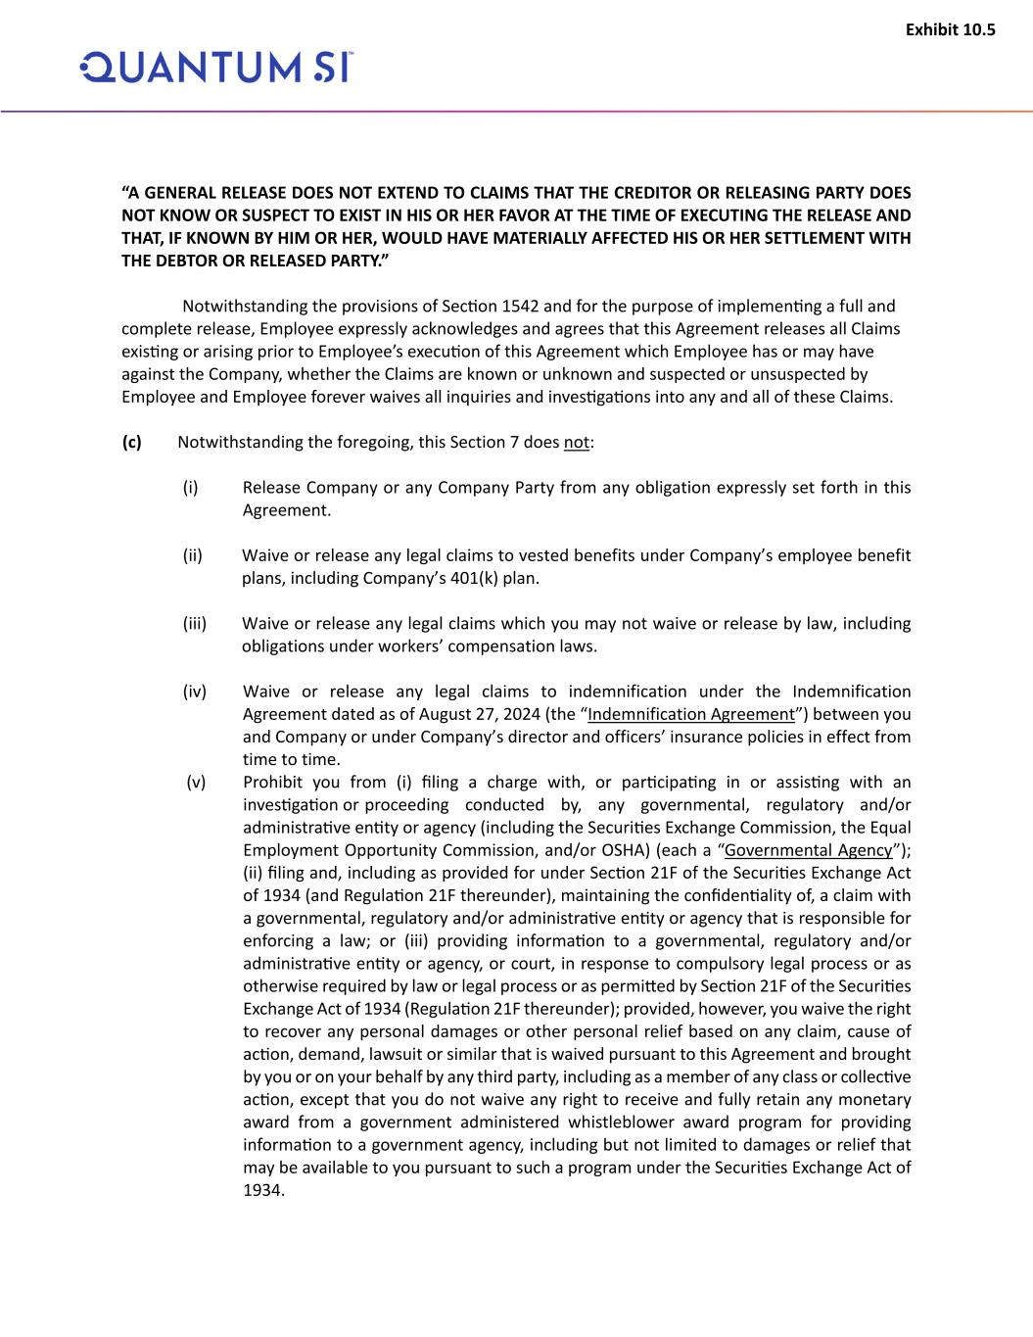
Exhibit 10.5 “A GENERAL RELEASE DOES NOT EXTEND TO CLAIMS THAT THE CREDITOR OR RELEASING PARTY DOES NOT KNOW OR SUSPECT TO EXIST IN HIS OR HER FAVOR AT THE TIME OF EXECUTING THE RELEASE AND THAT, IF KNOWN BY HIM OR HER, WOULD HAVE MATERIALLY AFFECTED HIS OR HER SETTLEMENT WITH THE DEBTOR OR RELEASED PARTY.” Notwithstanding the provisions of Section 1542 and for the purpose of implementing a full and complete release, Employee expressly acknowledges and agrees that this Agreement releases all Claims existing or arising prior to Employee’s execution of this Agreement which Employee has or may have against the Company, whether the Claims are known or unknown and suspected or unsuspected by Employee and Employee forever waives all inquiries and investigations into any and all of these Claims. (c) Notwithstanding the foregoing, this Section 7 does not: (i) Release Company or any Company Party from any obligation expressly set forth in this Agreement. (ii) Waive or release any legal claims to vested benefits under Company’s employee benefit plans, including Company’s 401(k) plan. (iii) Waive or release any legal claims which you may not waive or release by law, including obligations under workers’ compensation laws. (iv) Waive or release any legal claims to indemnification under the Indemnification Agreement dated as of August 27, 2024 (the “Indemnification Agreement”) between you and Company or under Company’s director and officers’ insurance policies in effect from time to time. (v) Prohibit you from (i) filing a charge with, or participating in or assisting with an investigation or proceeding conducted by, any governmental, regulatory and/or administrative entity or agency (including the Securities Exchange Commission, the Equal Employment Opportunity Commission, and/or OSHA) (each a “Governmental Agency”); (ii) filing and, including as provided for under Section 21F of the Securities Exchange Act of 1934 (and Regulation 21F thereunder), maintaining the confidentiality of, a claim with a governmental, regulatory and/or administrative entity or agency that is responsible for enforcing a law; or (iii) providing information to a governmental, regulatory and/or administrative entity or agency, or court, in response to compulsory legal process or as otherwise required by law or legal process or as permitted by Section 21F of the Securities Exchange Act of 1934 (Regulation 21F thereunder); provided, however, you waive the right to recover any personal damages or other personal relief based on any claim, cause of action, demand, lawsuit or similar that is waived pursuant to this Agreement and brought by you or on your behalf by any third party, including as a member of any class or collective action, except that you do not waive any right to receive and fully retain any monetary award from a government administered whistleblower award program for providing information to a government agency, including but not limited to damages or relief that may be available to you pursuant to such a program under the Securities Exchange Act of 1934.

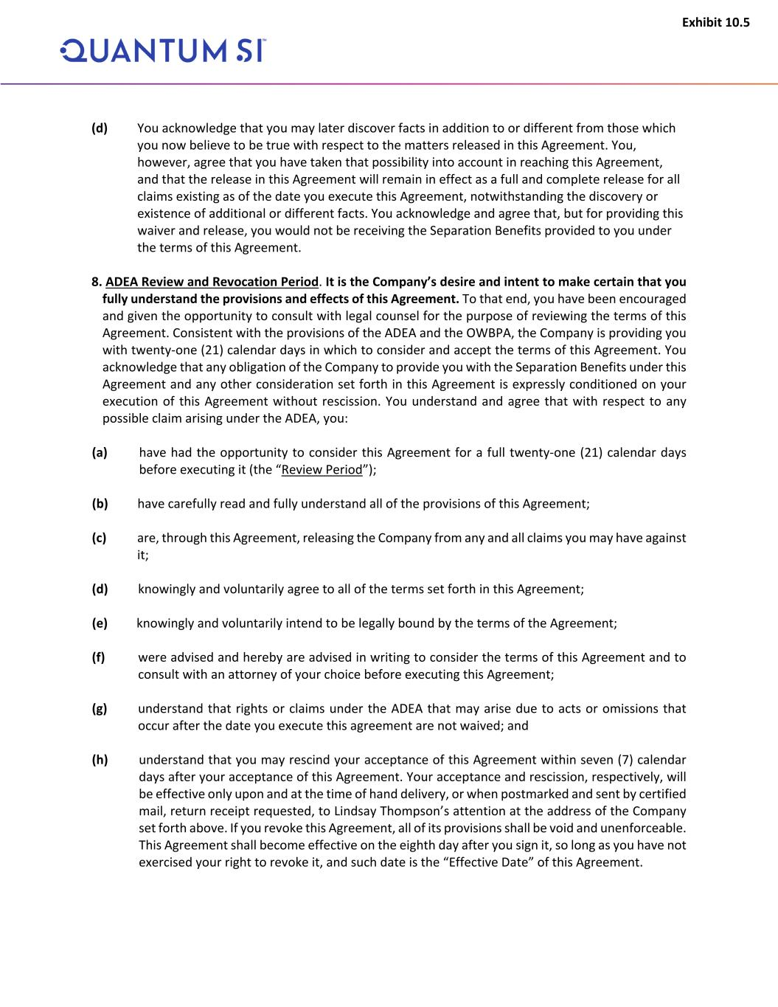
Exhibit 10.5 (d) You acknowledge that you may later discover facts in addition to or different from those which you now believe to be true with respect to the matters released in this Agreement. You, however, agree that you have taken that possibility into account in reaching this Agreement, and that the release in this Agreement will remain in effect as a full and complete release for all claims existing as of the date you execute this Agreement, notwithstanding the discovery or existence of additional or different facts. You acknowledge and agree that, but for providing this waiver and release, you would not be receiving the Separation Benefits provided to you under the terms of this Agreement. 8. ADEA Review and Revocation Period. It is the Company’s desire and intent to make certain that you fully understand the provisions and effects of this Agreement. To that end, you have been encouraged and given the opportunity to consult with legal counsel for the purpose of reviewing the terms of this Agreement. Consistent with the provisions of the ADEA and the OWBPA, the Company is providing you with twenty-one (21) calendar days in which to consider and accept the terms of this Agreement. You acknowledge that any obligation of the Company to provide you with the Separation Benefits under this Agreement and any other consideration set forth in this Agreement is expressly conditioned on your execution of this Agreement without rescission. You understand and agree that with respect to any possible claim arising under the ADEA, you: (a) have had the opportunity to consider this Agreement for a full twenty-one (21) calendar days before executing it (the “Review Period”); (b) have carefully read and fully understand all of the provisions of this Agreement; (c) are, through this Agreement, releasing the Company from any and all claims you may have against it; (d) knowingly and voluntarily agree to all of the terms set forth in this Agreement; (e) knowingly and voluntarily intend to be legally bound by the terms of the Agreement; (f) were advised and hereby are advised in writing to consider the terms of this Agreement and to consult with an attorney of your choice before executing this Agreement; (g) understand that rights or claims under the ADEA that may arise due to acts or omissions that occur after the date you execute this agreement are not waived; and (h) understand that you may rescind your acceptance of this Agreement within seven (7) calendar days after your acceptance of this Agreement. Your acceptance and rescission, respectively, will be effective only upon and at the time of hand delivery, or when postmarked and sent by certified mail, return receipt requested, to Lindsay Thompson’s attention at the address of the Company set forth above. If you revoke this Agreement, all of its provisions shall be void and unenforceable. This Agreement shall become effective on the eighth day after you sign it, so long as you have not exercised your right to revoke it, and such date is the “Effective Date” of this Agreement.

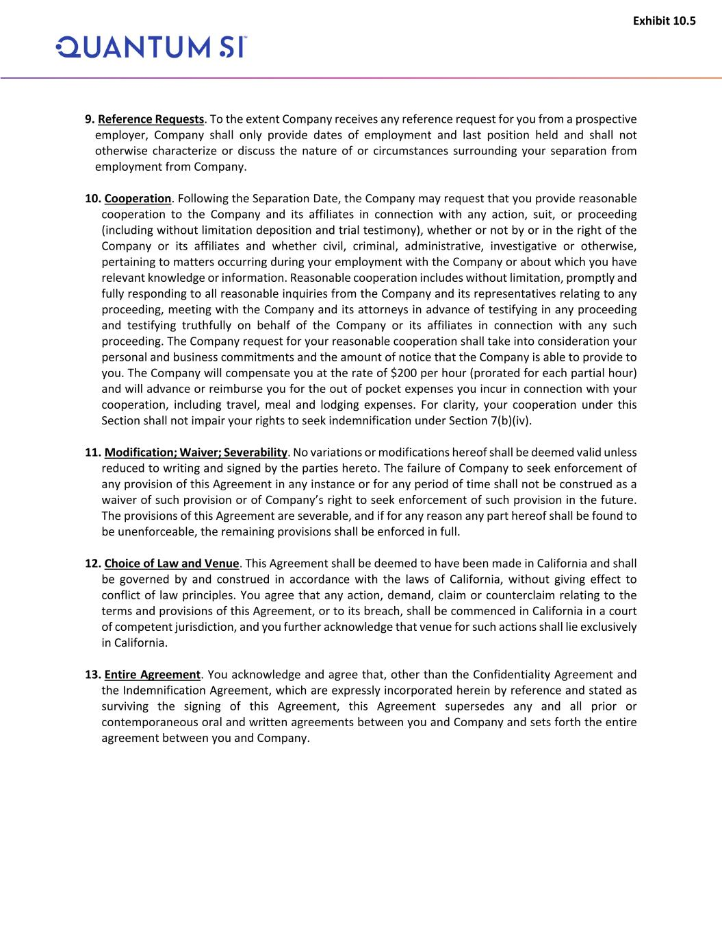
Exhibit 10.5 9. Reference Requests. To the extent Company receives any reference request for you from a prospective employer, Company shall only provide dates of employment and last position held and shall not otherwise characterize or discuss the nature of or circumstances surrounding your separation from employment from Company. 10. Cooperation. Following the Separation Date, the Company may request that you provide reasonable cooperation to the Company and its affiliates in connection with any action, suit, or proceeding (including without limitation deposition and trial testimony), whether or not by or in the right of the Company or its affiliates and whether civil, criminal, administrative, investigative or otherwise, pertaining to matters occurring during your employment with the Company or about which you have relevant knowledge or information. Reasonable cooperation includes without limitation, promptly and fully responding to all reasonable inquiries from the Company and its representatives relating to any proceeding, meeting with the Company and its attorneys in advance of testifying in any proceeding and testifying truthfully on behalf of the Company or its affiliates in connection with any such proceeding. The Company request for your reasonable cooperation shall take into consideration your personal and business commitments and the amount of notice that the Company is able to provide to you. The Company will compensate you at the rate of $200 per hour (prorated for each partial hour) and will advance or reimburse you for the out of pocket expenses you incur in connection with your cooperation, including travel, meal and lodging expenses. For clarity, your cooperation under this Section shall not impair your rights to seek indemnification under Section 7(b)(iv). 11. Modification; Waiver; Severability. No variations or modifications hereof shall be deemed valid unless reduced to writing and signed by the parties hereto. The failure of Company to seek enforcement of any provision of this Agreement in any instance or for any period of time shall not be construed as a waiver of such provision or of Company’s right to seek enforcement of such provision in the future. The provisions of this Agreement are severable, and if for any reason any part hereof shall be found to be unenforceable, the remaining provisions shall be enforced in full. 12. Choice of Law and Venue. This Agreement shall be deemed to have been made in California and shall be governed by and construed in accordance with the laws of California, without giving effect to conflict of law principles. You agree that any action, demand, claim or counterclaim relating to the terms and provisions of this Agreement, or to its breach, shall be commenced in California in a court of competent jurisdiction, and you further acknowledge that venue for such actions shall lie exclusively in California. 13. Entire Agreement. You acknowledge and agree that, other than the Confidentiality Agreement and the Indemnification Agreement, which are expressly incorporated herein by reference and stated as surviving the signing of this Agreement, this Agreement supersedes any and all prior or contemporaneous oral and written agreements between you and Company and sets forth the entire agreement between you and Company.

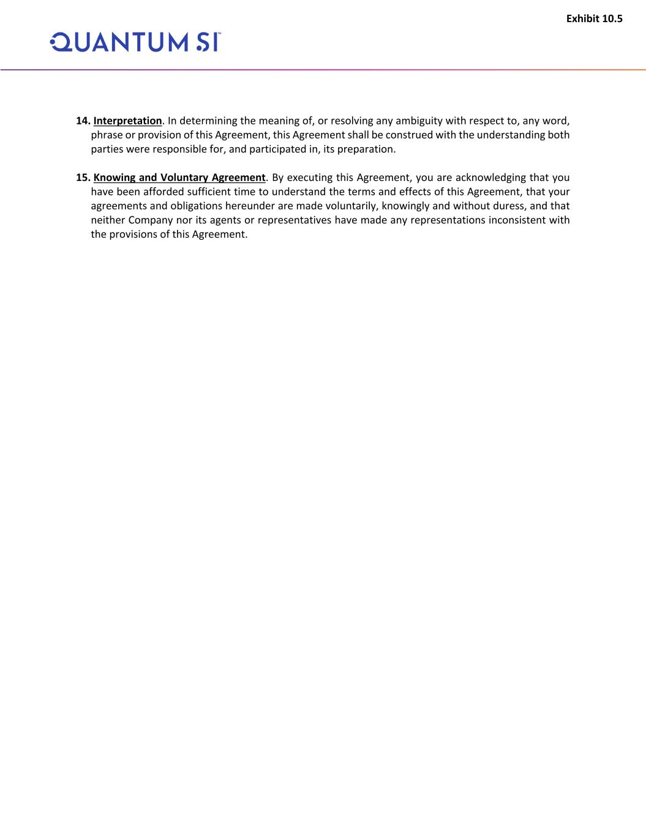
Exhibit 10.5 14. Interpretation. In determining the meaning of, or resolving any ambiguity with respect to, any word, phrase or provision of this Agreement, this Agreement shall be construed with the understanding both parties were responsible for, and participated in, its preparation. 15. Knowing and Voluntary Agreement. By executing this Agreement, you are acknowledging that you have been afforded sufficient time to understand the terms and effects of this Agreement, that your agreements and obligations hereunder are made voluntarily, knowingly and without duress, and that neither Company nor its agents or representatives have made any representations inconsistent with the provisions of this Agreement.

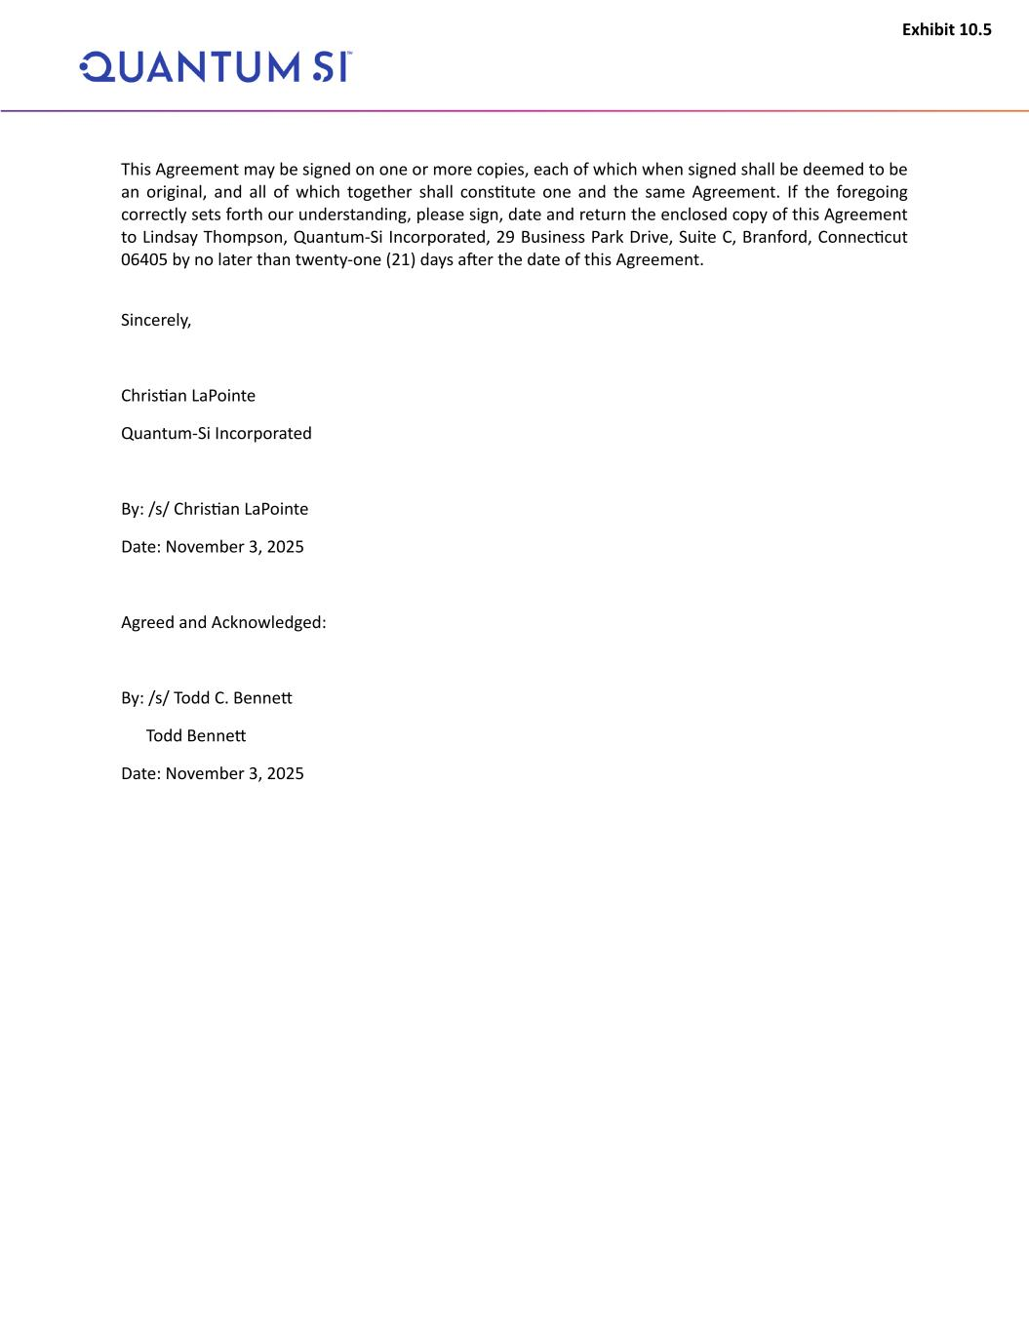
Exhibit 10.5 This Agreement may be signed on one or more copies, each of which when signed shall be deemed to be an original, and all of which together shall constitute one and the same Agreement. If the foregoing correctly sets forth our understanding, please sign, date and return the enclosed copy of this Agreement to Lindsay Thompson, Quantum-Si Incorporated, 29 Business Park Drive, Suite C, Branford, Connecticut 06405 by no later than twenty-one (21) days after the date of this Agreement. Sincerely, Christian LaPointe Quantum-Si Incorporated By: /s/ Christian LaPointe Date: November 3, 2025 Agreed and Acknowledged: By: /s/ Todd C. Bennett Todd Bennett Date: November 3, 2025

Exhibit 31.1
CERTIFICATIONS UNDER SECTION 302
I, Jeffrey Hawkins, certify that:
1.I have reviewed this quarterly report on Form 10-Q of Quantum-Si Incorporated;
2.Based on my knowledge, this report does not contain any untrue statement of a material fact or omit to state a material fact necessary to make the statements made, in light of the circumstances under which such statements were made, not misleading with respect to the period covered by this report;
3.Based on my knowledge, the financial statements, and other financial information included in this report, fairly present in all material respects the financial condition, results of operations and cash flows of the registrant as of, and for, the periods presented in this report;
4.The registrant’s other certifying officer and I are responsible for establishing and maintaining disclosure controls and procedures (as defined in Exchange Act Rules 13a-15(e) and 15d-15(e)) and internal control over financial reporting (as defined in Exchange Act Rules 13a-15(f) and 15d-15(f)) for the registrant and have:
a)designed such disclosure controls and procedures, or caused such disclosure controls and procedures to be designed under our supervision, to ensure that material information relating to the registrant, including its consolidated subsidiaries, is made known to us by others within those entities, particularly during the period in which this report is being prepared;
b)designed such internal control over financial reporting, or caused such internal control over financial reporting to be designed under our supervision, to provide reasonable assurance regarding the reliability of financial reporting and the preparation of financial statements for external purposes in accordance with generally accepted accounting principles;
c)evaluated the effectiveness of the registrant’s disclosure controls and procedures and presented in this report our conclusions about the effectiveness of the disclosure controls and procedures, as of the end of the period covered by this report based on such evaluation; and
d)disclosed in this report any change in the registrant’s internal control over financial reporting that occurred during the registrant’s most recent fiscal quarter (the registrant’s fourth fiscal quarter in the case of an annual report) that has materially affected, or is reasonably likely to materially affect, the registrant’s internal control over financial reporting; and
5.The registrant’s other certifying officer(s) and I have disclosed, based on our most recent evaluation of internal control over financial reporting, to the registrant’s auditors and the audit committee of the registrant’s board of directors (or persons performing the equivalent functions):
a)all significant deficiencies and material weaknesses in the design or operation of internal control over financial reporting which are reasonably likely to adversely affect the registrant’s ability to record, process, summarize and report financial information; and
b)any fraud, whether or not material, that involves management or other employees who have a significant role in the registrant’s internal control over financial reporting.
Date: November 5, 2025
/s/ Jeffrey Hawkins
Jeffrey Hawkins
President and Chief Executive Officer
(Principal Executive Officer)

Exhibit 31.2
CERTIFICATIONS UNDER SECTION 302
I, Jeffry Keyes, certify that:
1.I have reviewed this quarterly report on Form 10-Q of Quantum-Si Incorporated;
2.Based on my knowledge, this report does not contain any untrue statement of a material fact or omit to state a material fact necessary to make the statements made, in light of the circumstances under which such statements were made, not misleading with respect to the period covered by this report;
3.Based on my knowledge, the financial statements, and other financial information included in this report, fairly present in all material respects the financial condition, results of operations and cash flows of the registrant as of, and for, the periods presented in this report;
4.The registrant’s other certifying officer and I are responsible for establishing and maintaining disclosure controls and procedures (as defined in Exchange Act Rules 13a-15(e) and 15d-15(e)) and internal control over financial reporting (as defined in Exchange Act Rules 13a-15(f) and 15d-15(f)) for the registrant and have:
a)designed such disclosure controls and procedures, or caused such disclosure controls and procedures to be designed under our supervision, to ensure that material information relating to the registrant, including its consolidated subsidiaries, is made known to us by others within those entities, particularly during the period in which this report is being prepared;
b)designed such internal control over financial reporting, or caused such internal control over financial reporting to be designed under our supervision, to provide reasonable assurance regarding the reliability of financial reporting and the preparation of financial statements for external purposes in accordance with generally accepted accounting principles;
c)evaluated the effectiveness of the registrant’s disclosure controls and procedures and presented in this report our conclusions about the effectiveness of the disclosure controls and procedures, as of the end of the period covered by this report based on such evaluation; and
d)disclosed in this report any change in the registrant’s internal control over financial reporting that occurred during the registrant’s most recent fiscal quarter (the registrant’s fourth fiscal quarter in the case of an annual report) that has materially affected, or is reasonably likely to materially affect, the registrant’s internal control over financial reporting; and
5.The registrant’s other certifying officer(s) and I have disclosed, based on our most recent evaluation of internal control over financial reporting, to the registrant’s auditors and the audit committee of the registrant’s board of directors (or persons performing the equivalent functions):
a)all significant deficiencies and material weaknesses in the design or operation of internal control over financial reporting which are reasonably likely to adversely affect the registrant’s ability to record, process, summarize and report financial information; and
b)any fraud, whether or not material, that involves management or other employees who have a significant role in the registrant’s internal control over financial reporting.
Date: November 5, 2025
/s/ Jeffry Keyes
Jeffry Keyes
Chief Financial Officer and Treasurer
(Principal Financial Officer)

Exhibit 32.1
CERTIFICATIONS UNDER SECTION 906
Pursuant to section 906 of the Sarbanes-Oxley Act of 2002 (subsections (a) and (b) of section 1350, chapter 63 of title 18, United States Code), the undersigned officer of Quantum-Si Incorporated, a Delaware corporation (the “Company”), does hereby certify, to such officer’s knowledge, that:
The Quarterly Report for the quarter ended September 30, 2025 (the “Form 10-Q”) of the Company fully complies with the requirements of Section 13(a) or 15(d) of the Securities Exchange Act of 1934, and the information contained in the Form 10-Q fairly presents, in all material respects, the financial condition and results of operations of the Company.
Dated: November 5, 2025 |  |  | /s/ Jeffrey Hawkins
 |  |  | Jeffrey Hawkins
 |  |  | President and Chief Executive Officer
 |  |  | (Principal Executive Officer)

Exhibit 32.2
CERTIFICATIONS UNDER SECTION 906
Pursuant to section 906 of the Sarbanes-Oxley Act of 2002 (subsections (a) and (b) of section 1350, chapter 63 of title 18, United States Code), the undersigned officer of Quantum-Si Incorporated, a Delaware corporation (the “Company”), does hereby certify, to such officer’s knowledge, that:
The Quarterly Report for the quarter ended September 30, 2025 (the “Form 10-Q”) of the Company fully complies with the requirements of Section 13(a) or 15(d) of the Securities Exchange Act of 1934, and the information contained in the Form 10-Q fairly presents, in all material respects, the financial condition and results of operations of the Company.
Dated: November 5, 2025 |  |  | /s/ Jeffry Keyes
 |  |  | Jeffry Keyes
 |  |  | Chief Financial Officer and Treasurer
 |  |  | (Principal Financial Officer)

